EAXEE THOUGHT LEADERSHIP SERIES

Designed Not to Break
  - A field manual for operational resilience, regulatory traceability and cyber-aware architecture with EAXEE

Voice: practical, disciplined and field-oriented — written as an executive resilience manual with rules, tests and operational lessons.

Enterprise architecture for decisions that matter

Field rule 1: begin with the service, not the server
Operational resilience is often discussed in technical language: redundancy, backup, recovery time and failover. Those mechanisms matter, but the business experiences disruption as a failed service, delayed decision, broken customer journey or unavailable control. The correct starting point is therefore the business service and the outcome it must continue to provide.
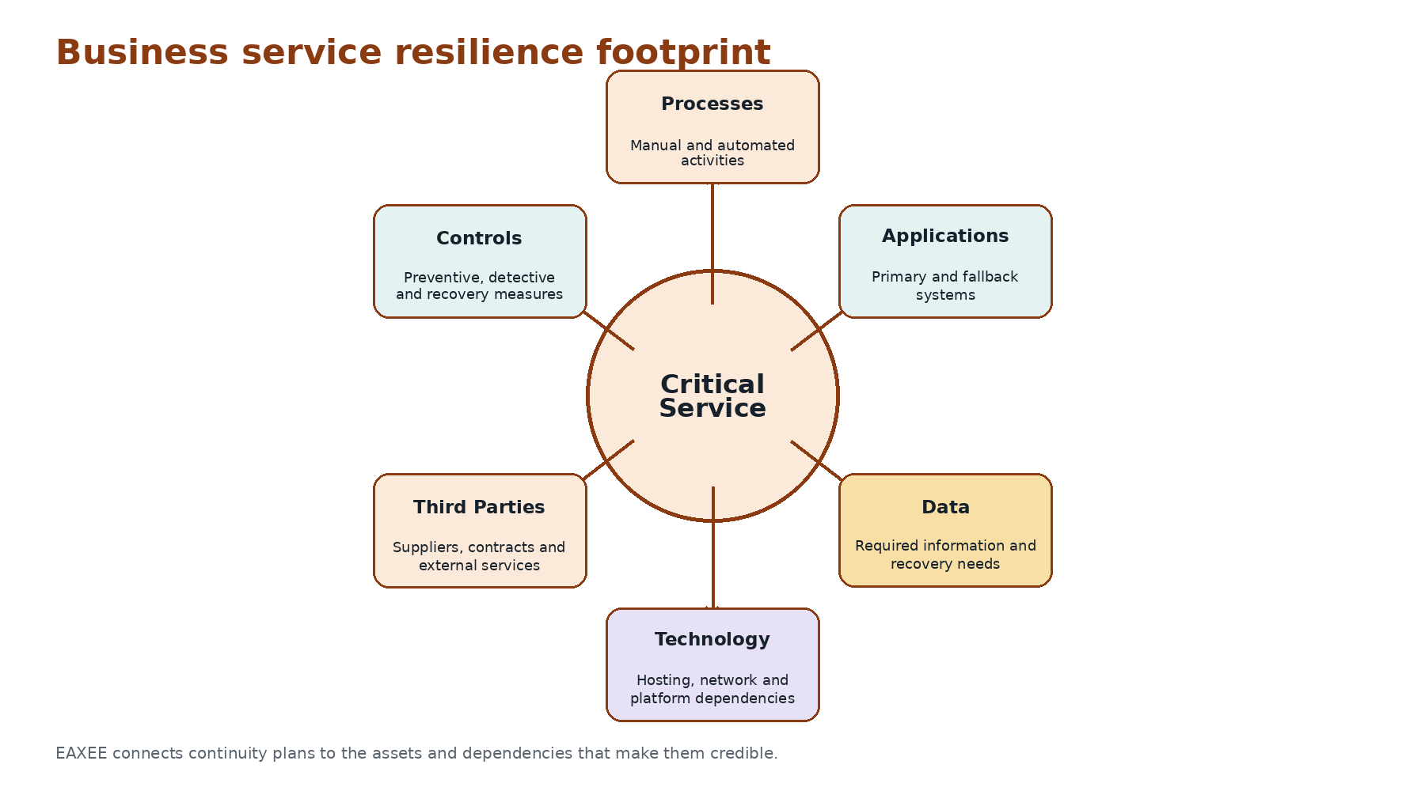
Figure 1. An EAXEE business service resilience footprint.
EAXEE connects a critical service to processes, people, applications, data, technology, suppliers, controls and recovery arrangements. This creates a single navigable footprint for continuity, cybersecurity, operations, architecture, risk and audit teams.

Field rule 2: map propagation, not just failure
A component failure is rarely the final consequence. It propagates through dependency chains. A certificate expiry can interrupt an integration; the integration can block identity validation; identity failure can prevent guest check-in; the service interruption can trigger regulatory, financial and reputational consequences. EAXEE makes these paths visible.
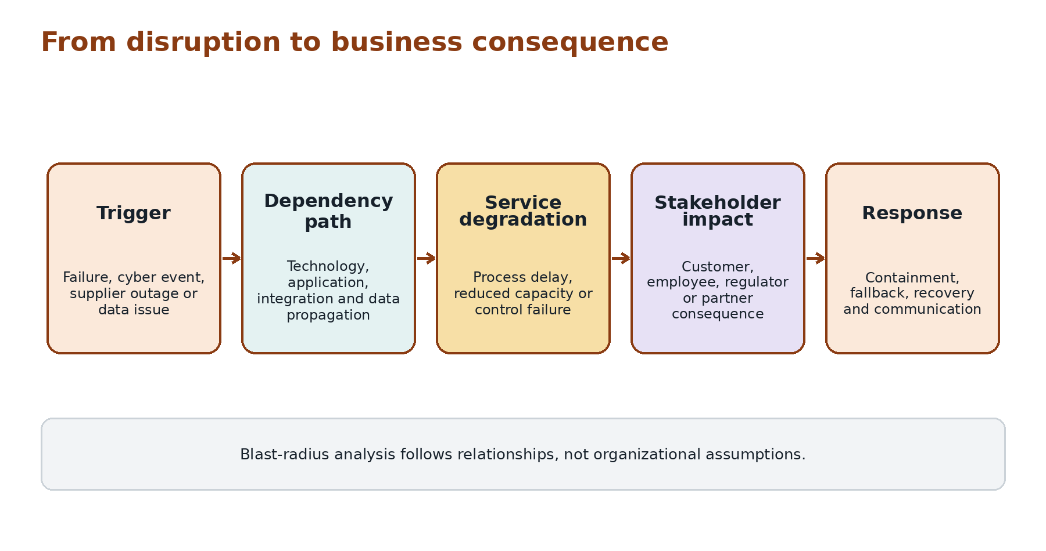
Figure 2. A disruption path from trigger to consequence.

Field rule 3: define tolerances in business terms
Recovery targets are stronger when tied to service impact. Instead of stating only that an application must recover within four hours, define the level and duration of service degradation the organization can tolerate, the minimum viable process, the data required and the point at which customer, safety, financial or regulatory harm becomes unacceptable.
Tolerance dimension | Example | EAXEE linkage
Time | Guest check-in cannot remain unavailable for more than 30 minutes | Service, journey stage, application and recovery target
Volume | Manual fallback can support 35% of peak demand | Process, role capacity, location and continuity procedure
Data | Transactions may be queued but not lost | Data entity, integration, reconciliation and control
Control | High-value credits require human approval during degraded mode | Policy, role, threshold and fallback workflow
Stakeholder | Regulator notification required within defined period | Obligation, trigger, owner and evidence

Field rule 4: measure resilience debt
Organizations knowingly tolerate fragility: unsupported products, single suppliers, untested recovery, undocumented manual procedures, concentrated skills and temporary workarounds. Each may be rational in isolation. Together they form Resilience Debt — the accumulated exposure created when known weaknesses remain embedded in critical service footprints.
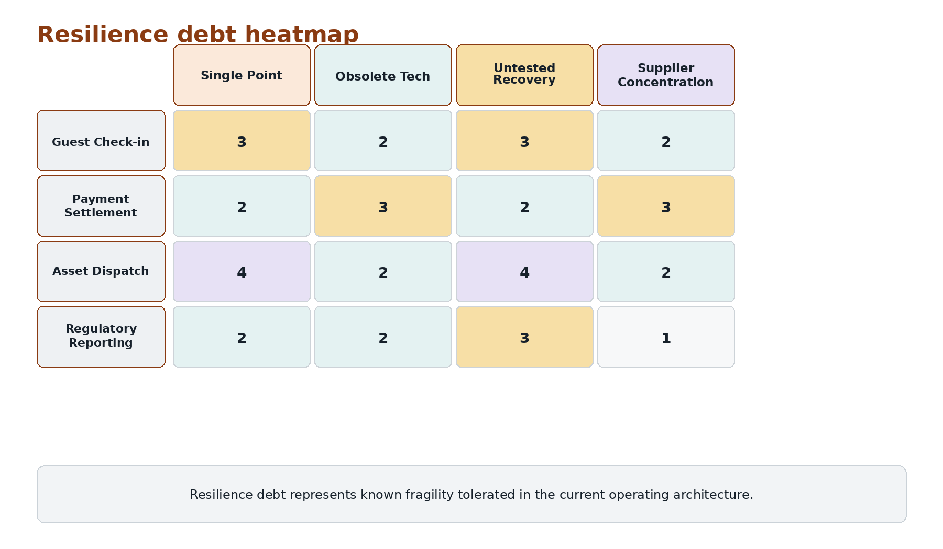
Figure 3. Illustrative resilience debt heatmap.

Field rule 5: connect cyber risk to business consequence
Cyber inventories describe vulnerabilities. Executives need to know which business services, customers, revenues, obligations and safety outcomes are exposed. EAXEE translates a vulnerable technology product or compromised identity path into an enterprise blast radius, enabling risk-based remediation rather than generic patch urgency.

Field rule 6: make regulatory traceability executable
Compliance becomes expensive when obligations, controls, processes, applications and evidence are managed separately. EAXEE can create a Regulatory Evidence Chain: obligation to policy, policy to control, control to process or system implementation, implementation to owner and owner to current evidence. A change to any link exposes the obligations requiring reassessment.
Chain element | Question answered
Obligation | What must the organization demonstrate?
Interpretation | How has the requirement been translated into internal policy?
Control | What prevents, detects or corrects non-compliance?
Implementation | Where is the control embedded in process, data or technology?
Ownership | Who is accountable for operation and evidence?
Evidence | What current artifact proves the control is working?

Field rule 7: test the architecture, not only the plan
A continuity plan can be complete while the underlying architecture has changed. New integrations, suppliers, identity services or data dependencies may invalidate old assumptions. EAXEE supports continuous assurance by comparing tests and plans with the current service footprint. It highlights missing recovery evidence, stale ownership, untested dependencies and newly introduced single points of failure.
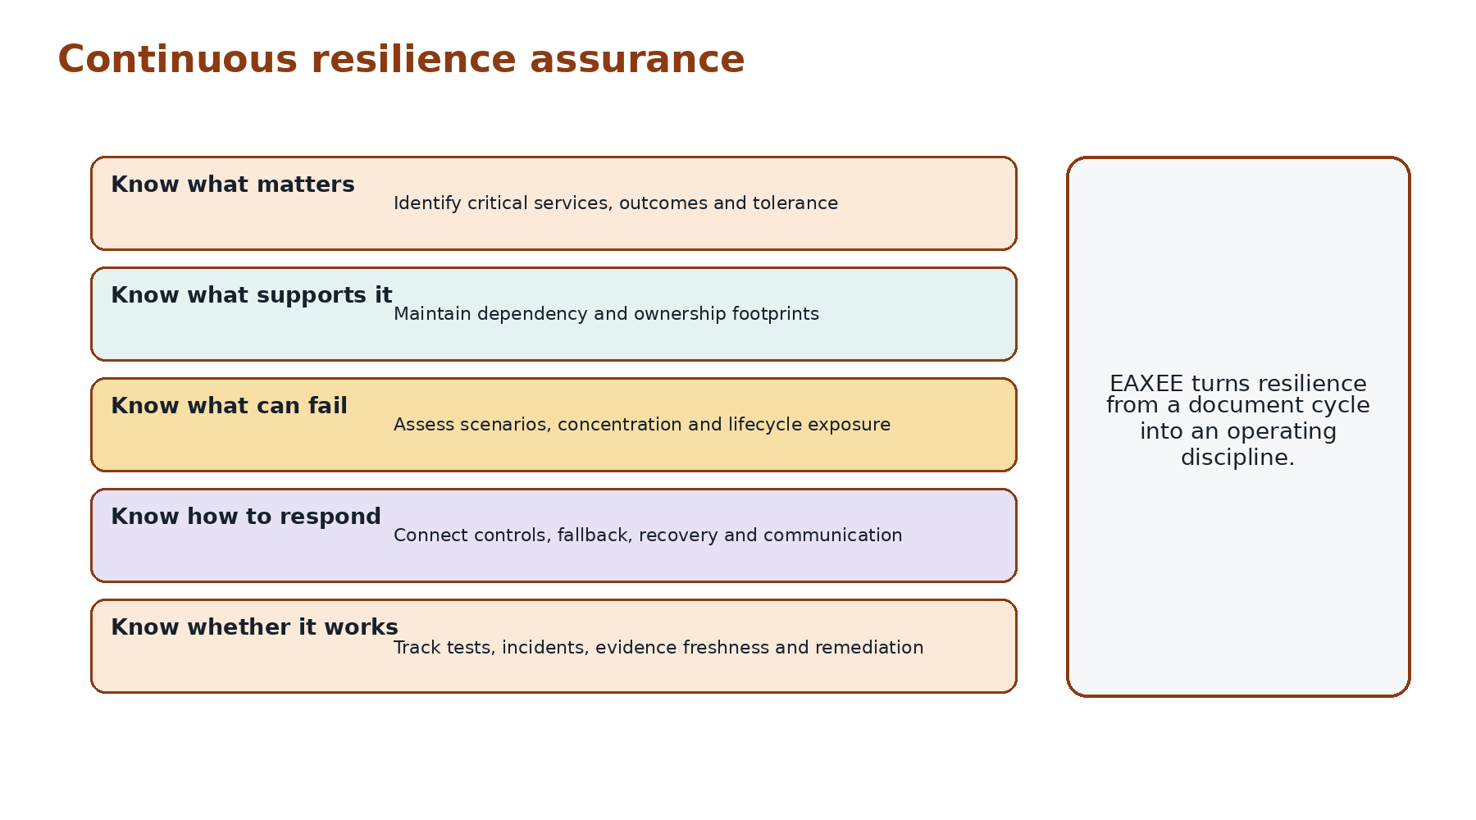
Figure 4. Continuous resilience assurance in EAXEE.

Three operational lessons
- Redundancy without independence can be false resilience. Two services may fail together because they share identity, network, location or supplier dependencies.
- A fallback that has never been capacity-tested is an assumption, not a control.
- Transition states often carry the highest risk because old and new architectures coexist, responsibilities blur and recovery procedures lag behind change.

Example: payment settlement disruption
A payment service outage may initially appear to be a vendor incident. EAXEE can reveal affected booking channels, refund processes, finance reconciliation, loyalty awards, supplier settlements, regulatory reporting and customer communications. It can also show which locations can operate offline, which transactions require later reconciliation and which applications share the same provider. Response priorities become business-led and evidence-based.

What EAXEE adds commercially
- A common resilience model across business, risk, cyber, continuity and technology teams.
- Faster incident assessment through pre-existing dependency and ownership paths.
- More targeted investment by ranking fragility against critical service consequence.
- Lower audit effort through connected, current control evidence.
- Safer transformation by identifying temporary transition-state exposure.

The resilience readiness test
Choose one critical business service. Ask the organization to identify every supporting process, application, data flow, technology product, supplier, control, owner and fallback. Then remove one dependency and trace the consequence. EAXEE is valuable precisely because it turns that exercise from a workshop into a repeatable enterprise capability.
“Resilience is not the absence of failure. It is the architecture of continued purpose when failure arrives.”

Conclusion
EAXEE helps organizations design resilience into the enterprise rather than append it to individual systems. By connecting services to dependencies, tolerances, controls, evidence and change, it makes fragility visible before disruption and response more intelligent when disruption occurs.

