EAXEE AS A
TRANSFORMATION TWIN
A state-of-the-art white paper on making enterprise change observable, explainable, simulatable, governable and learnable
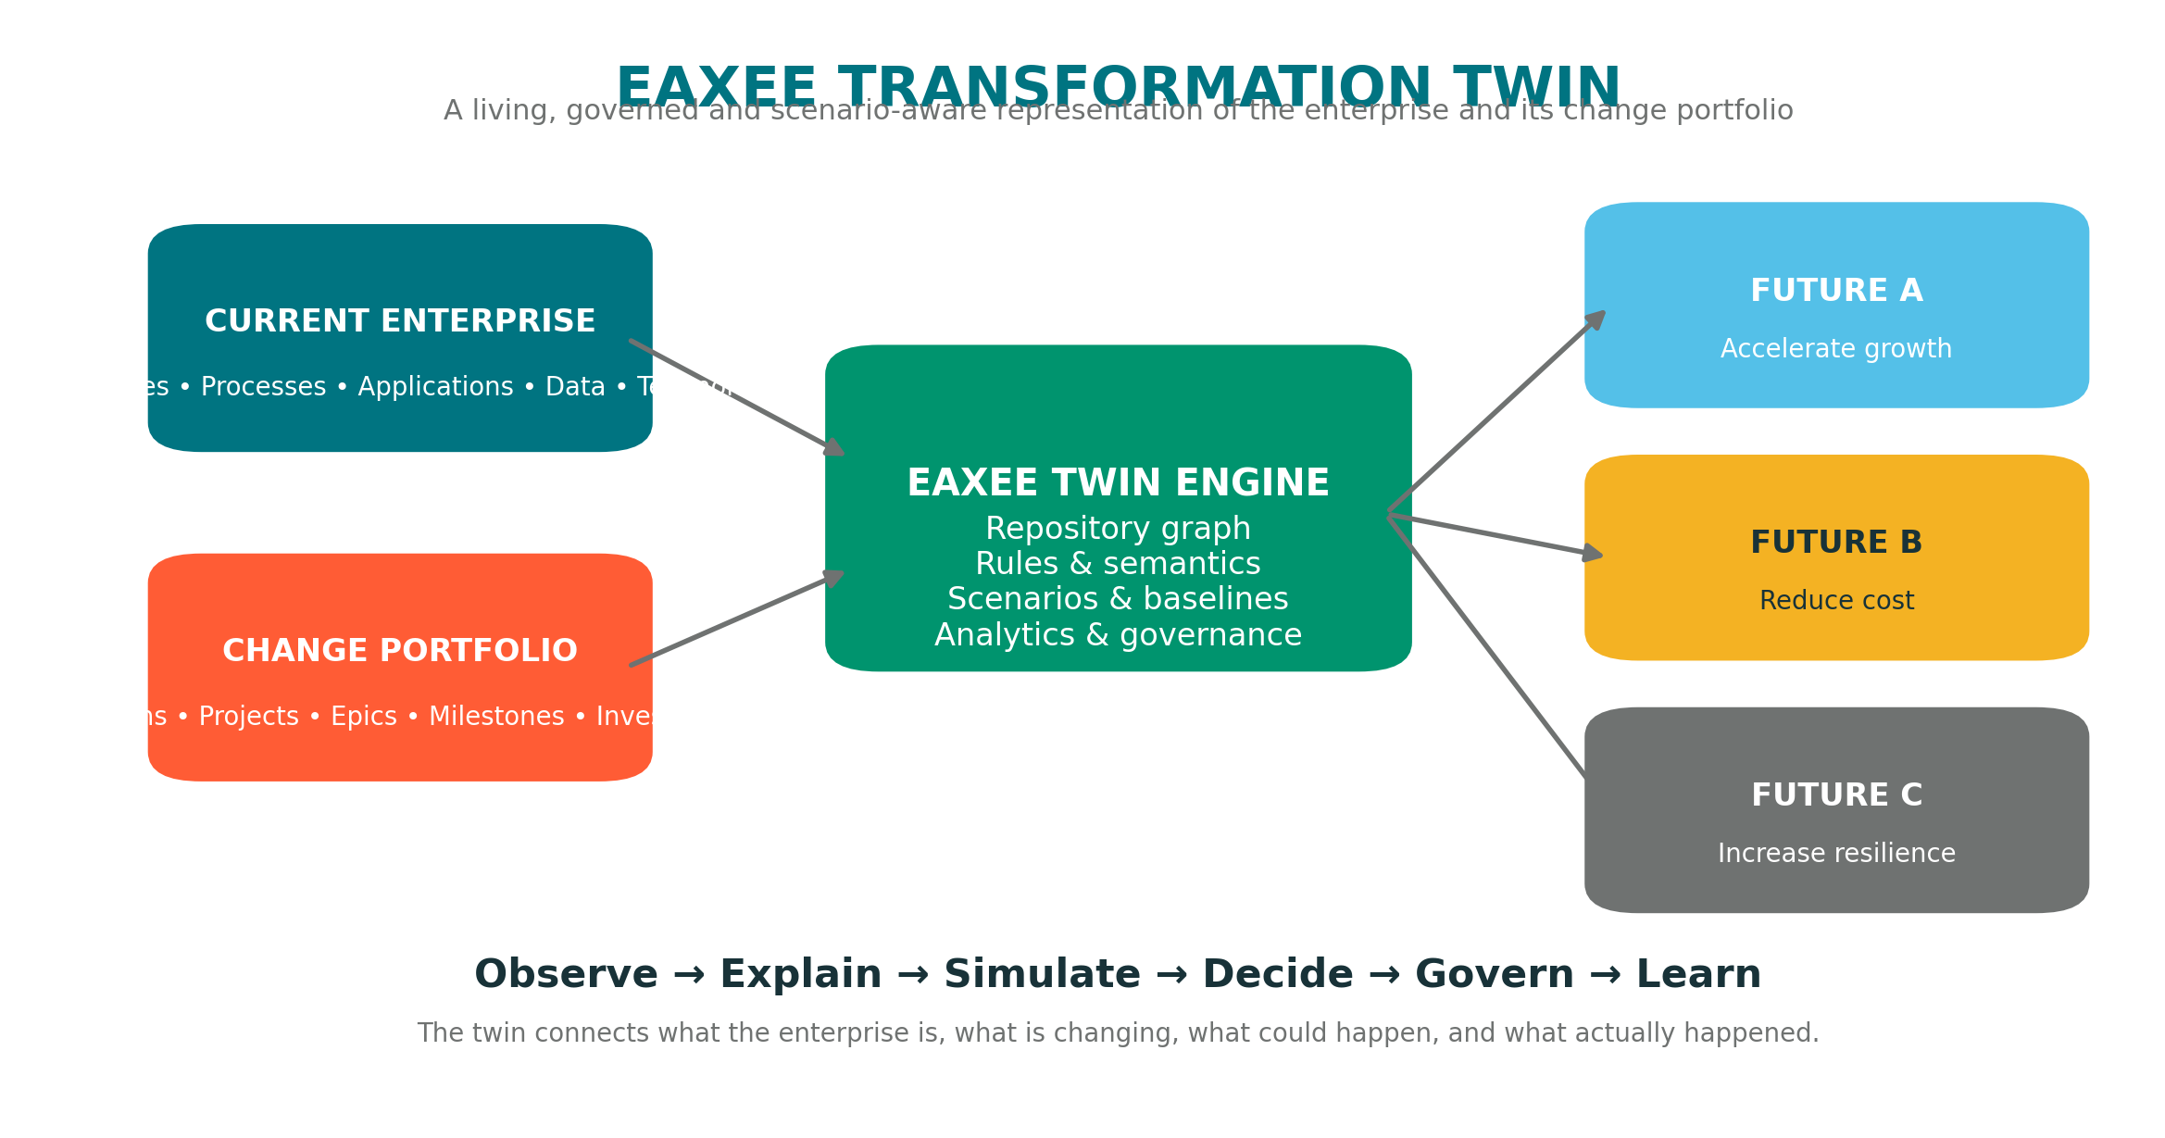
Figure 1. EAXEE Transformation Twin concept
EAXEE Enterprise Architecture Software
July 2026

Executive Summary
Most transformation programs do not fail because organizations lack projects, funding or technology. They fail because decision-makers cannot continuously see how strategy, capabilities, processes, applications, data, technology, people, risks, costs and initiatives interact as one changing system.
A Transformation Twin is the enterprise’s decision-grade digital counterpart: a living model that connects the current state, the change portfolio, alternative futures, execution evidence and realized outcomes.
EAXEE can serve as this Transformation Twin by using its configurable metamodel, relationship-rich repository, architecture views, lifecycle information, analytical dashboards, governance workflows and scenario models to create an authoritative transformation intelligence layer. It does not merely document architecture. It establishes a shared system of meaning through which executives, architects, portfolio leaders, risk teams, finance teams and delivery teams can reason about change.
The value is practical and immediate. EAXEE makes hidden dependencies visible before they become delivery surprises; exposes collisions among programs; connects investment to business outcomes; tests target-state alternatives; highlights stranded assets and resilience debt; turns decisions into governed records; and learns from actual results. In doing so, it transforms Enterprise Architecture from a periodic documentation practice into a continuous capability for steering enterprise change.
Traditional transformation management | EAXEE Transformation Twin
Separate plans, spreadsheets and presentations | A connected semantic model of enterprise structure and change
Static current-state and target-state diagrams | Baselines, time-aware scenarios and transition states
Impact analysis by workshops and expert memory | Repeatable relationship traversal and blast-radius analysis
Project status without architecture context | Initiatives linked to capabilities, applications, data, risks and outcomes
Decisions captured in minutes or email | Traceable decision records with rationale, assumptions and measures
Benefits assessed after delivery | Outcome measures fed back to improve future scenarios

Contents
1. The Transformation Twin Imperative
2. What Makes EAXEE a Transformation Twin
3. The Semantic Enterprise Graph
4. From Current State to Multiple Futures
5. Transformation Intelligence Use Cases
6. State-of-the-Art Concepts and Analytics
7. Practical Examples
8. Operating Model and Governance
9. Implementation Roadmap
10. Lessons for Successful Adoption
11. Measures of Value
12. Conclusion

1. The Transformation Twin Imperative
Digital transformation is not a linear migration from an old state to a new state. It is a continuously changing network of strategic choices, operating-model shifts, technology replacements, data dependencies, policy constraints, vendor commitments, human adoption and emerging risk. A decision in one area can alter cost, resilience, customer experience and delivery timing elsewhere.
Organizations commonly manage this complexity through disconnected artifacts: strategy decks, capability maps, process models, project schedules, application inventories, CMDB records, risk registers, financial plans and solution designs. Each artifact may be useful, yet none alone represents the transformation system. The missing capability is a coherent, queryable and governed twin of enterprise change.
The Transformation Twin closes this gap by maintaining five connected realities:
- The observed enterprise: what exists, who owns it, how it behaves and how healthy it is.
- The intended enterprise: strategic outcomes, target capabilities, principles, standards and target architectures.
- The change system: programs, projects, milestones, dependencies, decisions, funding and delivery constraints.
- Alternative futures: scenarios that show different sequences, technologies, sourcing choices and risk postures.
- The learned enterprise: actual benefits, incidents, costs and adoption results that recalibrate future decisions.
Figure 2. A Transformation Twin connects current enterprise, change portfolio and alternative futures.

2. What Makes EAXEE a Transformation Twin
EAXEE becomes a Transformation Twin when its EA repository is operated as a living transformation system rather than a passive inventory. The distinction is not primarily technical; it is semantic and operational. A repository becomes a twin when it is sufficiently connected, time-aware, scenario-aware, governed and continuously enriched by evidence.
Twin characteristic | How EAXEE enables it | Organizational benefit
Identity | Unique, governed objects for capabilities, processes, applications, data, technology, organizations, projects and risks | Teams refer to the same enterprise things instead of maintaining conflicting lists.
Semantics | Configurable concepts, attributes, legal relationships and relationship direction | The model preserves business meaning rather than storing generic nodes and links.
Time | Lifecycle dates, architecture states, milestones and baselines | Decision-makers can distinguish current, transitional, planned and retired states.
Scenarios | Alternative target and transition architectures | Options can be compared without overwriting the approved baseline.
Evidence | Links to documents, assessments, controls, costs, incidents and decisions | Architecture claims remain explainable and auditable.
Analytics | Dashboards, matrices, traversals, heatmaps and AI-assisted questions | Complex repository data becomes decision-ready insight.
Governance | Ownership, approvals, mandatory attributes, validation and change controls | The twin remains trusted enough to influence investment and delivery.

A critical design principle is that EAXEE should not attempt to duplicate every operational record. Instead, it should hold the architecture-significant identity, relationships, states and decisions, while integrating with systems such as portfolio management, ITSM, CMDB, ERP, GRC and data governance platforms where appropriate.
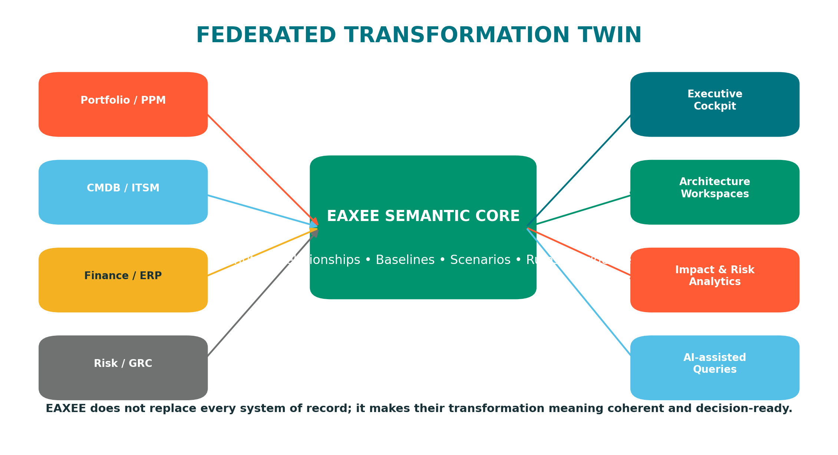
Figure 3. EAXEE acts as the semantic core of a federated transformation information ecosystem.

3. The Semantic Enterprise Graph
The foundation of the Transformation Twin is a semantic enterprise graph. In EAXEE, the graph is constructed from well-defined concepts and governed relationships. This enables the software to answer not only “what exists?” but also “what enables what?”, “what depends on what?”, “what is changing?”, “who is accountable?”, “where does risk propagate?” and “which outcomes are affected?”
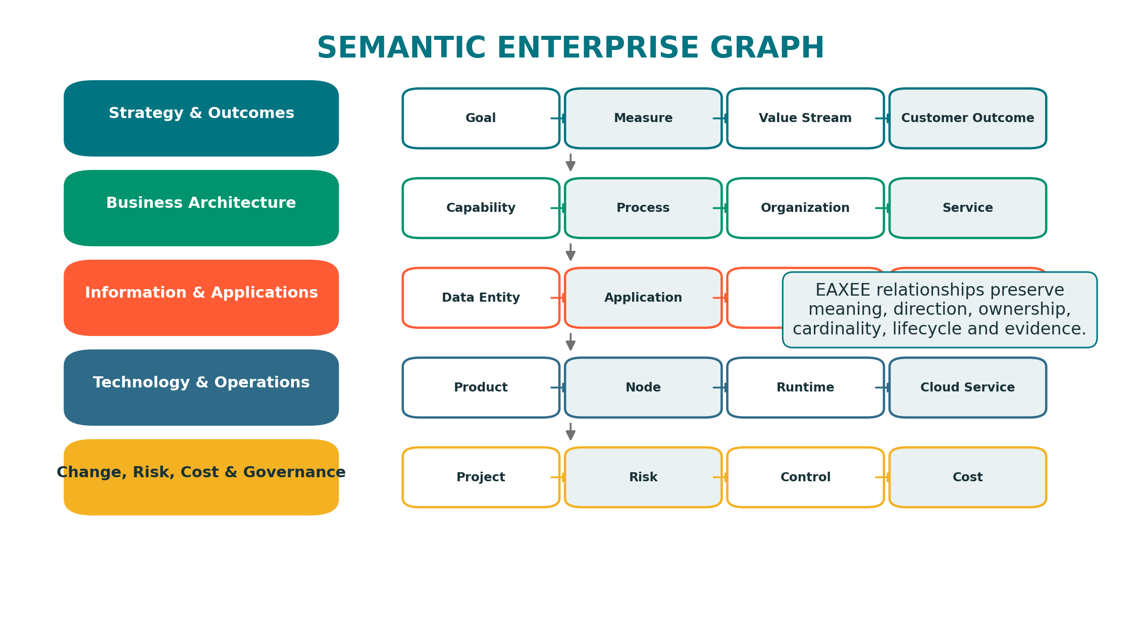
Figure 4. Example semantic layers and interconnected EAXEE concepts.
The graph should support traversals across domains. For example, a customer outcome can be traced to the value stream that creates it, the capabilities required, the processes and organizations that perform the work, the applications and integrations that automate it, the data that informs it, the technology that hosts it, the risks and controls that protect it, and the initiatives that will change it.
This cross-domain traceability is more valuable than isolated “business”, “application”, “data” and “technology” diagrams. The Transformation Twin treats those domains as different perspectives of one enterprise system.

4. From Current State to Multiple Futures
Transformation decisions rarely have one obvious target state. Leaders choose among competing futures: consolidate platforms or preserve diversity; migrate rapidly or modernize selectively; centralize services or federate them; build internally or buy; optimize for speed, cost, sovereignty, resilience or experience. EAXEE can preserve these alternatives as scenario branches connected to the same baseline.
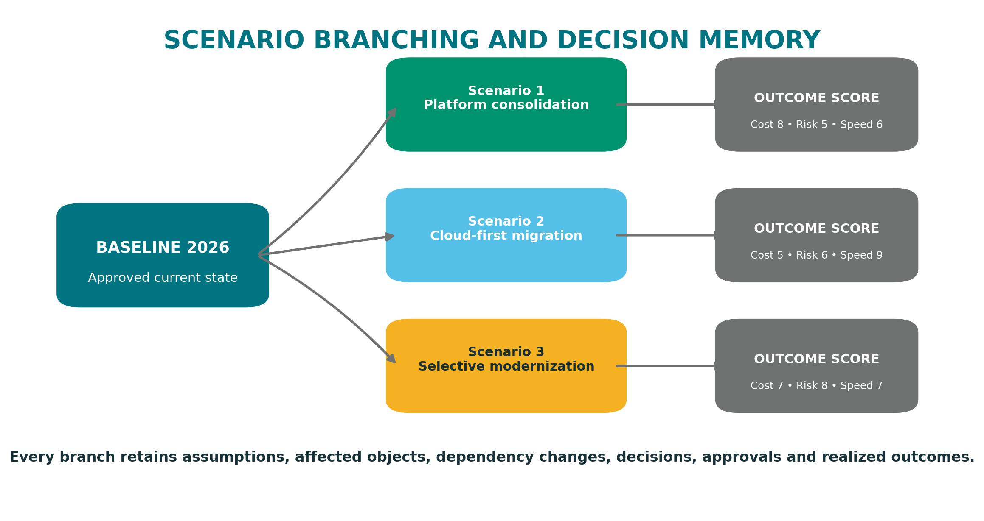
Figure 5. Scenario branches preserve alternative futures and their decision evidence.
Each scenario should contain more than a target diagram. It should record assumptions, affected architecture objects, required transitions, decommissioning implications, estimated costs, benefit hypotheses, risk exposure, capability gaps, dependencies, decision owners and measurable outcomes. This turns scenario planning into a repeatable management practice rather than a presentation exercise.
A powerful use of the twin is sequence simulation. Two scenarios may reach a similar final architecture but have radically different transition risk. EAXEE can make intermediate states explicit, exposing temporary duplicate platforms, data synchronization needs, unsupported integrations, skill bottlenecks and control gaps that would otherwise remain hidden.

5. Transformation Intelligence Use Cases

Digital transformation
Connect strategic outcomes to capability changes, operating-model shifts, technology enablers and delivery initiatives. EAXEE reveals whether the change portfolio collectively implements the intended strategy or merely funds disconnected projects.

Impact analysis
Traverse from a proposed change through applications, interfaces, data, processes, organizations, controls, vendors and business outcomes. The result is an explainable blast radius, including direct and indirect dependencies.

Transformation planning
Model transition architectures, sequence initiatives, identify prerequisites, test resource contention and expose periods of elevated operational risk.

Application rationalization
Combine functional overlap, technical health, lifecycle, cost, risk, strategic fit, user reach and dependency criticality. EAXEE avoids simplistic “keep/replace/retire” recommendations that ignore business and integration consequences.

Operational resilience
Trace critical services to processes, applications, infrastructure, suppliers, locations, recovery capabilities and controls. Weakness is evaluated end-to-end, not asset-by-asset.

Cost and value analysis
Attribute run cost, change cost, vendor cost and technical debt to the capabilities and outcomes they support. Leaders see where spending protects value, creates differentiation or sustains unnecessary complexity.

Risk management
Model risk as a propagating condition. A vulnerable product may affect runtime instances, applications, processes, customer services and regulatory obligations. Controls can be tested against the complete exposure path.

Decision-making
Create an evidence-led decision cockpit where alternatives are evaluated against value, feasibility, risk, standards, cost, time and reversibility, with rationale and accountability preserved.
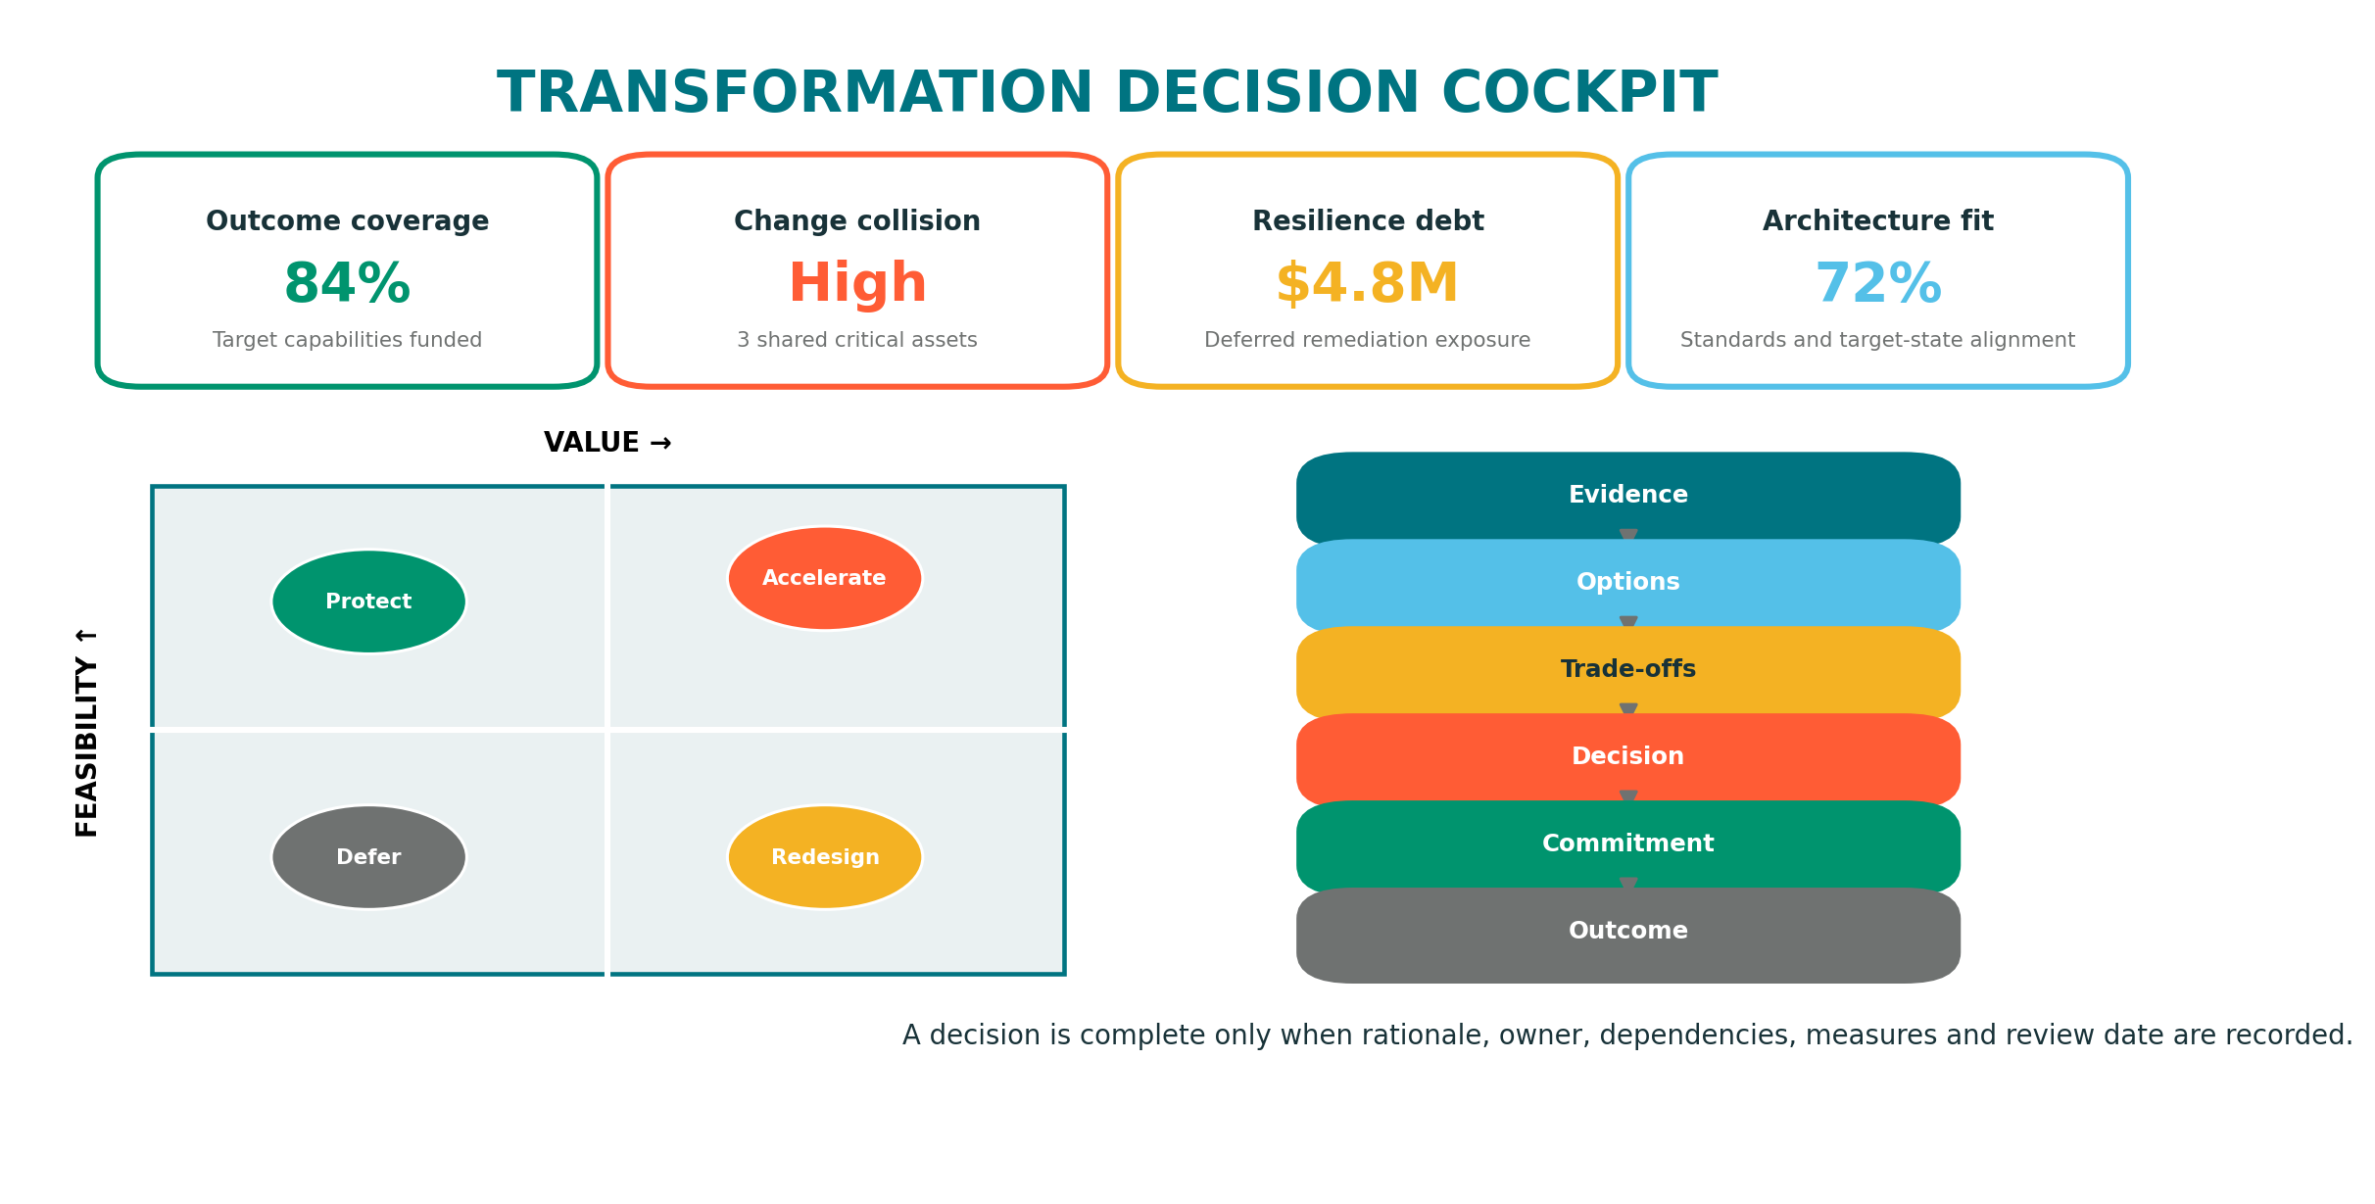
Figure 6. Transformation Decision Cockpit combining evidence, trade-offs and commitment.

6. State-of-the-Art Concepts and Analytics

Change Collision Index
Measures the degree to which multiple initiatives modify the same capability, process, application, interface, data entity, vendor service or constrained team within overlapping time windows. A high score signals integration, scheduling, capacity and accountability risk.

Architecture Option Portfolio
Treats architecture scenarios as a managed portfolio of options rather than a single forecast. Options can be accelerated, deferred, combined or abandoned as evidence changes, preserving strategic flexibility.

Transformation Coherence Score
Evaluates whether strategic outcomes, capability priorities, funded initiatives, target architectures and success measures remain aligned. Low coherence indicates activity without a credible transformation chain.

Resilience Debt
Represents deferred remediation whose consequences accumulate across critical services. It combines technical weakness, business criticality, recovery gaps, dependency concentration and time to remediation.

Functional Shadow Price
Estimates the hidden economic cost of retaining duplicate applications by including not only license and support cost but also duplicated integrations, data reconciliation, controls, skills, testing and change friction.

Decision Half-Life
Defines the period after which a decision should be reassessed because its assumptions, dependencies, costs or external conditions may no longer hold. EAXEE can flag decisions approaching review expiry.

Transition-State Risk Window
Identifies periods during which temporary architectures create elevated exposure—for example dual master data, parallel identity systems, unsupported interfaces or incomplete segregation of duties.

Architecture Entropy
Tracks growth in uncontrolled variants, exceptions, duplicate technologies, undocumented interfaces and ownership ambiguity. Rising entropy warns that the enterprise is becoming harder and more expensive to change.

Value Leakage Path
Traces where intended benefits are lost between strategic intent and operational realization: unfunded capability gaps, delayed dependencies, low adoption, process workarounds, poor data quality or missing controls.

Twin Confidence Score
Expresses how trustworthy an analysis is based on data completeness, freshness, ownership, evidence quality and relationship coverage. It prevents false precision and directs stewardship effort.
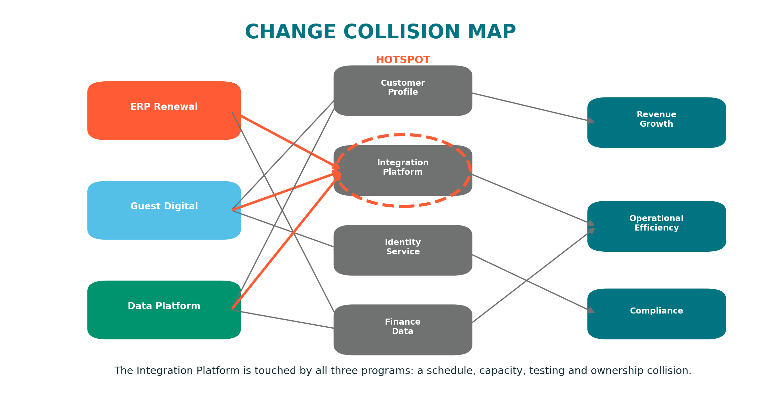
Figure 7. Change collision analysis exposes shared transformation hotspots.

7. Practical Examples

Example A: Guest Arrival Transformation
An organization plans to redesign guest arrival through mobile identity, pre-arrival preferences, automated access, personalized transport and real-time service orchestration. A conventional project view shows several workstreams. The EAXEE Transformation Twin shows the enterprise consequences: identity and consent capabilities, guest-profile data, CRM and property systems, integration services, mobile applications, physical access technology, cyber controls, operating procedures, external partners and service-level objectives.
EAXEE reveals that three programs depend on the same identity service and integration platform. It also shows that a proposed platform retirement would remove an interface still required by two properties. The organization resequences the retirement, creates a shared integration test window and funds a resilience upgrade. The value is not a better picture; it is avoidance of a transformation failure caused by hidden dependencies.

Example B: ERP and Finance Modernization
A finance transformation proposes a new ERP, shared services and standardized master data. EAXEE traces financial capabilities to regional processes, legal entities, reporting obligations, applications, data owners, interfaces and projects. Scenario analysis compares a single-wave migration with a phased approach. The single wave is faster but creates a concentrated cutover and control risk. The phased option creates temporary reconciliation cost and duplicate controls. Decision-makers can see and accept the trade-off rather than discovering it during delivery.

Example C: Application Rationalization Beyond Cost
Two applications appear functionally redundant. A cost-only assessment recommends retiring the more expensive one. EAXEE shows that the expensive application supports a small but highly regulated process, provides unique audit evidence and is integrated with a critical external party. The cheaper application has broader user adoption but cannot satisfy the regulatory control without customization. The resulting decision is to retain the regulated component temporarily, isolate the unique capability and plan a controlled convergence. The twin prevents a superficially attractive saving from creating compliance exposure.

Example D: Cyber Vulnerability Propagation
A technology product reaches end of support. EAXEE identifies every infrastructure component and runtime instance using the product, the applications hosted, the business services enabled, the data classifications involved and the transformation initiatives already scheduled to replace affected components. Risk treatment can then prioritize assets by business impact and coordinate remediation with planned change instead of launching an indiscriminate upgrade campaign.

8. Operating Model and Governance
A Transformation Twin succeeds when accountability for meaning is distributed but governance is coherent. Enterprise Architecture should own the metamodel, cross-domain semantics, quality rules and transformation analytics. Domain owners should steward their objects. Program and project teams should maintain change intent, milestones, dependencies and realized outcomes. Risk, finance, security and operations should contribute authoritative attributes and evidence.
Role | Primary accountability in EAXEE
Executive sponsor | Mandates use of the twin for material transformation decisions and resolves cross-functional ownership.
Enterprise Architecture Office | Owns metamodel, repository governance, scenario standards, analytics and architecture decision records.
Business capability owner | Validates capability health, priorities, outcomes and business impacts.
Application / technology owner | Maintains lifecycle, cost, technical health, dependencies and remediation plans.
Program / project owner | Links initiatives to affected architecture, assumptions, milestones, dependencies and benefits.
Risk / security / compliance | Maintains risk, control and obligation relationships and validates propagation analysis.
Finance / portfolio management | Provides investment, run cost, forecast and benefit information.
Data steward | Maintains data definitions, ownership, classification, flows and quality evidence.

Recommended governance gates include: investment concept approval, architecture option review, solution design approval, release readiness, decommission approval, benefit realization review and post-implementation learning. Each gate should query the twin rather than ask teams to recreate evidence in separate documents.
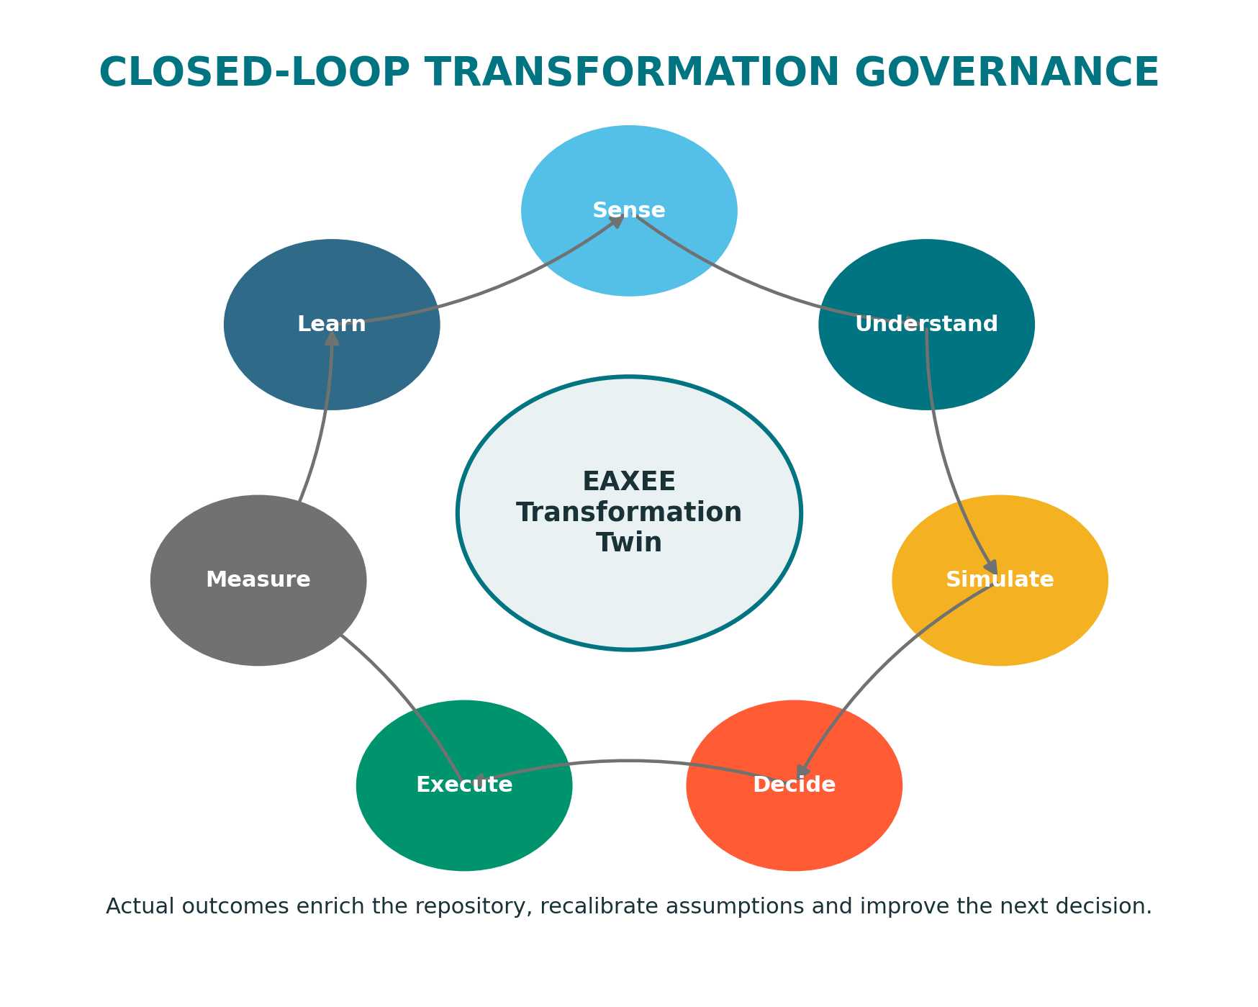
Figure 8. Closed-loop transformation governance converts execution outcomes into institutional learning.

9. Implementation Roadmap
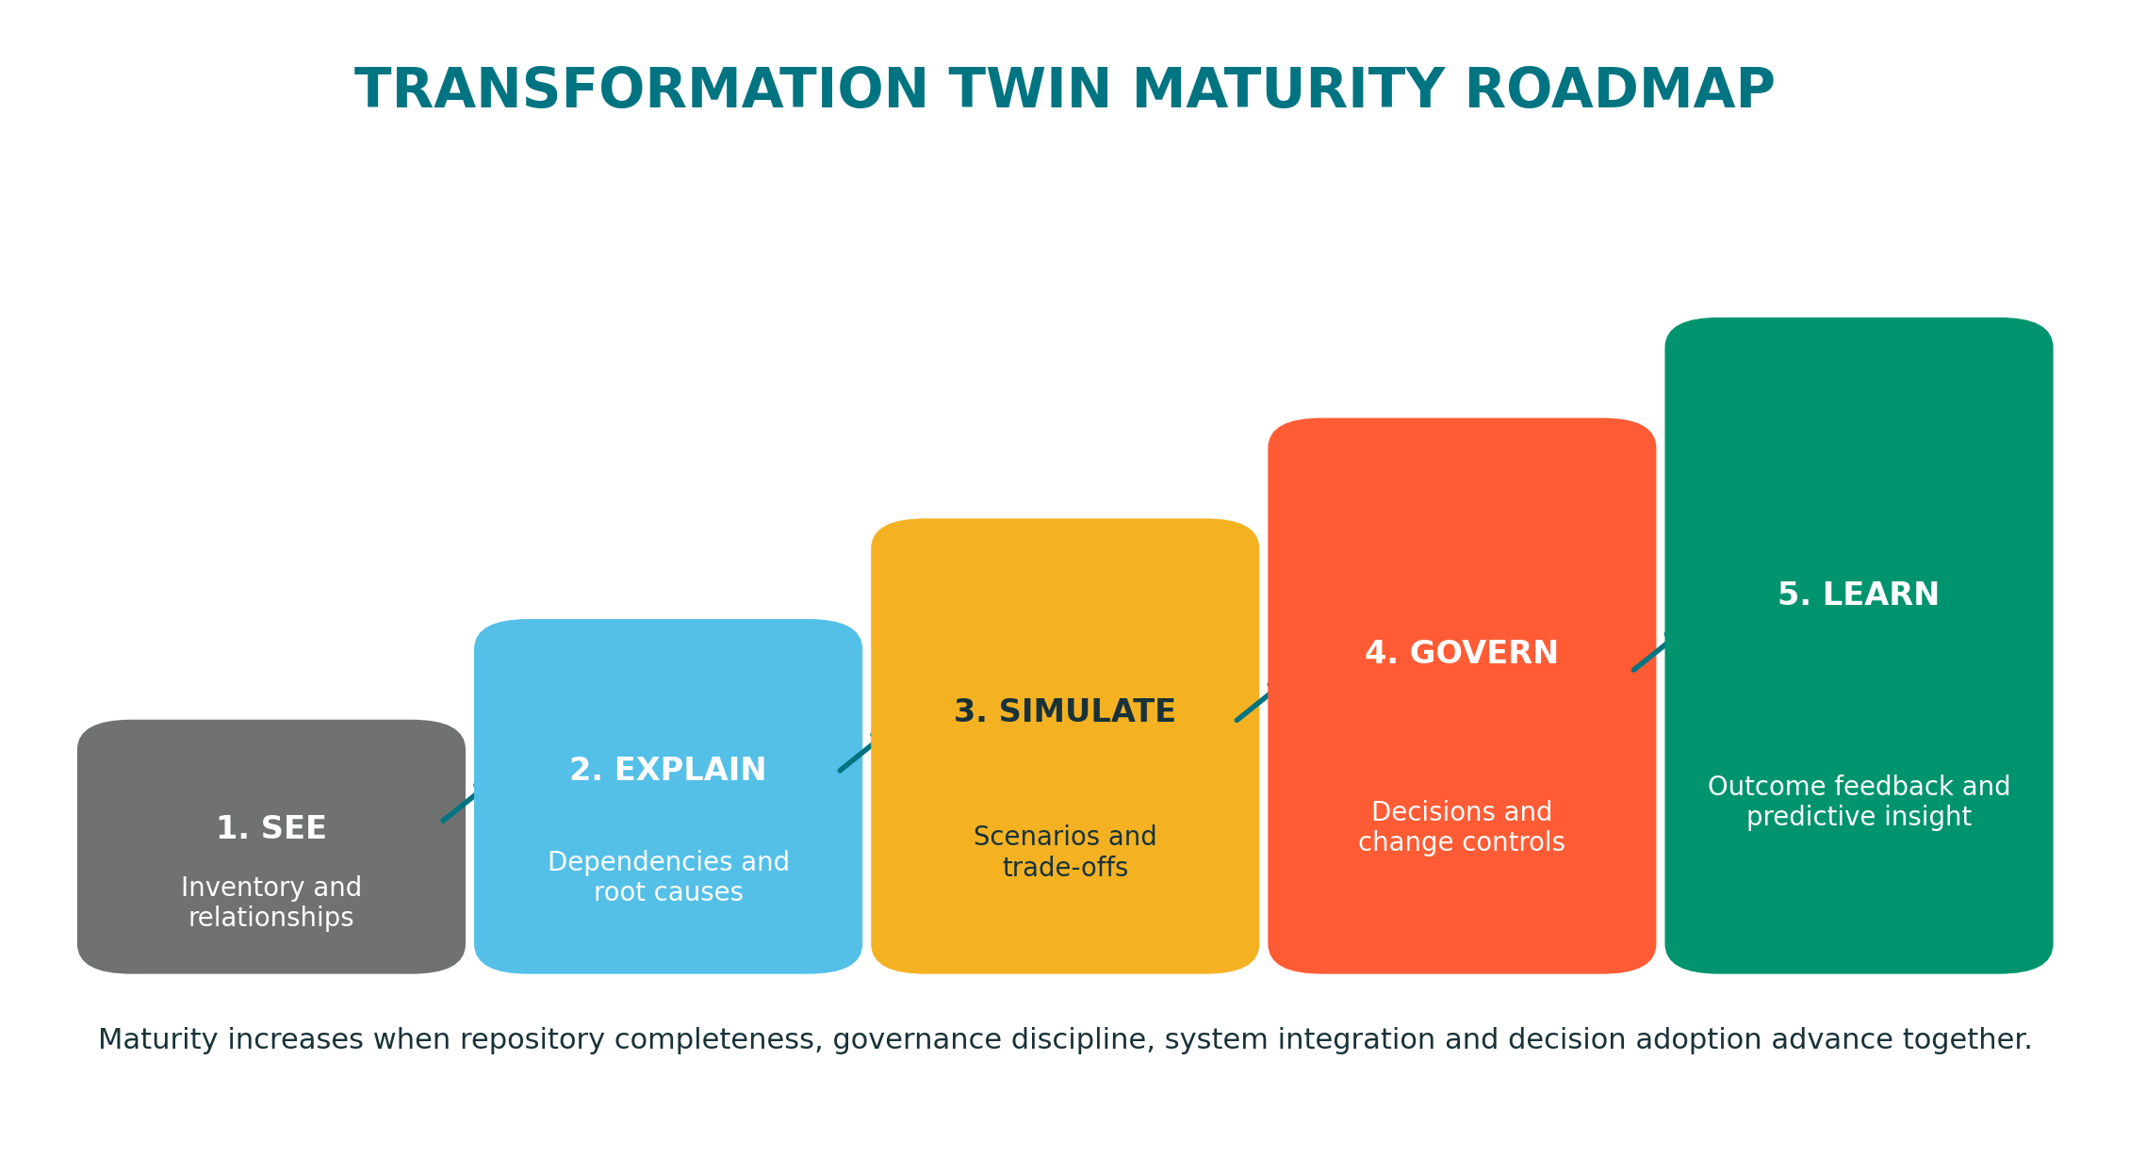
Figure 9. Transformation Twin maturity roadmap.
Phase | Focus | Representative deliverables
Phase 1 — See | Establish trusted scope and identity | Priority concepts, ownership, critical services, application and technology inventory, initial relationship coverage.
Phase 2 — Explain | Enable dependency and impact analysis | End-to-end footprints, impact traversals, lifecycle dashboards, risk propagation, critical-path dependencies.
Phase 3 — Simulate | Introduce scenarios and transition states | Baselines, alternative futures, transition architectures, assumptions, option scorecards and sequencing models.
Phase 4 — Govern | Embed the twin into decisions and delivery | Architecture decision records, portfolio gates, project-to-architecture traceability, collision monitoring and compliance evidence.
Phase 5 — Learn | Close the outcome feedback loop | Benefit realization, actual cost and incident feedback, decision reviews, predictive indicators and AI-assisted analysis.

Implementation should begin with a decision domain where value can be demonstrated quickly—for example application rationalization, a major transformation program, resilience of critical services or portfolio collision management. Attempting to model the entire enterprise before delivering insight creates delay and reduces sponsorship.

10. Lessons for Successful Adoption

Model for decisions, not completeness
Every object and relationship should support a question, control or decision. A smaller governed graph is more valuable than a large untrusted inventory.

Separate facts, assumptions and decisions
Current-state evidence, scenario assumptions and approved decisions must be distinguishable. Mixing them destroys trust and makes historical reasoning impossible.

Treat transition states as first-class architecture
Many failures occur between current and target states. Model coexistence, temporary interfaces, migration waves, rollback paths and control gaps explicitly.

Make confidence visible
Analytics should show data freshness and completeness. Decision-makers must know whether a result is authoritative, directional or speculative.

Integrate selectively
Federate with operational systems where data already has an owner. Do not turn EAXEE into another ERP, CMDB or project scheduling tool.

Govern relationships as carefully as objects
The value of the twin comes from connections. Missing, ambiguous or directionally incorrect relationships produce misleading impact analysis.

Capture why, not only what
Decision rationale, rejected alternatives, assumptions and review triggers are essential organizational memory.

Measure realized outcomes
A twin that never learns from actual delivery remains a sophisticated planning repository. Close the loop with benefits, incidents, cost and adoption evidence.

Design for multiple audiences
Executives need outcome and risk views; architects need dependency detail; delivery teams need actionable scope; stewards need quality worklists.

Build trust through visible wins
Use the twin to prevent a real collision, identify a hidden dependency, justify a retirement or improve a major decision. Adoption follows demonstrated value.

11. Measures of Value
Dimension | Illustrative measure
Decision speed | Reduction in elapsed time to complete impact analysis or architecture option assessment.
Decision quality | Percentage of material decisions supported by traceable evidence, alternatives and measurable outcomes.
Delivery predictability | Reduction in late-discovered dependencies, scope changes and integration conflicts.
Portfolio coherence | Percentage of strategic outcomes with funded capability changes and accountable initiatives.
Rationalization value | Run-cost reduction and complexity removed without degradation of critical business capabilities.
Resilience | Reduction in unmitigated critical dependency concentration and resilience debt.
Risk | Earlier identification of propagated risk and improved coverage of controls across end-to-end services.
Repository trust | Ownership, freshness, completeness and evidence scores for decision-critical architecture.
Learning | Percentage of completed initiatives with actual outcome evidence and documented lessons returned to the twin.

Benefits should be measured in both direct and avoided value. Direct value includes reduced licenses, infrastructure, support effort and consulting analysis. Avoided value includes prevented outages, avoided rework, earlier risk treatment, reduced project delay and better sequencing of investments.

12. Conclusion
The strategic promise of EAXEE is not simply to describe the enterprise. It is to help the enterprise change itself with greater confidence.
Positioned as a Transformation Twin, EAXEE provides a shared and governed representation of enterprise structure, transformation intent, alternative futures, execution dependencies and realized outcomes. It allows leaders to see the whole system behind a decision, architects to test consequences, delivery teams to understand context, risk teams to trace exposure, finance teams to connect cost with value, and the organization to retain the memory of why change occurred.
The result is a transformation capability that is more coherent, resilient, economical and learnable. Projects become part of an intentional enterprise journey rather than isolated delivery events. Target architectures become testable hypotheses rather than static pictures. Decisions become evidence-led commitments. Outcomes become feedback. EAXEE becomes the living intelligence layer through which the organization continuously observes, simulates, governs and improves its transformation.

Appendix A — High-Value Questions the EAXEE Twin Should Answer
- Which strategic outcomes are unsupported by funded capability changes?
- Which applications, interfaces or data entities are being changed by multiple initiatives in the same period?
- What is the full business and technology blast radius of retiring this platform?
- Which target-state assumptions have expired or lack evidence?
- Where will temporary transition states create duplicate controls, data synchronization or operational exposure?
- Which critical services depend on a single vendor, product, location, integration platform or specialist team?
- What costs are attributable to duplicated functionality rather than differentiated business value?
- Which architecture exceptions are increasing entropy and future change cost?
- Which planned investments conflict with lifecycle, risk or resilience priorities?
- What decisions should be reviewed because their assumptions have changed?
- Which completed initiatives delivered less value than expected, and what architectural conditions explain the gap?
- What is the most reversible sequence for reaching the target architecture?

Appendix B — Minimum Decision Record
Field | Purpose
Decision statement | Defines the approved choice unambiguously.
Decision owner | Establishes accountability.
Context and trigger | Explains why the decision is required now.
Options considered | Preserves credible alternatives.
Evaluation criteria | Makes value, risk, cost, time and standards explicit.
Assumptions | Identifies conditions on which the decision depends.
Affected architecture | Links the decision to capabilities, applications, data, technology, risks and initiatives.
Dependencies and constraints | Exposes prerequisites and limiting factors.
Expected outcomes and measures | Defines what success means.
Review date / trigger | Prevents decisions from remaining valid after their context expires.
Evidence and approvals | Creates auditability and organizational memory.

