BEFORE AI, ARCHITECTURE
How EAXEE Turns Enterprise Complexity into an AI-Ready Operating System
A provocative field guide for executives, transformation leaders, enterprise architects and technology buyers
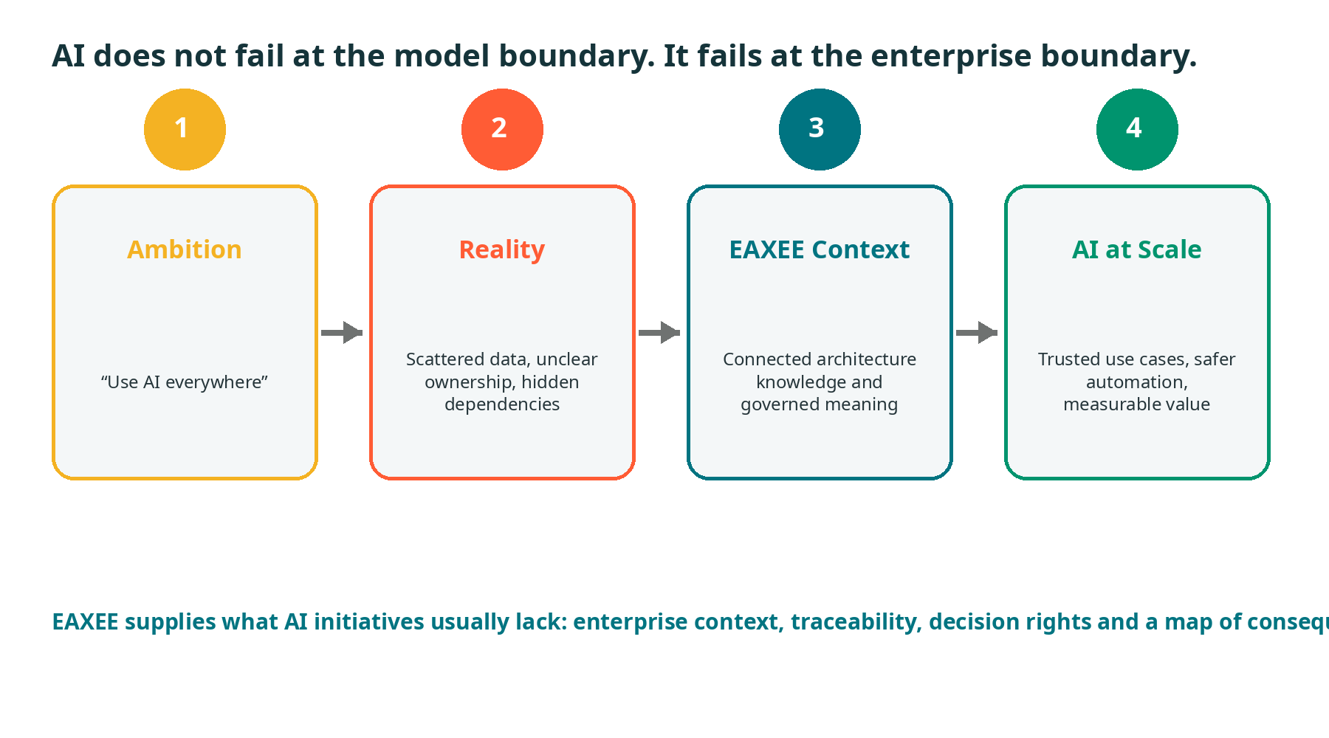
The enterprise boundary is where AI ambition meets organizational reality.
EAXEE Enterprise Architecture Software
White Paper | 2026

A NOTE TO THE READER
This is not another paper about choosing a large language model.
Models will improve. Prices will fall. Interfaces will become easier. None of that solves the harder problem: an organization cannot ask AI to reason reliably about a business it has never described coherently.
The real AI race is therefore not only a race for algorithms. It is a race to create usable enterprise context: what the organization is trying to achieve, how work is performed, which applications and data enable it, where dependencies hide, who owns what, what may change, and what must never be compromised.
EAXEE provides that context. It turns architecture from a collection of diagrams into an operational knowledge graph for AI-enabled decisions, assistants and agents.
The thesis of this paper
The organizations that scale AI successfully will not be those with the most pilots. They will be those that can connect each AI use case to business value, trusted evidence, architecture dependencies, risk controls, accountable owners and measurable outcomes. EAXEE is the connective tissue for doing exactly that.
The voice is intentionally direct. AI enablement is too important to be buried under vague maturity language and decorative roadmaps.

1. THE UNCOMFORTABLE TRUTH: AI IS STARVING FOR CONTEXT
Most enterprises do not have an AI shortage. They have a context shortage.
A chatbot can summarize a document. An agent can call an API. A model can classify a service ticket. But enterprise-grade AI must answer harder questions: Which business capabilities are affected? Which data is authoritative? Which systems are nearing end of life? Which regulations apply? Which owner can approve an action? What happens downstream if the recommendation is wrong?
These are architecture questions disguised as AI questions.
- Without shared semantics, different systems use the same word to mean different things.
- Without relationship models, AI sees records but not consequences.
- Without ownership, AI produces recommendations that nobody can authorize.
- Without lifecycle and criticality data, AI treats a prototype and a mission-critical service as equivalent.
- Without guardrails, automation becomes faster than governance.
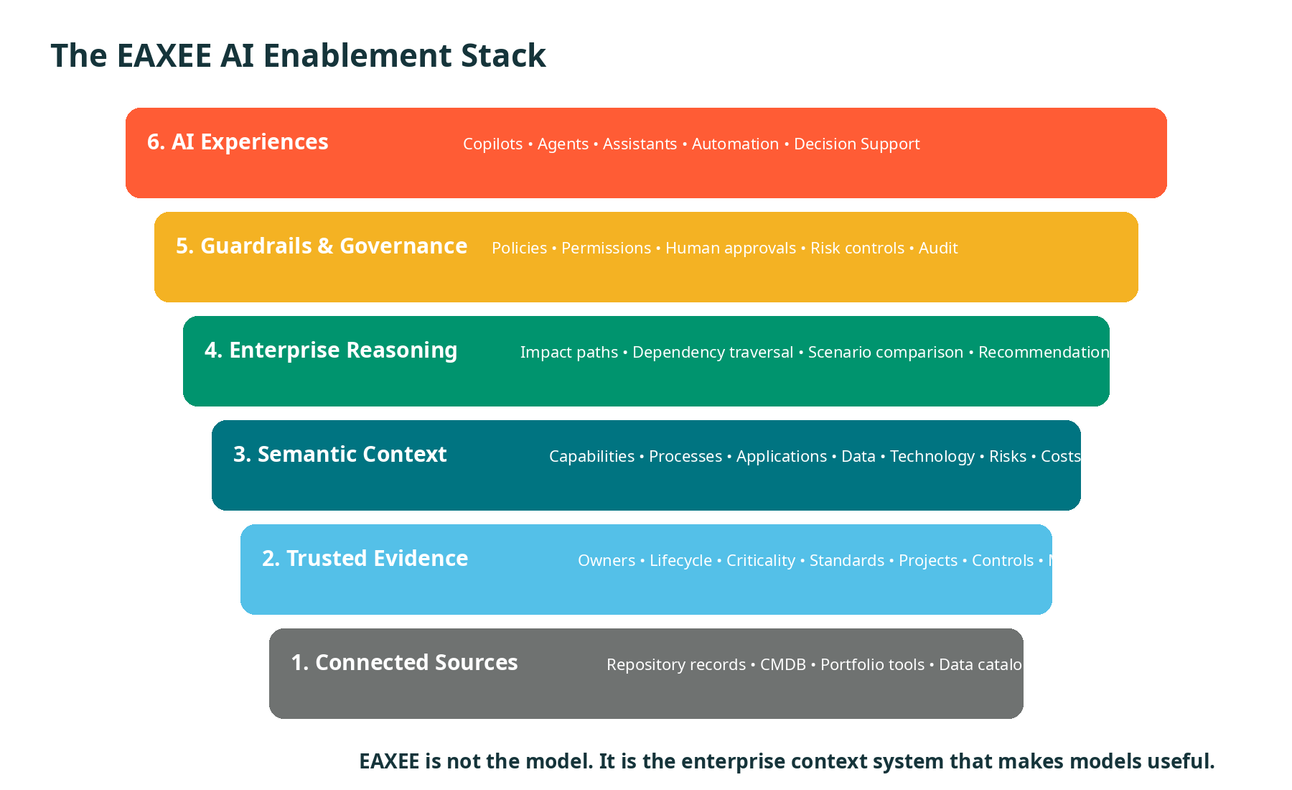
Figure 1. EAXEE sits beneath AI experiences as the governed context, reasoning and evidence layer.

2. EAXEE IS NOT “AI IN AN EA TOOL”
That description is too small.
The bigger opportunity is to use EAXEE as the enterprise context system that makes many AI solutions more accurate, explainable and useful. EAXEE can support an embedded assistant inside the platform, but its strategic role extends further: it becomes a reusable knowledge foundation for transformation copilots, service-management assistants, portfolio agents, risk advisers, data-governance tools and executive decision support.
A useful distinction
Approach | What it does | Why it matters
AI added to a tool | Adds search, summarization or chat features. | Improves convenience.
EAXEE as AI enabler | Supplies governed enterprise meaning, relationships, permissions and change context. | Improves the quality and safety of AI decisions across the organization.
EAXEE as agent control plane | Defines what an agent may inspect, recommend, change, escalate and record. | Makes autonomous action governable and auditable.
The procurement implication is clear: evaluate EAXEE not only as an architecture repository, but as strategic infrastructure for enterprise AI.

3. THE SIX JOBS EAXEE PERFORMS FOR AI
Job 1 — It gives AI a vocabulary
EAXEE defines concepts such as capability, process, application, service, data entity, technology product, project, risk and control. The model teaches AI what each object means and how it may relate to others.
Job 2 — It gives AI a map
Relationships reveal how strategy becomes execution and how a change propagates. AI can traverse rather than merely retrieve.
Job 3 — It gives AI boundaries
Repositories, roles, permissions, classifications and policies limit what users and agents may see or do.
Job 4 — It gives AI memory with accountability
Decisions, exceptions, owners, lifecycle states and rationale create institutional memory that can be inspected and challenged.
Job 5 — It gives AI a way to admit uncertainty
Missing relationships, stale attributes and unconfirmed ownership can be exposed as confidence warnings rather than hidden behind fluent language.
Job 6 — It gives AI a route to action
Recommendations can be linked to projects, work packages, owners, approvals, target states and measurable benefits.
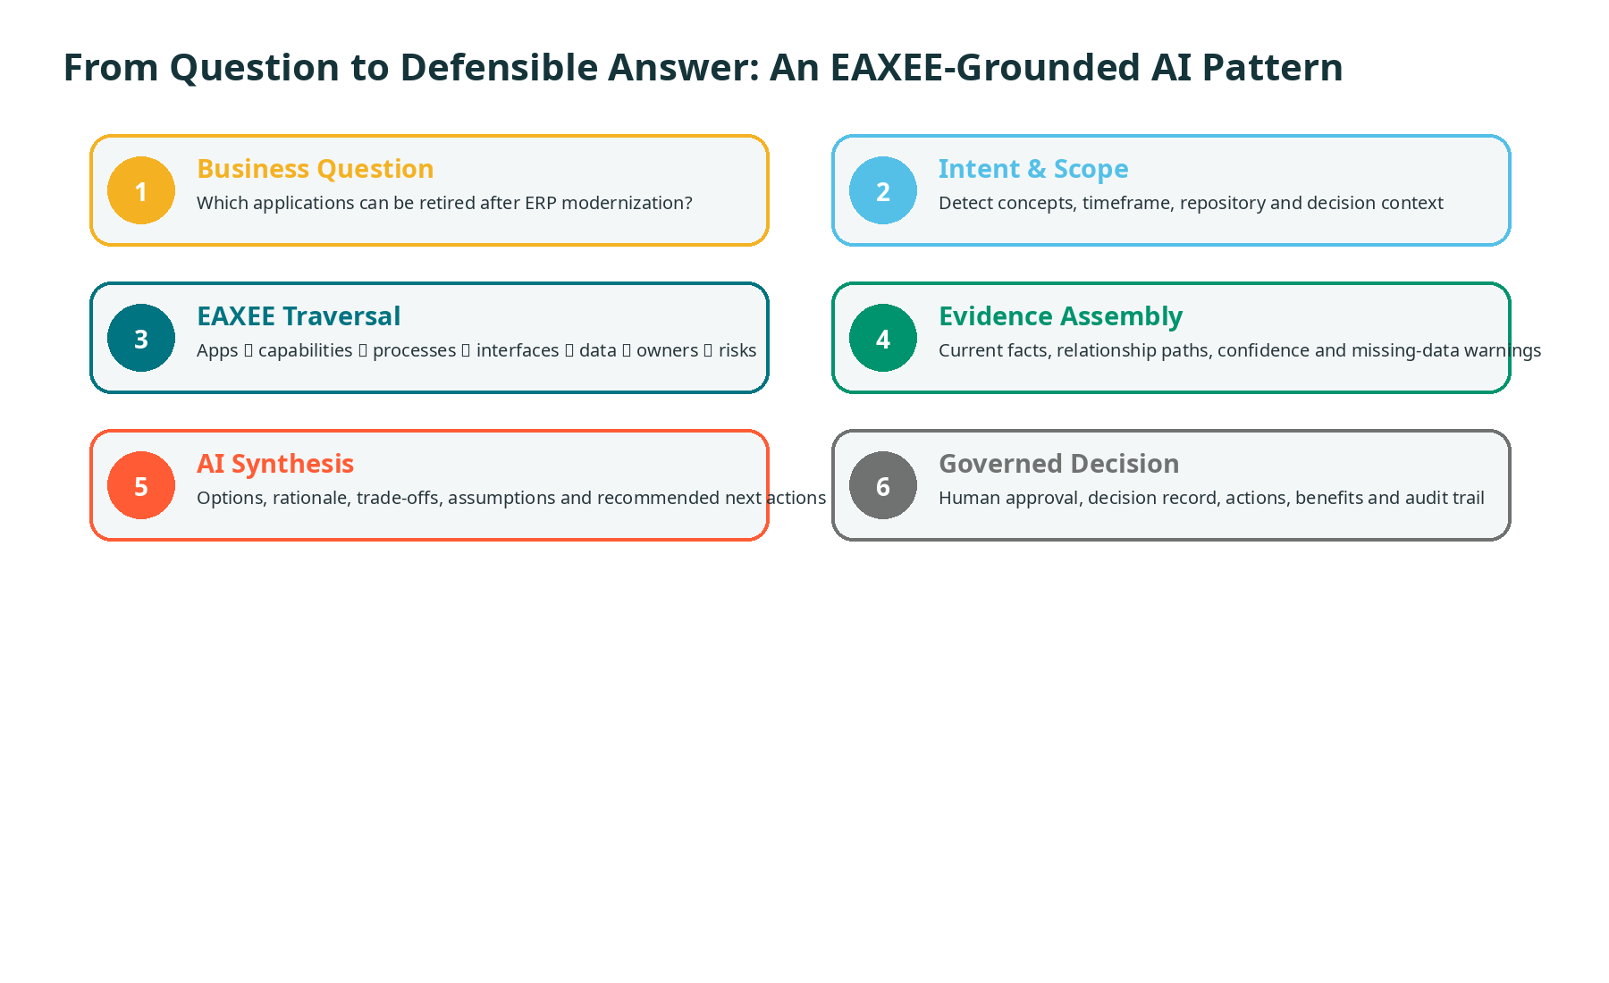
Figure 2. A grounded AI response is assembled from traceable EAXEE evidence before synthesis and decision.

4. THE AI READINESS GRAPH
Forget the generic readiness checklist. Readiness is a graph.
An AI use case is ready only when the organization can connect the desired outcome to the work, applications, data, technology, controls and accountable people required to deliver it. EAXEE makes that connected readiness visible.
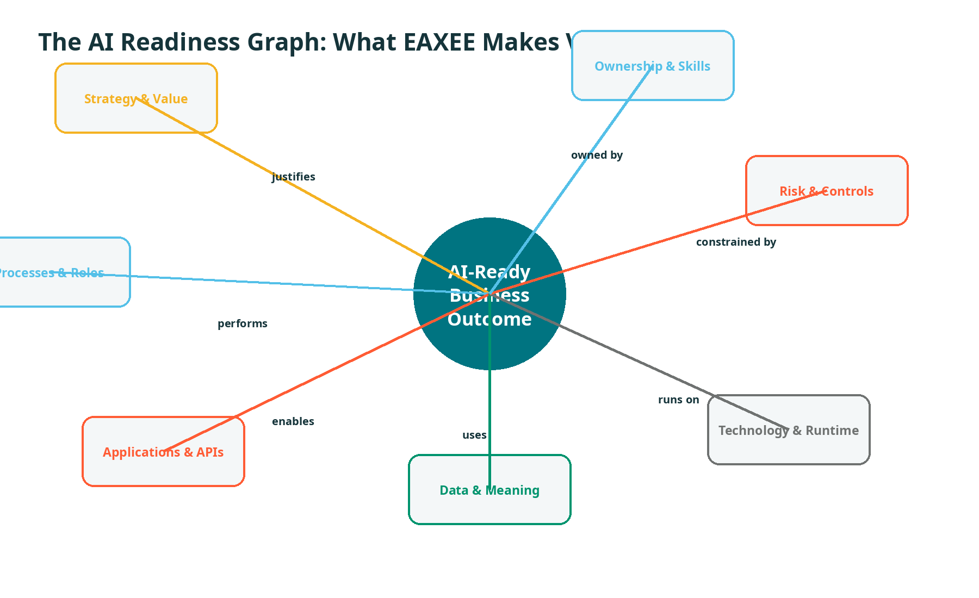
Figure 3. EAXEE models AI readiness as a connected set of business, information, technology and governance dependencies.
A proposed AI use case should be challenged with seven questions:
- What business decision or activity will improve?
- Which capability, process or service owns the outcome?
- Which data provides the evidence, and what does “authoritative” mean here?
- Which applications, integrations and runtime environments are involved?
- Which risk, privacy, regulatory and security controls apply?
- Who is accountable for the recommendation and for any automated action?
- How will value, errors, exceptions and human overrides be measured?

5. A PORTFOLIO, NOT A PARADE OF PILOTS
AI demand arrives as a flood. Governance often responds with a queue. EAXEE enables something better: a portfolio.
Every candidate use case can be linked to capabilities, pain points, strategic goals, applications, data, risks, owners and transformation initiatives. This makes duplication visible and permits comparison using value, context availability, delivery difficulty, risk exposure and reuse potential.
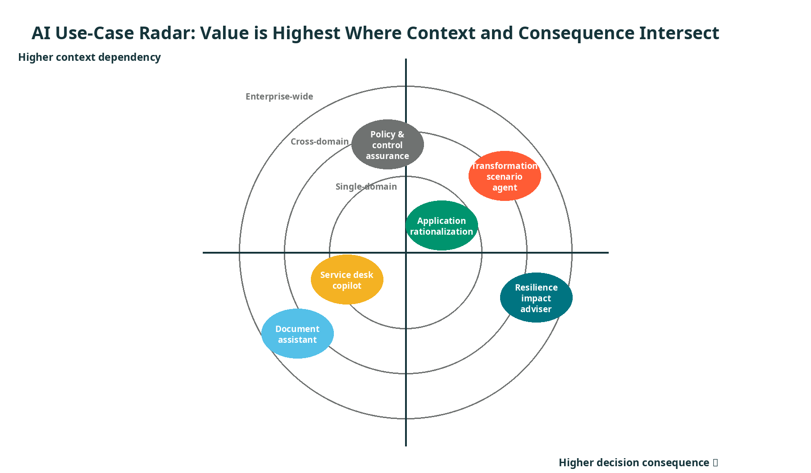
Figure 4. The most valuable enterprise AI use cases often require the richest cross-domain context and carry the greatest decision consequence.
Three portfolio questions that change the conversation
- Which use cases solve the same underlying decision problem and should share one knowledge foundation?
- Which use cases depend on data or architecture work already funded elsewhere?
- Which “small” use cases create reusable context, controls or connectors that unlock larger opportunities?
Out-of-the-box concept: Context Reuse Dividend
The value of modelling a capability, application dependency or data lineage should not be charged to one AI use case alone. Once captured in EAXEE, that context can support many assistants and agents. The Context Reuse Dividend measures how often one governed architecture fact is reused across decisions, automations and assurance activities.
6. FOUR STORIES FROM THE REAL ENTERPRISE
Story A — The application rationalization adviser
A CIO asks which applications can be retired after an ERP modernization. EAXEE identifies applications providing overlapping functionality, the processes and capabilities they support, interfaces still in use, data retained for compliance, contracts nearing renewal and projects already changing the same landscape. The AI adviser proposes retirement waves and explicitly lists the evidence and assumptions behind each recommendation.
Story B — The resilience impact agent
A critical infrastructure node is reported unavailable. EAXEE traverses runtime instances, applications, services, business processes, sites, customer journeys and accountable teams. The agent produces an impact brief, ranks affected services by criticality, identifies known workarounds and routes escalation to the right owners.
Story C — The transformation collision detector
Two programs plan changes to the same customer data domain and integration platform in the same quarter. EAXEE detects shared dependencies before implementation. An AI assistant explains the collision, suggests sequencing options and shows which strategic outcomes and delivery milestones are at risk.
Story D — The architecture assurance copilot
A solution design is submitted. The copilot checks proposed technologies against standards, verifies required controls, identifies duplicate applications, highlights missing data ownership and traces exceptions to approvers. Architects spend less time searching and more time exercising judgment.
The common pattern
In every story, AI generates value because EAXEE supplies the enterprise map, not because the prompt is clever.

7. TRUST: THE FEATURE THAT CANNOT BE BOLTED ON LATER
Fluent answers are not the same as trustworthy answers.
EAXEE can make trust visible by attaching each AI response to source objects, relationship paths, owners, timestamps, classifications, confidence indicators and known gaps. This supports a “show your work” design for enterprise AI.
Recommended trust contract for every consequential AI response
- Evidence: Which EAXEE objects and external sources were used?
- Reasoning path: Which relationships connected the question to the conclusion?
- Freshness: When was the evidence last validated?
- Completeness: Which expected data or relationships were missing?
- Authority: Who owns the source and who may approve the action?
- Alternatives: What other options were considered?
- Reversibility: Can the decision or automated action be safely reversed?
Out-of-the-box concept: Architectural Grounding Score
A weighted score that reflects how well an AI answer is supported by verified EAXEE objects, complete relationship paths, current ownership, fresh evidence and applicable controls. It does not pretend to prove truth; it exposes the strength of enterprise grounding.

8. AGENTS NEED AN ENTERPRISE RULEBOOK
An assistant recommends. An agent acts. That difference changes the governance problem.
EAXEE can provide the policy and architecture context needed to constrain agent behavior. An agent may be permitted to inspect an application portfolio but prohibited from viewing restricted data domains. It may draft a retirement recommendation but require human approval before creating a change request. It may update low-risk metadata automatically while escalating structural changes to the architecture board.
Agent action levels
Level | Permitted behavior | Example | Control
Observe | Read and summarize | Explain application dependencies | Role-based access and logging
Recommend | Propose options | Suggest rationalization candidates | Evidence and confidence required
Prepare | Create draft actions | Draft decision record or change request | Human review before submission
Execute | Perform approved low-risk actions | Update owner-confirmed metadata | Policy, threshold and rollback
Escalate | Stop and route to authority | Conflicting controls or high-impact change | Named decision owner
Out-of-the-box concept: Agent Blast Radius
Before an agent acts, EAXEE calculates the potential architectural reach of that action: affected capabilities, services, systems, data, users, controls and projects. The larger the blast radius, the stronger the approval and rollback requirements.

9. THE PROCUREMENT CASE
Why buy EAXEE now, when the organization is investing in AI?
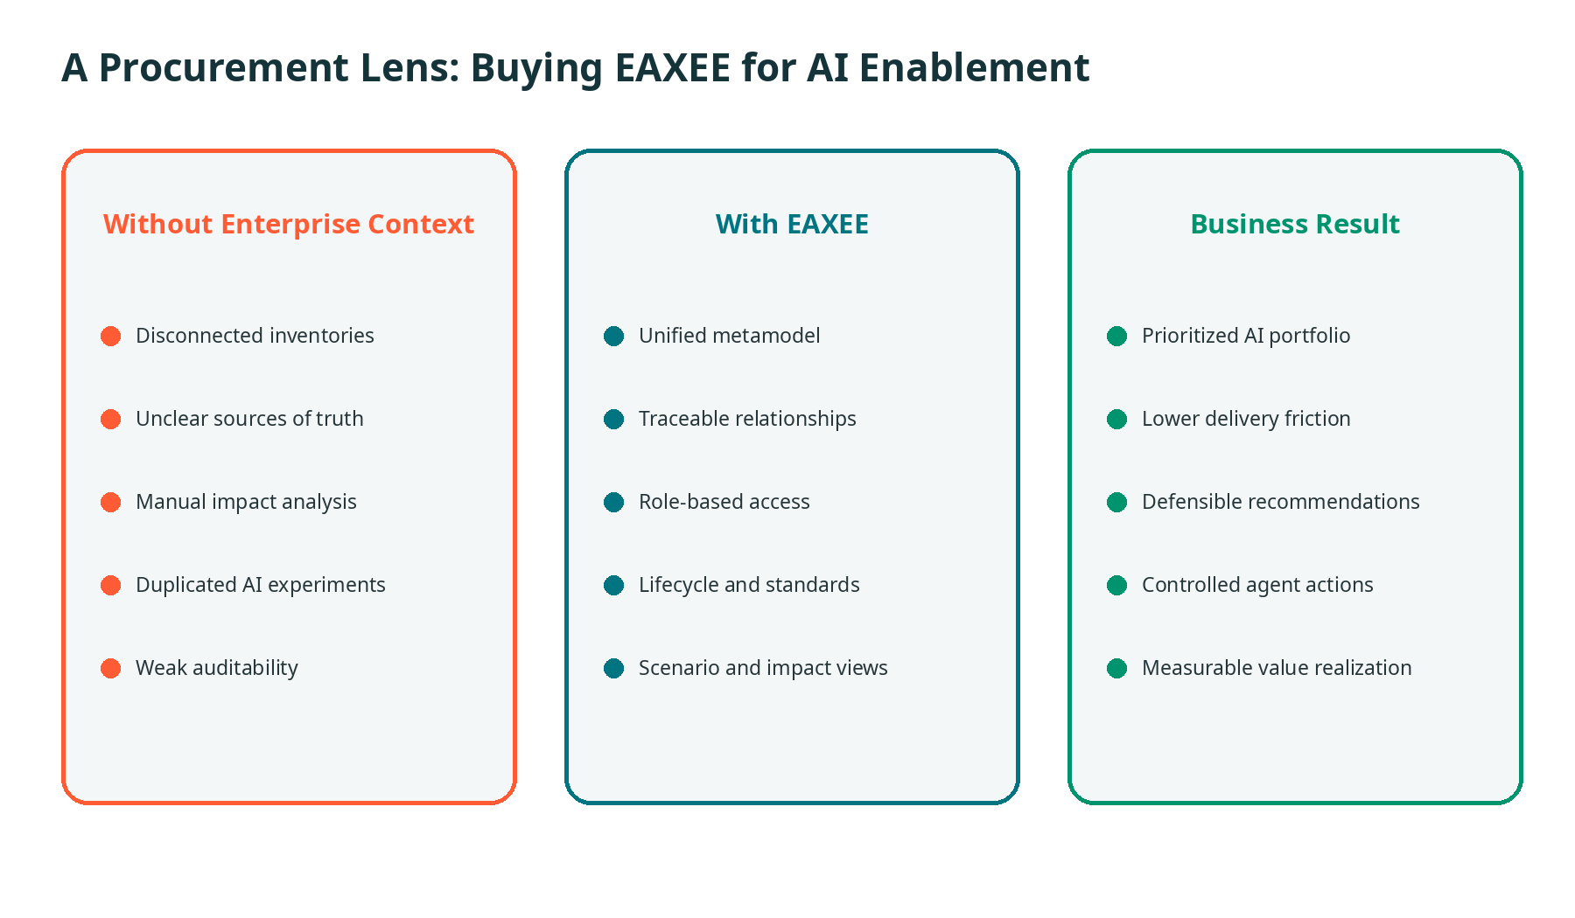
Figure 5. EAXEE converts fragmented inventories into governed context and measurable AI outcomes.
The business case should not be limited to EA productivity. It should include:
- Reduced duplication across AI initiatives through reusable context and connectors.
- Faster discovery of dependencies, owners, standards and risks.
- Improved explainability and auditability for consequential recommendations.
- Lower cost of impact analysis and solution assurance.
- Better prioritization of AI investments against strategic outcomes.
- A controlled path from copilots to agents.
- Preservation of institutional knowledge when people, suppliers and programs change.
Buyer warning
Do not procure an EA platform merely because it can draw diagrams or attach a chatbot. Procure it because it can maintain the semantic, relational and governance foundation that AI needs to operate across the enterprise.

10. WHAT “GOOD” LOOKS LIKE IN 90 DAYS
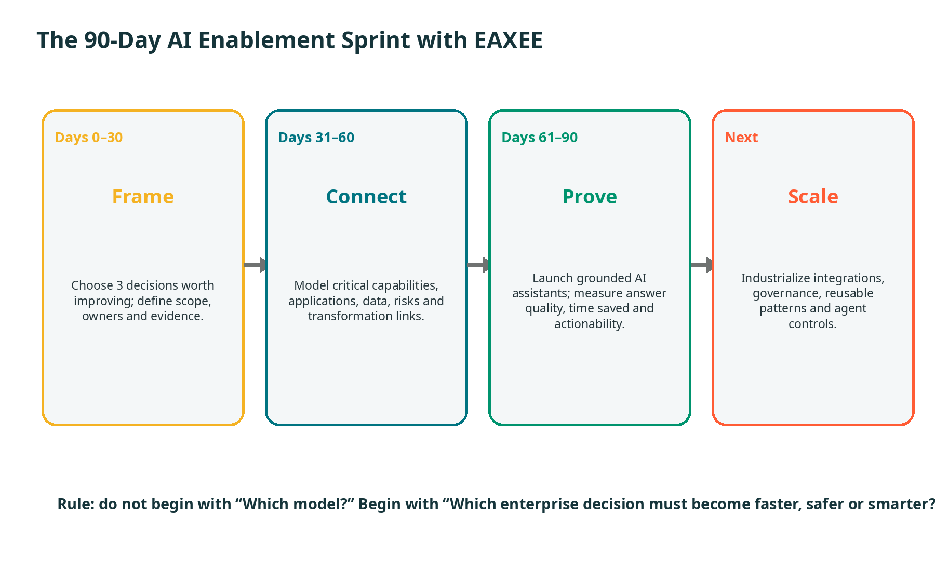
Figure 6. A focused 90-day sprint proves the value of EAXEE through decisions, not through repository volume.
Three proof points should exist at the end of the sprint:
- A business leader can ask a consequential question and receive an answer grounded in traceable EAXEE evidence.
- An architect can see missing context, stale records and risk warnings rather than receiving false certainty.
- A measurable decision cycle—such as impact analysis, solution review or rationalization—becomes faster without weakening governance.
Do not measure success by the number of objects loaded.
Measure the number of important decisions that became faster, clearer, safer or more reusable because the context was connected.

11. THE EAXEE AI CONTROL ROOM
AI enablement needs an operating view, not a collection of status slides.
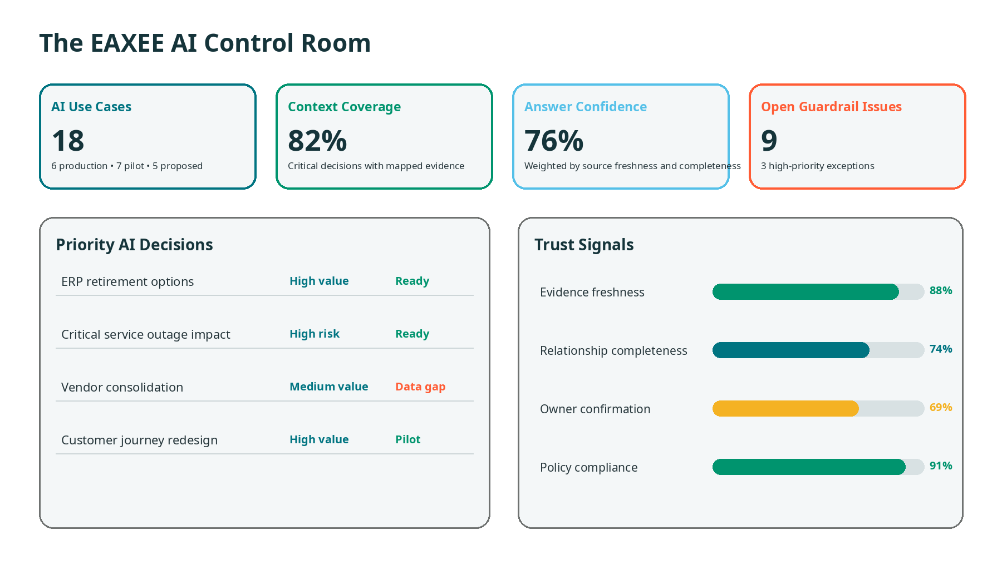
Figure 7. A conceptual EAXEE control room combines portfolio progress, context quality, confidence and guardrail signals.
Recommended executive indicators
- AI use cases by value, risk, stage and accountable owner.
- Percentage of priority use cases with complete architecture context.
- Evidence freshness and ownership confirmation.
- Average Architectural Grounding Score for consequential answers.
- Number of agent actions by level, exception and override.
- Decision-cycle time before and after enablement.
- Context Reuse Dividend across assistants and agents.
- Benefits realized, not merely pilots launched.

12. LESSONS FOR LEADERS WHO DO NOT WANT ANOTHER “AI PROGRAM”
Start with decisions, not demos.
A polished demonstration can hide the absence of enterprise value. Choose decisions that are frequent, expensive, risky or slow.
Model only what the decision needs—then expand deliberately.
An empty repository is useless. An indiscriminate repository is expensive. Build context around prioritized decisions.
Treat missing data as a product signal.
A gap exposed by AI is not embarrassment; it is a prioritized architecture and governance backlog.
Keep the human accountable.
AI can accelerate analysis. Accountability remains with named roles and governance bodies.
Design for disagreement.
The system should preserve assumptions, alternatives, dissent and rationale—not merely the final answer.
Separate confidence from eloquence.
The most fluent answer may have the weakest evidence. Show grounding, gaps and freshness.
Build for reuse.
A capability map, interface relationship or ownership record should support many use cases. Reuse is where economics improve.
Govern agents before agents become useful.
The moment an agent can take action is too late to invent permissions, approvals, rollback and audit.

13. A BUYER’S CHECKLIST FOR EAXEE AS AI ENABLER
Evaluation area | Procurement question
Semantic foundation | Can the platform represent the organization’s own metamodel, vocabulary and relationship rules?
Traceable graph | Can users traverse from strategy to process, application, data, technology, risk and change?
Governed access | Can context be segmented by repository, role, classification and responsibility?
Evidence quality | Can freshness, completeness, ownership and missing links be surfaced?
Scenario intelligence | Can current, target and transition states be compared?
Integration readiness | Can EAXEE exchange context with service, portfolio, data, identity and operational systems?
AI grounding | Can AI responses cite the architecture objects and paths used?
Agent governance | Can actions be constrained by policy, approval, risk and blast radius?
Value measurement | Can use cases be linked to business outcomes and realized benefits?
Extensibility | Can the foundation support multiple models, assistants and agents rather than one vendor-specific experience?
A strong procurement process should ask vendors to demonstrate one end-to-end decision using the buyer’s own enterprise concepts—not a generic sample repository.

14. CLOSING ARGUMENT: ARCHITECTURE IS THE PRECONDITION FOR AI AT SCALE
The next phase of digital transformation will not be defined by who experiments with AI. It will be defined by who can operationalize it without losing control of meaning, dependencies, accountability and risk.
EAXEE gives the enterprise a durable advantage: a living representation of how value is created, how technology enables it, how change propagates, where risk accumulates and who has authority to act. That representation becomes the grounding layer for better copilots today and governable agents tomorrow.
The model is not the strategy. The prompt is not the operating model. The chatbot is not the transformation.
The advantage comes from connecting AI to the enterprise itself. That is the role of EAXEE.
Before AI, Architecture.

