WHITE PAPER

Digital Transformation Governance
From Vision to Execution — How EAXEE turns strategic ambition into governed, measurable enterprise change

The central proposition
Digital transformation does not fail because organizations lack projects. It fails because intent, choices, dependencies, delivery and evidence are governed in different places. EAXEE provides the connected governance record that closes those gaps.

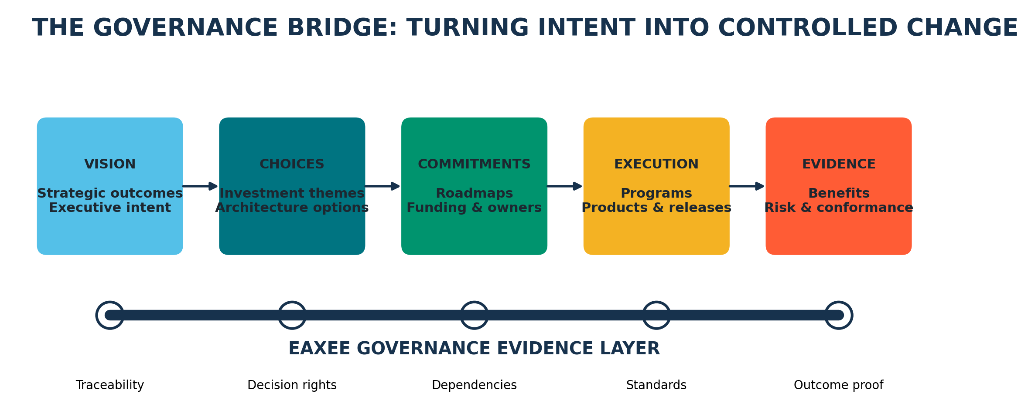
Figure 1 — The governance bridge supported by EAXEE’s shared evidence layer.
Executive White Paper • July 2026

Abstract
Most organizations can explain their digital vision. Far fewer can prove that every funded initiative, design decision, technology exception and release commitment is advancing that vision. The missing capability is not another approval board. It is a governance system that makes enterprise change visible, traceable and contestable.
This paper presents Digital Transformation Governance as a practical operating discipline and shows how EAXEE Enterprise Architecture Software becomes its system of record and system of insight. The discussion is deliberately organized as a field guide: it starts with the questions leaders must be able to answer, defines the governance mechanisms needed to answer them, and then demonstrates how EAXEE connects strategy, architecture, investment, delivery, risk and benefits into one continuously refreshed evidence model.

What makes this paper different
- It treats governance as a sequence of decision moments, not a committee structure.
- It distinguishes control from bureaucracy: the objective is faster, better decisions with explicit evidence.
- It introduces original governance concepts such as Strategic Traceability Coverage, Decision Half-Life, Exception Debt, Transformation Collision Exposure and Evidence Freshness.
- It provides practical patterns for boards, architecture authorities, transformation offices, product teams and delivery leaders.

A one-page executive reading route
Question | Where addressed
How does vision become executable? | Sections 2–4
How are decision rights made explicit? | Section 5
How does EAXEE control portfolio collisions and architecture drift? | Sections 6–8
How are benefits and risks proven? | Sections 9–11
How should adoption begin? | Sections 12–14

1. The governance gap hiding inside digital transformation
Digital transformation is usually described in verbs: digitize, automate, integrate, personalize, modernize. Governance is where those verbs are forced to become commitments. Which customer outcome will improve? Which capabilities must change? Which architecture option is acceptable? Which dependencies constrain sequencing? Who accepts residual risk? What evidence will prove that value was realized?
In many enterprises, each answer lives in a separate medium. Strategy is in presentations. Funding is in portfolio tools. architecture is in diagrams. Risks are in spreadsheets. Delivery is in agile platforms. Benefits are in finance packs. The organization therefore governs fragments while the transformation itself behaves as a connected system.
Governance failure pattern
A project can be “green” inside its delivery tool while simultaneously undermining an enterprise standard, colliding with another release, duplicating a capability, increasing operational fragility and failing to support a measurable strategic outcome.

Symptoms that the enterprise is governing documents rather than transformation
- The same initiative has different objectives depending on which presentation is opened.
- Architecture approvals record a decision but not its assumptions, expiry conditions or downstream obligations.
- Programs compete for the same data, integration, identity or infrastructure assets without a shared collision view.
- Exceptions become permanent because no owner, remediation path or expiry date is attached.
- Benefits are reported after delivery but are not connected to the capability, process and technology changes that were supposed to create them.

2. A sharper definition: governance is the enterprise’s change operating system
Digital Transformation Governance is the set of decision rights, evidence requirements, control loops and feedback mechanisms through which an organization converts strategic intent into coordinated change and verifies that the change produces acceptable value, risk and architectural outcomes.
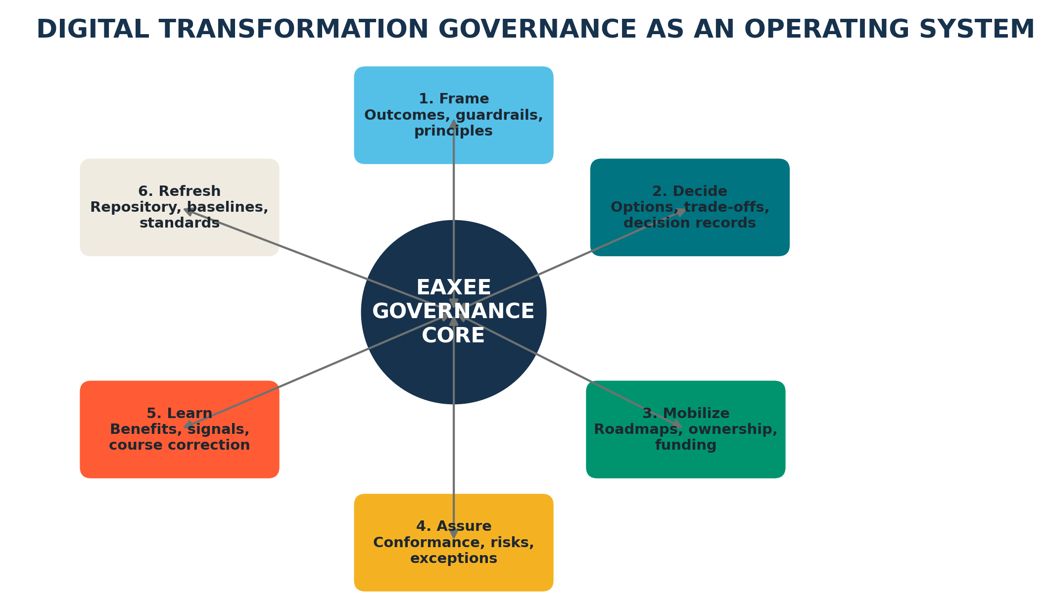
Figure 2 — Six repeating governance motions managed through EAXEE.
This definition matters because it removes governance from the narrow territory of compliance. Good governance does not merely stop bad ideas. It frames good choices, exposes trade-offs early, accelerates escalation, protects shared assets, preserves optionality and ensures that learning changes the roadmap.

3. The seven questions every transformation leadership team should answer
Board question | Governance meaning | EAXEE contribution

Question | Governance test | How EAXEE helps
1. What strategic outcome are we changing, and how will it be measured? | A decision cannot be considered governed until this question has an owner and evidence. | EAXEE links goals, outcomes, indicators, value streams and initiatives.
2. What must be different in the operating model? | A decision cannot be considered governed until this question has an owner and evidence. | Capabilities, processes, organizations, roles, information and policies are connected to target changes.
3. What architecture choices are available? | A decision cannot be considered governed until this question has an owner and evidence. | Baseline, target, transition and alternative solution options can be compared with explicit trade-offs.
4. Where are the dependencies and collisions? | A decision cannot be considered governed until this question has an owner and evidence. | Cross-program impact paths reveal shared applications, data, integrations, vendors, infrastructure and release windows.
5. Who owns each decision and obligation? | A decision cannot be considered governed until this question has an owner and evidence. | Decision records, object owners, accountable roles, approvers and action owners create clear authority.
6. What risk and cost are we accepting? | A decision cannot be considered governed until this question has an owner and evidence. | Risks, controls, technical debt, lifecycle exposure, costs and exceptions are attached to affected architecture objects.
7. What evidence proves value? | A decision cannot be considered governed until this question has an owner and evidence. | Benefits, KPIs, adoption, service performance and realized outcomes are traced back to the approved transformation hypothesis.

4. From vision to execution: the traceability thread
The most important governance object is not a project, an application or even a target architecture. It is the traceability thread that connects an approved promise to the evidence of its delivery. EAXEE makes this thread explicit and navigable.
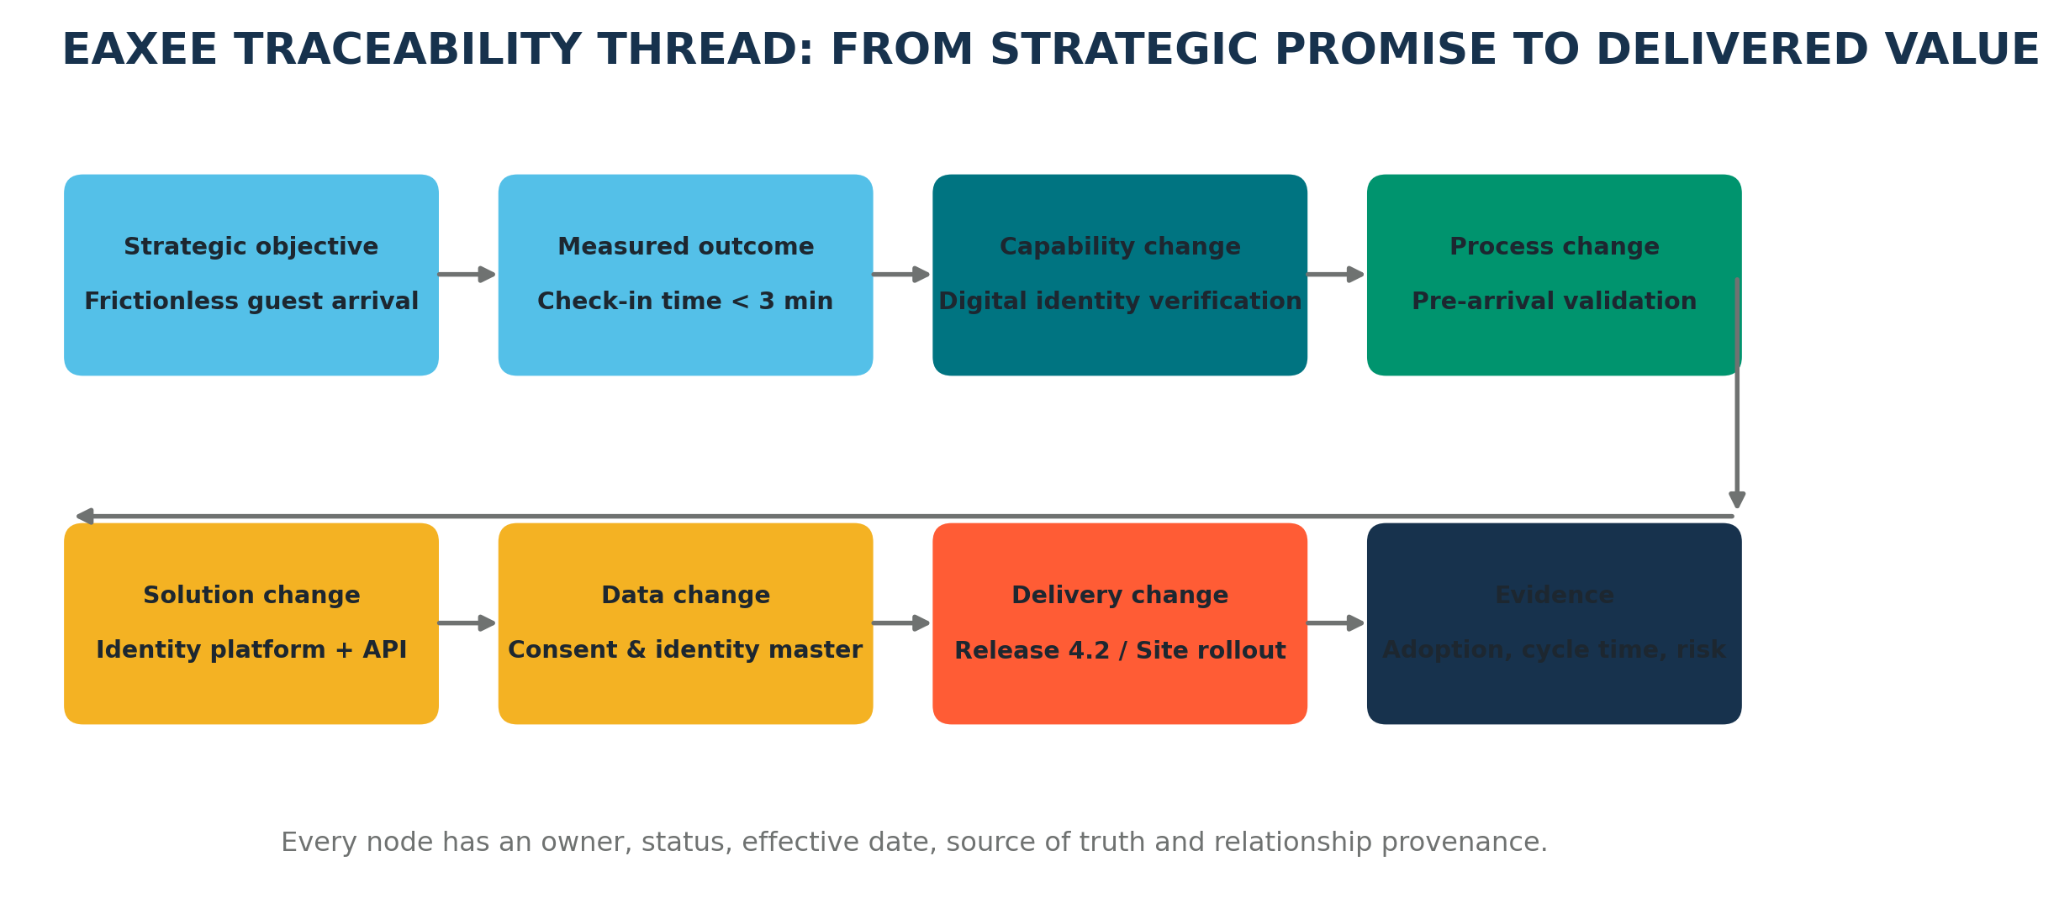
Figure 3 — Example traceability from strategic promise to outcome evidence.

Example: frictionless guest arrival
Assume an organization adopts the strategic objective “deliver a seamless and personalized guest journey.” That statement is too broad to govern. EAXEE decomposes it into a measurable outcome, the capability and process changes required, the applications and data affected, the releases that will deliver the changes, the risks introduced and the evidence that will confirm success.
- Define the outcome: reduce median check-in time below three minutes while maintaining identity assurance.
- Identify enabling capability changes: digital identity verification, pre-arrival validation and exception handling.
- Model impacts: customer profile, consent, identity master, mobile experience, integration APIs and site connectivity.
- Select and record the architecture option: reuse enterprise identity platform, procure a specialist service or build an internal component.
- Connect delivery commitments: releases, sites, owners, milestones, funding and operational readiness.
- Capture proof: adoption rate, cycle time, failed verification rate, support incidents and guest satisfaction.
Takeaway
EAXEE does not merely show what is connected. It records why the connection matters, who is accountable, when it becomes effective and what evidence will confirm or falsify the transformation hypothesis.

5. Decision rights: clarity without centralizing every decision
Governance weakens when every decision is escalated and when no decision is escalated. The remedy is a tiered model in which authority follows impact. Local teams should decide within approved guardrails; enterprise forums should decide where choices affect shared capabilities, strategic outcomes, risk appetite or irreversible investment.
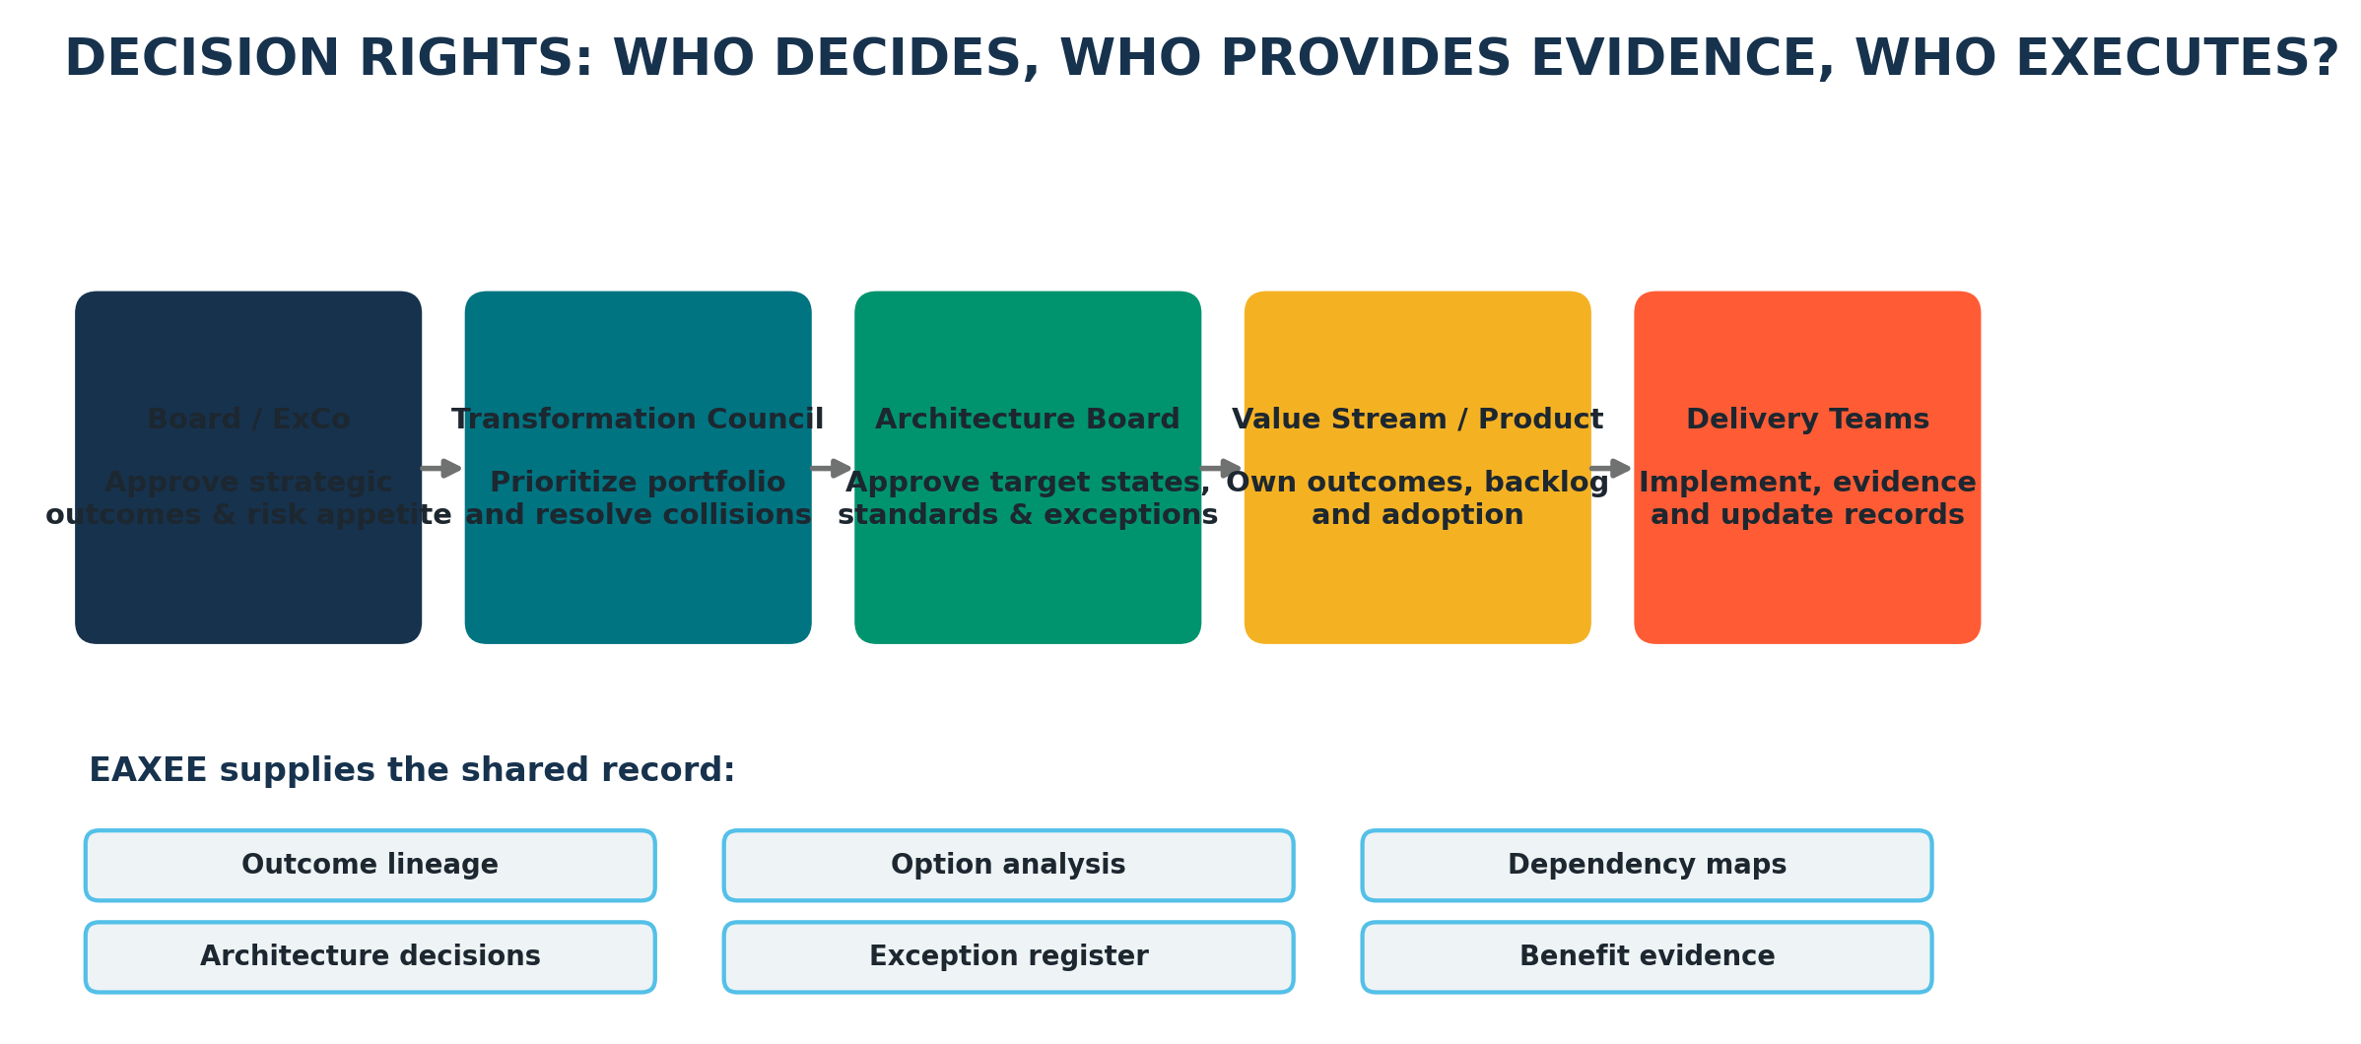
Figure 4 — A federated decision-rights model supported by shared EAXEE evidence.
Decision class | Typical authority | EAXEE evidence required
Strategic direction | Board / Executive Committee | Outcome definitions, investment themes, risk appetite, enterprise principles
Portfolio priority | Transformation Council | Strategic coverage, dependencies, collision exposure, capacity and value cases
Architecture choice | Architecture Board | Options, trade-offs, target state, standards, transition risks and decision record
Product / value-stream choice | Product or value-stream owner | Outcome impact, backlog implications, operational acceptance and adoption plan
Implementation choice | Delivery team within guardrails | Conformance evidence, interface contracts, non-functional requirements and release record
Exception acceptance | Named risk owner at correct tier | Rationale, compensating controls, cost, expiry, remediation and residual risk

The decision record should outlive the meeting
Minutes document conversation. A decision record documents organizational intent. EAXEE should capture the question, options considered, assumptions, evidence, decision, accountable owner, effective date, dependencies, obligations, review trigger and expiry conditions. This turns decisions into reusable enterprise knowledge and allows future teams to understand not just what was chosen, but why.

6. Portfolio governance: manage the enterprise as a shared change surface
Transformation portfolios are commonly governed initiative by initiative. Yet enterprise risk accumulates at the intersections: the same customer master changed by three programs; the same integration platform targeted by overlapping releases; the same subject-matter experts assigned to multiple critical milestones; the same vendor dependency embedded in several target solutions.
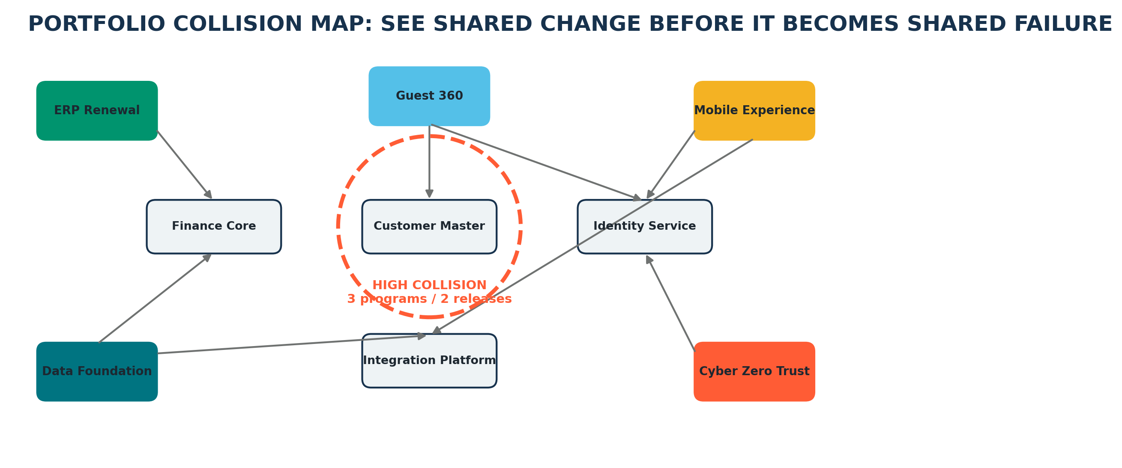
Figure 5 — EAXEE portfolio collision view centered on shared enterprise assets.

Original governance concept: Transformation Collision Exposure (TCE)
Transformation Collision Exposure measures the concentration of simultaneous change around a shared asset or capability. It is not a generic project dependency count. It combines the number of active initiatives, overlap in release windows, criticality of the shared asset, reversibility of the change, resource contention and architectural divergence.
Illustrative formula
TCE = Initiative Overlap × Asset Criticality × Timing Conflict × Change Irreversibility × Ownership Fragmentation. The score is used to trigger sequencing, joint design, integration testing or executive intervention—not to create a false sense of mathematical precision.

EAXEE can surface collision hotspots because projects, capabilities, applications, interfaces, data, technology products, vendors, releases and owners are represented in one relationship model. A transformation council can therefore govern shared change before it turns into operational incident or rework.

7. Architecture governance: from checkpoint approval to continuous assurance
Traditional architecture governance is event-driven. A team presents a design, receives comments, obtains approval and then proceeds. Digital delivery demands a more persistent model. Architecture intent, implementation evidence, exceptions, risks and outcomes must remain connected throughout delivery and operation.
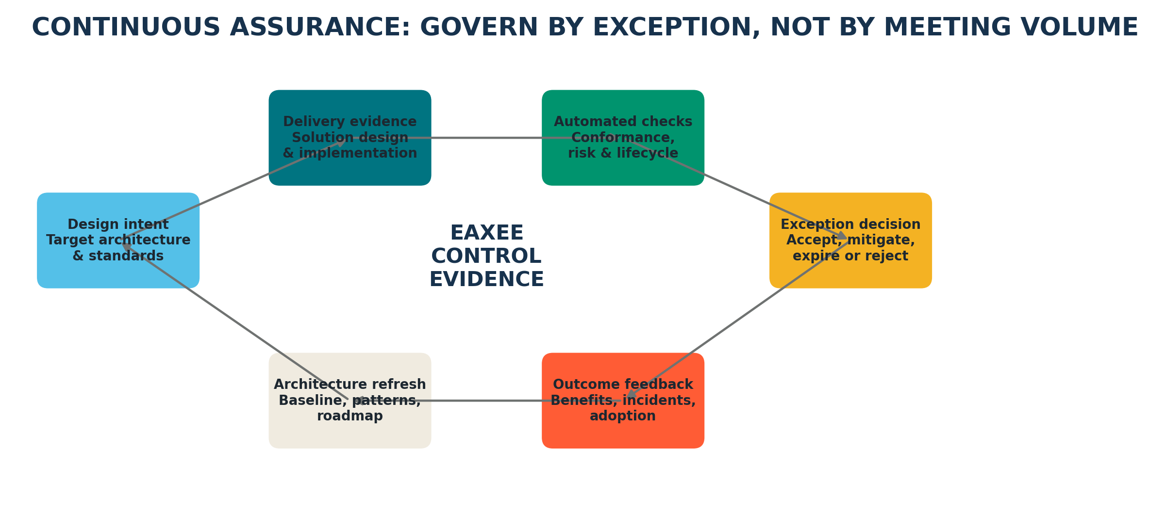
Figure 6 — Continuous assurance loop: governance by evidence and exception.

The EAXEE control pattern
- Set the approved target state and applicable standards.
- Associate requirements and guardrails with affected architecture objects.
- Collect delivery evidence such as solution designs, interface definitions, technology choices and deployment mappings.
- Evaluate conformance and identify material deviations.
- Route only meaningful exceptions to the appropriate decision authority.
- Attach mitigation, cost, risk owner and expiry conditions to every accepted exception.
- Feed incidents, adoption results and operational performance back into standards and roadmaps.

Original governance concept: Exception Debt
Exception Debt is the future cost and risk created when temporary deviations accumulate faster than they are retired. EAXEE can make this debt visible by connecting each exception to affected systems, standards, risks, remediation initiatives, estimated cost, expiry date and accountable owner. A portfolio with a low number of exceptions can still have severe debt if those exceptions sit on critical shared platforms.

8. Governing transformation options, not just approved plans
A mature organization does not confuse a preferred roadmap with certainty. External regulation, market conditions, funding constraints, vendor performance and operational incidents can alter the feasible path. EAXEE supports option-based governance by preserving alternative architectures and transition paths rather than deleting them once a decision is made.

Architecture Option Portfolio
For major decisions, EAXEE can maintain multiple coherent options, each with dependencies, cost ranges, risk profile, time-to-value, reversibility, capability impact and trigger conditions. The approved option is one member of the portfolio; alternatives remain available if assumptions change.
Option | Strength | Exposure | Governance trigger
A — Extend existing platforms | Fastest initial delivery | Higher technical debt and capacity risk | Use while demand remains below defined threshold
B — Strategic platform replacement | Better long-term standardization | Migration cost and transition complexity | Activate when funding and data readiness are secured
C — Progressive modularization | Preserves optionality | Requires disciplined interfaces and product ownership | Use where business change is uncertain or phased

Out-of-the-box lesson
The best governance question is often not “Which option is cheapest?” but “Which option preserves the most valuable future choices at an acceptable current cost?”

9. Benefits governance: prove the value chain, not merely the business case
Benefits are frequently governed as financial claims attached to programs. That makes them vulnerable to optimism, double counting and attribution disputes. EAXEE enables a richer benefits model by connecting an expected benefit to the operational mechanism that creates it.

The benefit evidence chain
A benefit should be linked to: the strategic outcome; the capability or process change; the enabling solution and data change; the affected population; the adoption behavior required; the leading indicator; the lagging indicator; the accountable benefit owner; and the evidence source. This converts a benefit from a forecast into a testable proposition.
Weak benefit statement | Governable EAXEE formulation
“Improve customer experience.” | Reduce failed digital check-ins from 12% to below 4% by improving pre-arrival identity validation across named guest segments and sites.
“Increase efficiency.” | Reduce manual invoice matching hours by 45% through automated three-way matching, measured from process telemetry and finance workload records.
“Reduce technology cost.” | Retire seven applications and twelve interfaces after migration of defined capabilities and data, with contract, infrastructure and support savings evidenced separately.

Original governance concept: Benefit Confidence
Benefit Confidence combines traceability completeness, evidence freshness, adoption readiness, dependency closure and historical forecast accuracy. It helps leadership distinguish a large but weakly evidenced promise from a smaller, highly credible outcome.

10. Risk governance: follow propagation paths, not isolated registers
Transformation risk is relational. A vendor delay affects a technology product; the product delays an application release; the release blocks a process change; the process change weakens an expected benefit; the benefit shortfall affects a strategic commitment. EAXEE can show this propagation path and identify where intervention has the greatest leverage.

Risk categories EAXEE can connect
- Strategic risk: transformation does not materially advance the intended outcome.
- Portfolio risk: initiatives collide, duplicate effort or create sequencing conflicts.
- Architecture risk: target state is incoherent, overly coupled or dependent on unsupported technology.
- Transition risk: temporary states reduce resilience, control effectiveness or operational capacity.
- Delivery risk: dependencies, skills, vendors, data or environments are not ready.
- Adoption risk: processes, roles, incentives and behaviors do not change.
- Benefits risk: evidence does not support the claimed value or benefits are double counted.
Governance implication
A risk register tells leaders what might go wrong. A connected EAXEE model tells them what the risk can affect, which initiatives amplify it, which controls reduce it, who owns the impacted outcomes and where the decision should be made.

11. The EAXEE governance cockpit: what leaders should see
Executive dashboards often contain too many indicators and too little decision context. An EAXEE governance cockpit should prioritize questions requiring intervention. Each signal should allow the user to traverse directly into the affected outcomes, initiatives, architecture objects, decisions, owners and evidence.
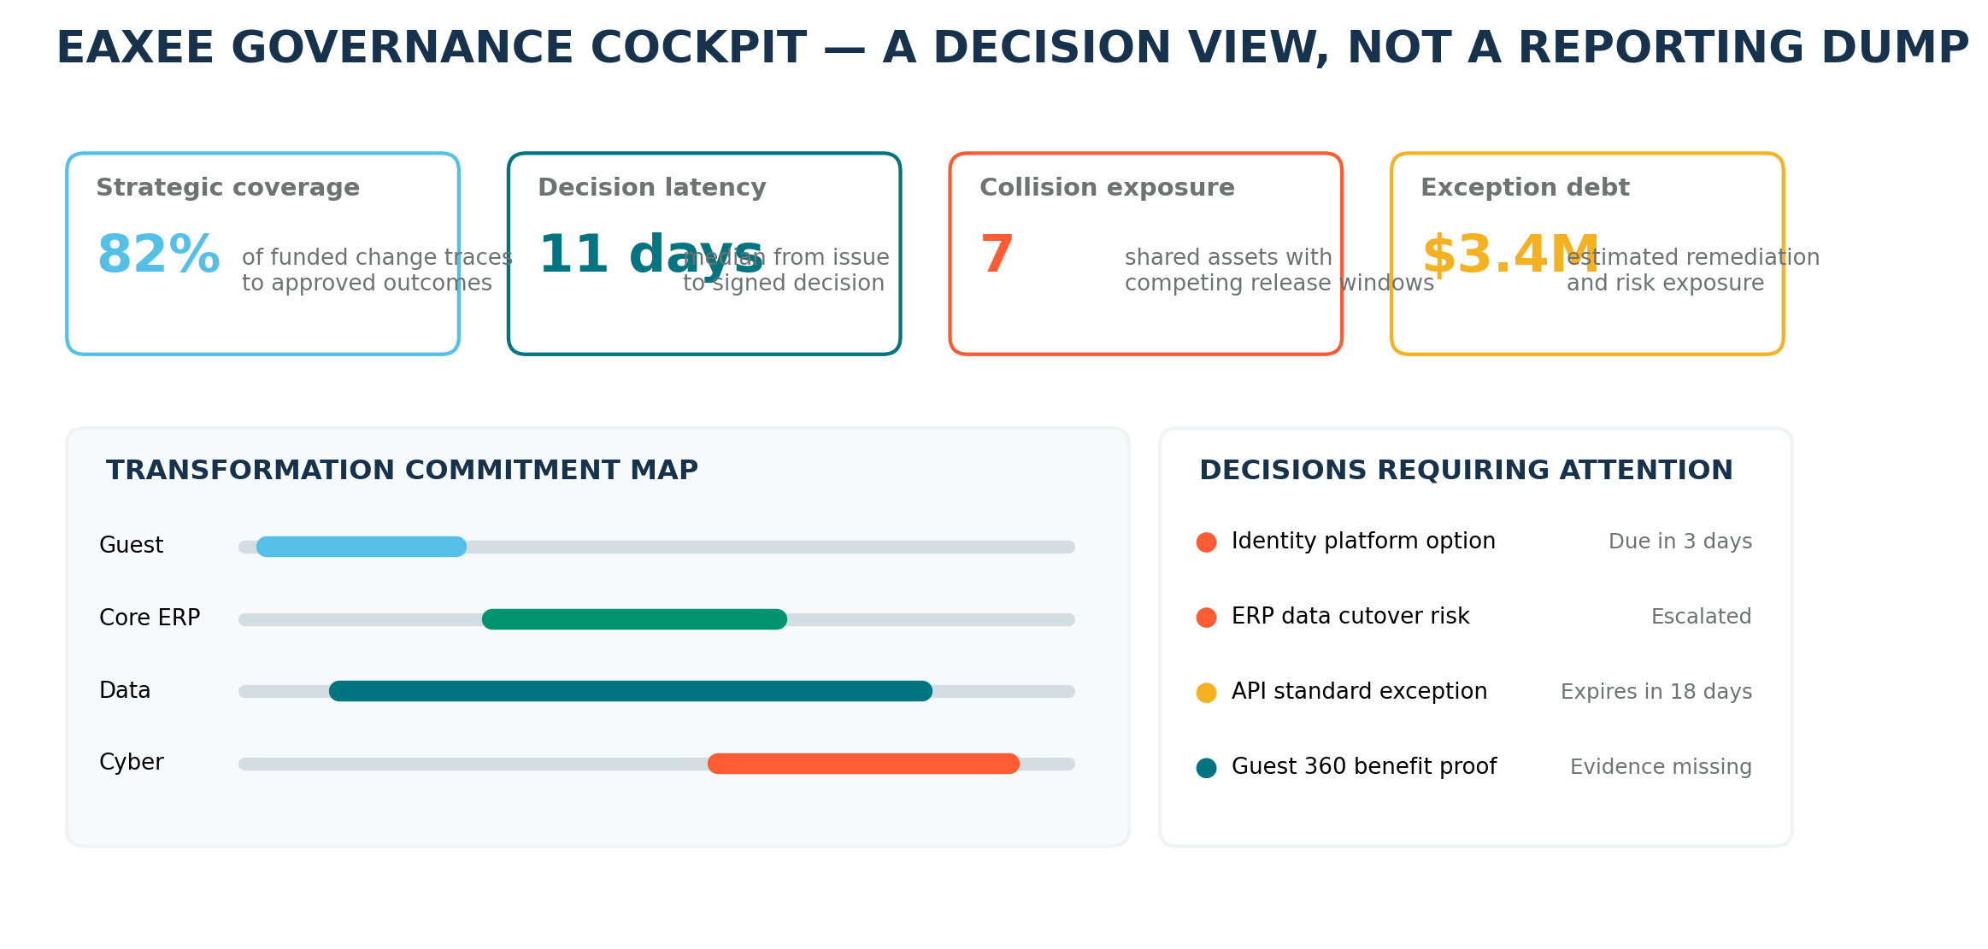
Figure 7 — Illustrative EAXEE governance cockpit focused on actionable decisions.

Recommended decision signals
Signal | What it reveals | Typical action
Strategic Traceability Coverage | Percentage of funded change connected to approved measurable outcomes | Challenge orphan initiatives or repair lineage
Decision Latency | Time between a material issue and an accountable decision | Clarify authority, evidence or escalation
Transformation Collision Exposure | Concentration of simultaneous change on shared assets | Resequence, integrate plans or create joint design authority
Exception Debt | Accumulated cost and risk of unresolved deviations | Fund remediation, retire exceptions or explicitly accept debt
Evidence Freshness | Age and reliability of critical architecture, risk and benefit data | Request validation or lower confidence in decisions
Target-State Drift | Distance between approved architecture and emerging implementation | Correct delivery, approve a revised target or record exception
Benefit Confidence | Credibility of expected and reported value | Adjust forecasts, strengthen adoption or stop weak investments

12. EAXEE capabilities that make governance operational
The usefulness of EAXEE in transformation governance comes from the combination of repository structure, relationship traversal, visualization, analysis, lifecycle management and controlled collaboration. The software becomes valuable when these capabilities are configured around governance questions rather than used only to store diagrams.
EAXEE capability | Governance utility
Configurable metamodel | Represents the organization’s own strategy, capability, value-stream, process, application, data, technology, risk, cost, project and decision concepts.
Relationship-rich repository | Creates traceability across domains and enables dependency, impact and propagation analysis.
Baseline, target and transition states | Allows governance of current reality, desired future and temporary risk-bearing states.
Architecture views and dashboards | Presents role-specific evidence for executives, architects, portfolio leaders, product teams and risk owners.
Lifecycle and effective dates | Shows when technologies, contracts, decisions, exceptions and target-state changes become relevant.
Ownership and responsibility mapping | Clarifies accountable owners, custodians, approvers and impacted stakeholders.
Scenario and option modelling | Maintains alternative futures and supports trade-off analysis under uncertainty.
Document and attachment support | Links authoritative designs, policies, evidence and approvals to governed objects.
AI-enabled querying and notifications | Can surface dependency questions, upcoming expiries, stale evidence, risk triggers and decision obligations using natural-language interaction.

13. Governance patterns for common transformation scenarios

Scenario A — Enterprise application rationalization
EAXEE connects applications to capabilities, processes, users, data, interfaces, costs, vendors, risks, lifecycle and strategic relevance. Governance can therefore distinguish genuine duplication from purposeful variation. A “retire” decision is not accepted until capability replacement, data migration, integration removal, contract termination, operational readiness and benefit ownership are visible.

Scenario B — ERP modernization
The governance challenge is not simply selecting a platform. It is controlling process standardization, local exceptions, data readiness, integration dependencies, transition states and benefit realization. EAXEE records global design decisions, approved deviations, impacted organization units, process ownership, data objects, migration waves and the technology retirement roadmap.

Scenario C — Digital customer or guest journey
A journey spans channels, processes, identities, data, integrations, operational teams and physical locations. EAXEE prevents channel teams from optimizing isolated touchpoints at the expense of end-to-end outcomes. The repository can reveal where a customer promise depends on manual workarounds, aging technology or fragmented data ownership.

Scenario D — Cybersecurity transformation
Security controls can be mapped to business services, applications, data, infrastructure, risks and transformation initiatives. Governance can prioritize controls by business exposure, identify where transformation creates temporary vulnerability, and ensure accepted security exceptions are explicit, owned and time-bound.

14. Adoption roadmap: build decision utility before repository scale
A common mistake is to begin by modelling everything. Governance value appears faster when EAXEE is configured around a small set of high-value decisions and then expanded. The roadmap below emphasizes decision utility, evidence quality and operating adoption.
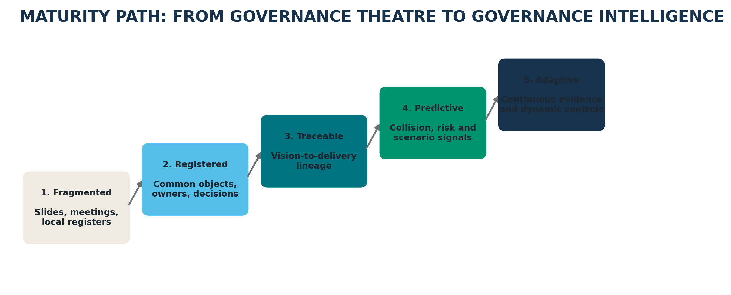
Figure 8 — Maturity path from fragmented governance to adaptive governance intelligence.
Phase | Focus | Deliverables | Exit test
1. Frame | Choose governance questions and scope | Principles, decision taxonomy, minimum metamodel, named owners | Leaders agree which decisions EAXEE must improve
2. Register | Create authoritative objects and ownership | Strategy, initiatives, key capabilities, applications, data, technologies, decisions and risks | Critical objects have accountable owners and source references
3. Trace | Connect vision, architecture and delivery | Outcome lineage, dependency paths, target states, roadmap and benefit links | Priority initiatives can be traced end to end
4. Assure | Embed controls and exception workflow | Standards, conformance checks, exception records, risk and lifecycle alerts | Material deviations are visible before release
5. Learn | Use outcomes to refresh governance | Benefit evidence, incident feedback, prediction signals, revised options and standards | Governance routinely changes decisions based on evidence

15. Lessons for making EAXEE a governance platform rather than an EA archive

Start with decisions, not diagrams.
Every view should answer a recurring governance question or support a named decision authority.

Model only what has an owner or a use.
Unowned detail creates false confidence and rapidly becomes stale.

Make effective dates first-class.
Transformation governance depends on knowing when a fact, target, exception, contract or decision applies.

Govern relationships as carefully as objects.
The value lies in traceability and dependency paths; uncontrolled links can be as misleading as missing data.

Separate evidence from assertion.
A claimed status, benefit or conformance result should point to its source and validation date.

Use confidence, not binary truth.
Some architecture and forecast information is uncertain. Record confidence, assumptions and expiry instead of hiding ambiguity.

Let local teams work within enterprise guardrails.
EAXEE should enable federated ownership and escalate only material cross-enterprise impacts.

Close the feedback loop.
Incidents, adoption, costs and benefits must update architecture choices, standards and future roadmaps.

16. A practical governance charter for EAXEE
The following charter can be adapted as a starting point for enterprise adoption.
Purpose
Use EAXEE as the authoritative, connected evidence environment for governing digital transformation from strategic intent through architecture choices, portfolio commitments, delivery conformance, risk acceptance and benefit realization.

Charter element | Recommended statement
Scope | Strategic outcomes, transformation initiatives, enterprise and solution architecture, key dependencies, decisions, exceptions, risks, costs, lifecycle and benefit evidence.
Authority | The approved EAXEE record is the governing reference for in-scope architecture and transformation decisions, subject to designated source systems for financial and delivery transactions.
Ownership | Every critical object and relationship has a named accountable owner and defined review cadence.
Minimum evidence | No material decision is complete without options, rationale, dependencies, risk, owner, effective date and review trigger.
Exception policy | All material exceptions require compensating controls, residual risk acceptance, remediation or retirement path and expiry date.
Data quality | Freshness, completeness, consistency and provenance are measured; low-confidence evidence is visibly flagged.
Review cadence | Executive monthly; portfolio fortnightly; architecture and exception reviews aligned with delivery flow; continuous lifecycle alerts.
Success measure | Faster decisions, fewer collisions, lower rework, reduced exception debt, improved strategic traceability and stronger benefit confidence.

17. Closing argument: governance that accelerates
The choice facing organizations is not between speed and governance. It is between unmanaged speed and informed speed. Unmanaged speed creates local progress, enterprise friction and expensive correction. Informed speed uses shared evidence to make clear choices, protect critical dependencies, preserve architectural coherence and learn from outcomes.
EAXEE can serve as the connective tissue of that discipline. It gives leaders a line of sight from vision to investment, from investment to architecture, from architecture to delivery, and from delivery to measurable value. It enables architects to move beyond diagram production, transformation offices to move beyond status aggregation, and executives to move beyond intuition unsupported by traceable evidence.
The result is not more governance. It is better governed transformation: fewer orphan initiatives, fewer invisible collisions, shorter decision latency, explicit risk acceptance, controlled exceptions, stronger benefit proof and a transformation portfolio that can explain—at any moment—what it is changing, why it matters, who owns the choice and what evidence will show that the enterprise is moving in the right direction.
Final takeaway
EAXEE transforms governance from an approval ceremony into an enterprise capability for making change coherent, accountable and measurable.

Appendix A — Suggested EAXEE governance objects
Domain | Core objects
Strategy | Vision, strategic objective, outcome, KPI, principle, policy
Business | Value stream, customer journey, capability, process, organization, role, service
Information | Data domain, data entity, information flow, owner, classification, quality rule
Application | Application, service, function, interface, integration, lifecycle, vendor
Technology | Technology product, infrastructure component, node, runtime instance, environment
Transformation | Initiative, program, project, release, milestone, workstream, roadmap, transition state
Governance | Decision, option, assumption, obligation, standard, exception, control, review
Value and risk | Benefit, cost, risk, issue, dependency, incident, measure, evidence source

Appendix B — Example governance queries for EAXEE
- Which funded initiatives have no traceable relationship to an approved measurable outcome?
- Which applications are being changed by more than one initiative in the same release window?
- Which accepted architecture exceptions expire in the next 90 days, and what business services depend on them?
- Which target capabilities rely on technology products reaching end of support before the planned transition is complete?
- Which strategic benefits are reported as on track but lack current adoption or operational evidence?
- Which decision assumptions have changed since approval, and what downstream commitments should be reviewed?
- Which transformation initiatives increase resilience risk during intermediate states?
- Where are multiple programs buying or building overlapping capability?
- Which critical data entities have unclear ownership across the initiatives that modify them?
- What is the blast radius of delaying a shared integration-platform release by one quarter?

