THE BUSINESS HAS AN ARCHITECTURE
Why Enterprise Architecture Is a Business Discipline—and Why EAXEE Makes It Actionable

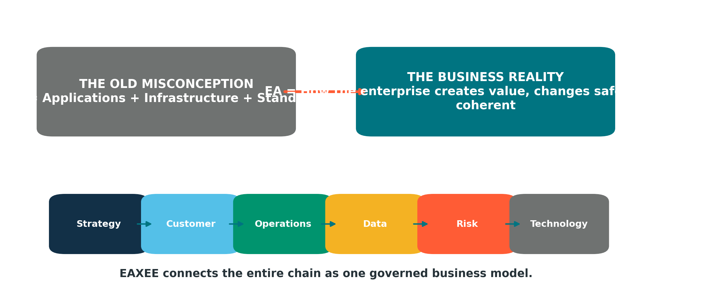
A commercial thought-leadership paper for leaders shaping strategy, transformation, governance, resilience and growth

EAXEE ENTERPRISE ARCHITECTURE SOFTWARE
Make the enterprise visible. Make change governable. Make decisions connected.

A Note to the Reader
This paper begins with a disagreement.
Enterprise architecture has been described for too long as the place where organizations catalogue applications, draw infrastructure diagrams and debate technology standards. Those activities matter. They are also the least interesting part of the discipline.
The deeper work of enterprise architecture is to explain how an enterprise hangs together: how strategy becomes capability; how capability becomes operating behavior; how information moves; how obligations are fulfilled; how customers experience the organization; how investments collide or reinforce one another; and how change in one corner alters outcomes elsewhere.
That is business work.
Technology is one of its materials—not its definition.
For organizations navigating digital transformation, regulatory pressure, data complexity, customer expectations, ecosystem dependence and continuous change, enterprise architecture is no longer an optional planning function. It is the discipline that keeps ambition connected to execution. EAXEE makes that discipline visible, collaborative, analyzable and operational.

Executive Premise
THE PREMISE | A business without an explicit architecture still has one. It is simply hidden inside habits, systems, spreadsheets, contracts, reporting lines, duplicated data and institutional memory.

The question is therefore not whether an organization has an enterprise architecture. The question is whether leaders can see it, test it, govern it and change it deliberately.
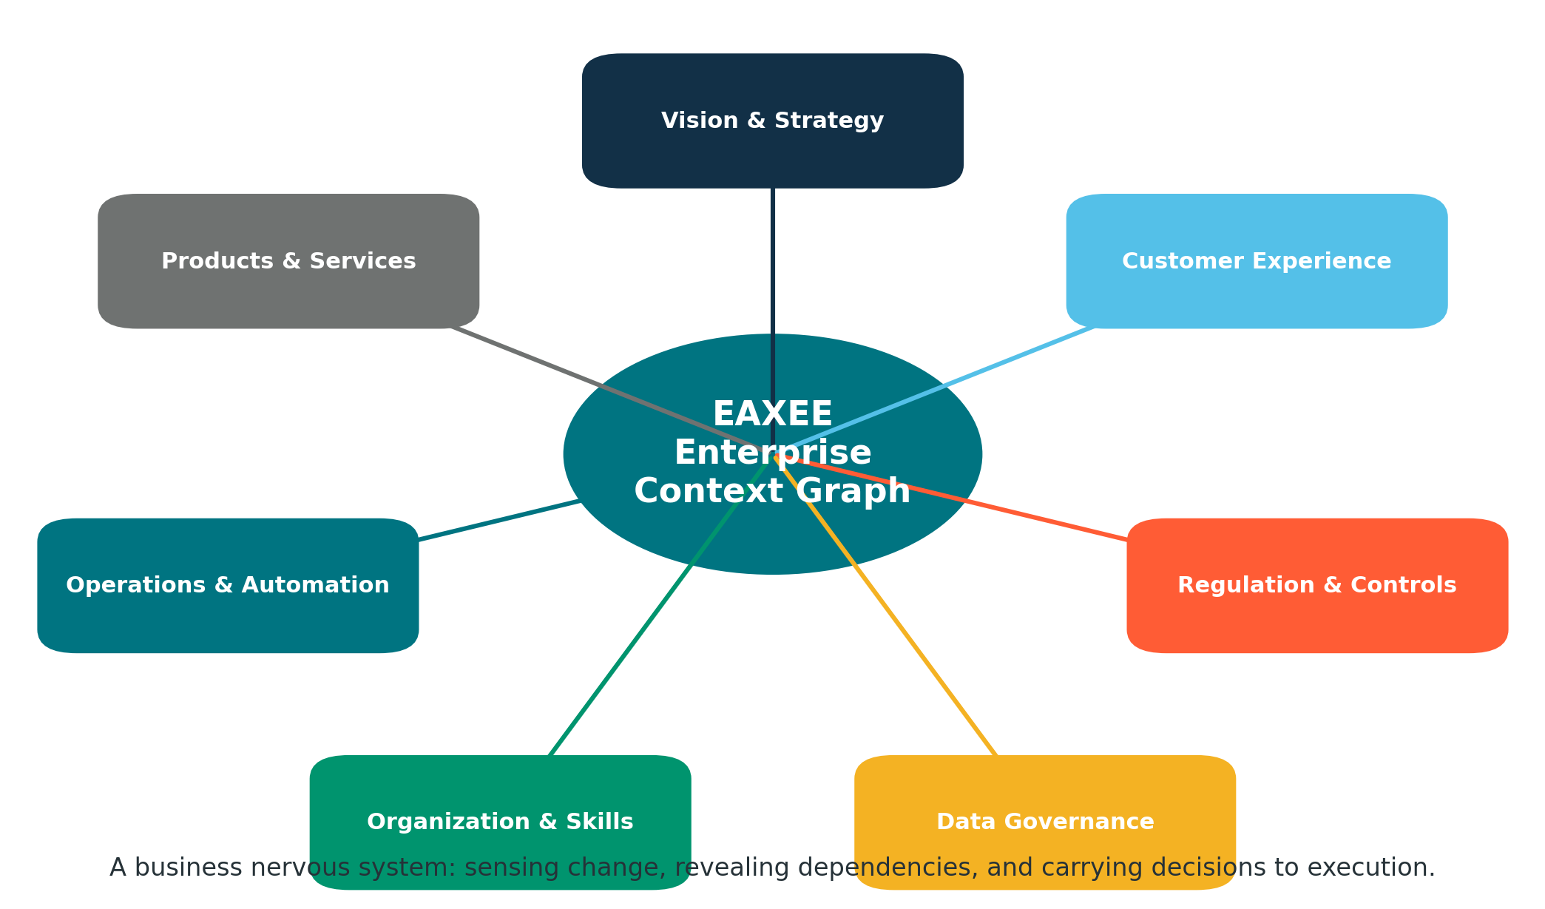
Figure 1. EAXEE as the connected business nervous system—not merely a technology inventory.

1. The Category Error
Calling enterprise architecture a technology discipline is a category error. It is comparable to calling finance a spreadsheet discipline or strategy a presentation discipline. Technology is highly visible in EA because it is expensive, interconnected and difficult to change. Yet the purpose of EA is not to describe technology for its own sake. Its purpose is to preserve enterprise coherence while the organization pursues value.
A useful test is to ask what an architecture decision actually changes. A decision to consolidate customer platforms changes process ownership, data definitions, channel experience, controls, cost allocation, vendor dependence, workforce skills and transformation sequencing. The application decision is only one layer of a larger business choice.

The business questions EA exists to answer
- Which capabilities must become stronger for the strategy to succeed?
- Which customer moments depend on fragile or fragmented operating arrangements?
- Where do regulations translate into policies, controls, processes, data obligations and evidence?
- Which transformations compete for the same people, platforms, data domains or change windows?
- Where is the organization paying twice for the same capability?
- What will break, become non-compliant or lose value when a major change is introduced?
- Who owns the outcome—not merely the system?
EAXEE gives these questions a common model. Strategy, capabilities, processes, organizations, information, applications, technologies, risks, controls, projects and outcomes can be represented as connected enterprise objects rather than isolated documents.

2. Digital Transformation: Architecture as the Missing Middle
Digital transformation often begins with a powerful sentence—“become more customer-centric,” “create a data-driven enterprise,” “automate operations,” “build a digital platform.” It then jumps quickly to programs, products and procurement. The missing middle is the architecture of change: the explicit chain between aspiration and the enterprise conditions required to realize it.
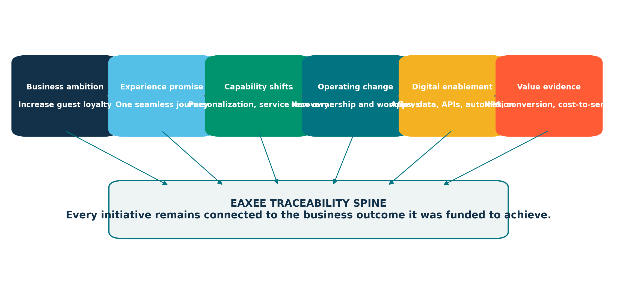
Figure 2. The vision-to-value traceability spine maintained in EAXEE.
EAXEE allows transformation leaders to trace an ambition through customer outcomes, capability changes, operating-model adjustments, information needs, digital services, platforms, projects and measurable benefits. This traceability changes the quality of governance. A steering committee can ask not only whether a project is on time, but whether the intended business capability is actually becoming stronger.

Example: “Create a seamless guest journey”
Without architecture, the statement may spawn separate initiatives for CRM, mobile, loyalty, contact center, identity, analytics and property systems. Each project may be locally sensible while the customer experience remains fragmented.
In EAXEE, the transformation can be modelled as one end-to-end footprint:
- The experience promise is connected to journey stages and measurable outcomes.
- Each journey stage is connected to the capabilities, processes and accountable teams that deliver it.
- The information required at each moment is mapped to authoritative data domains and sources.
- Applications, APIs and technology services are linked as enablers—not treated as the business outcome.
- Risks, controls, dependencies and projects are overlaid on the same model.
- Leaders can identify gaps, duplication, sequencing conflicts and weak ownership before implementation.
TAKEAWAY | Digital transformation fails less often from lack of technology than from lack of enterprise alignment. EAXEE gives alignment a visible structure.

3. Regulatory Compliance: From Requirement Lists to Evidence Architecture
Compliance programs frequently produce policies, control libraries, audit findings and remediation plans. What they often lack is an integrated view of where obligations live inside the operating enterprise.
Enterprise architecture provides that view. It connects a regulation to the business obligations it creates; obligations to policies and controls; controls to processes, roles, applications and data; and those assets to evidence, risks and accountable owners.
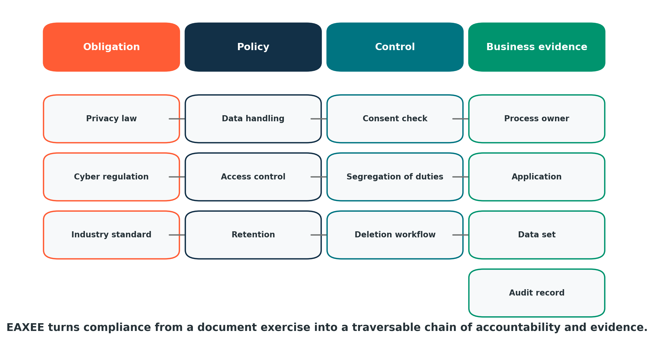
Figure 3. A compliance lattice in EAXEE: obligation to evidence, with ownership and operating context.

Why this matters
- Impact analysis becomes faster when a regulation changes.
- Control duplication becomes visible across functions and systems.
- Unowned obligations can be escalated before they become audit findings.
- Technology remediation can be prioritized by business and regulatory exposure.
- Audit evidence can be associated with the exact processes, data and systems it supports.
- Compliance becomes continuous architecture assurance rather than a periodic document chase.
EAXEE can become the reference environment where regulatory, risk, business and technology stakeholders work from the same evidence model. This is particularly valuable where privacy, cybersecurity, financial control, safety or industry regulation overlap.

4. Data Governance: Architecture Gives Data Its Business Meaning
Data governance becomes bureaucratic when it begins with tables, schemas and technical ownership. It becomes valuable when it begins with business meaning and decision consequence.
A data element is not important because it exists in a database. It is important because a business process, customer promise, regulatory obligation, management decision or AI model depends on it.
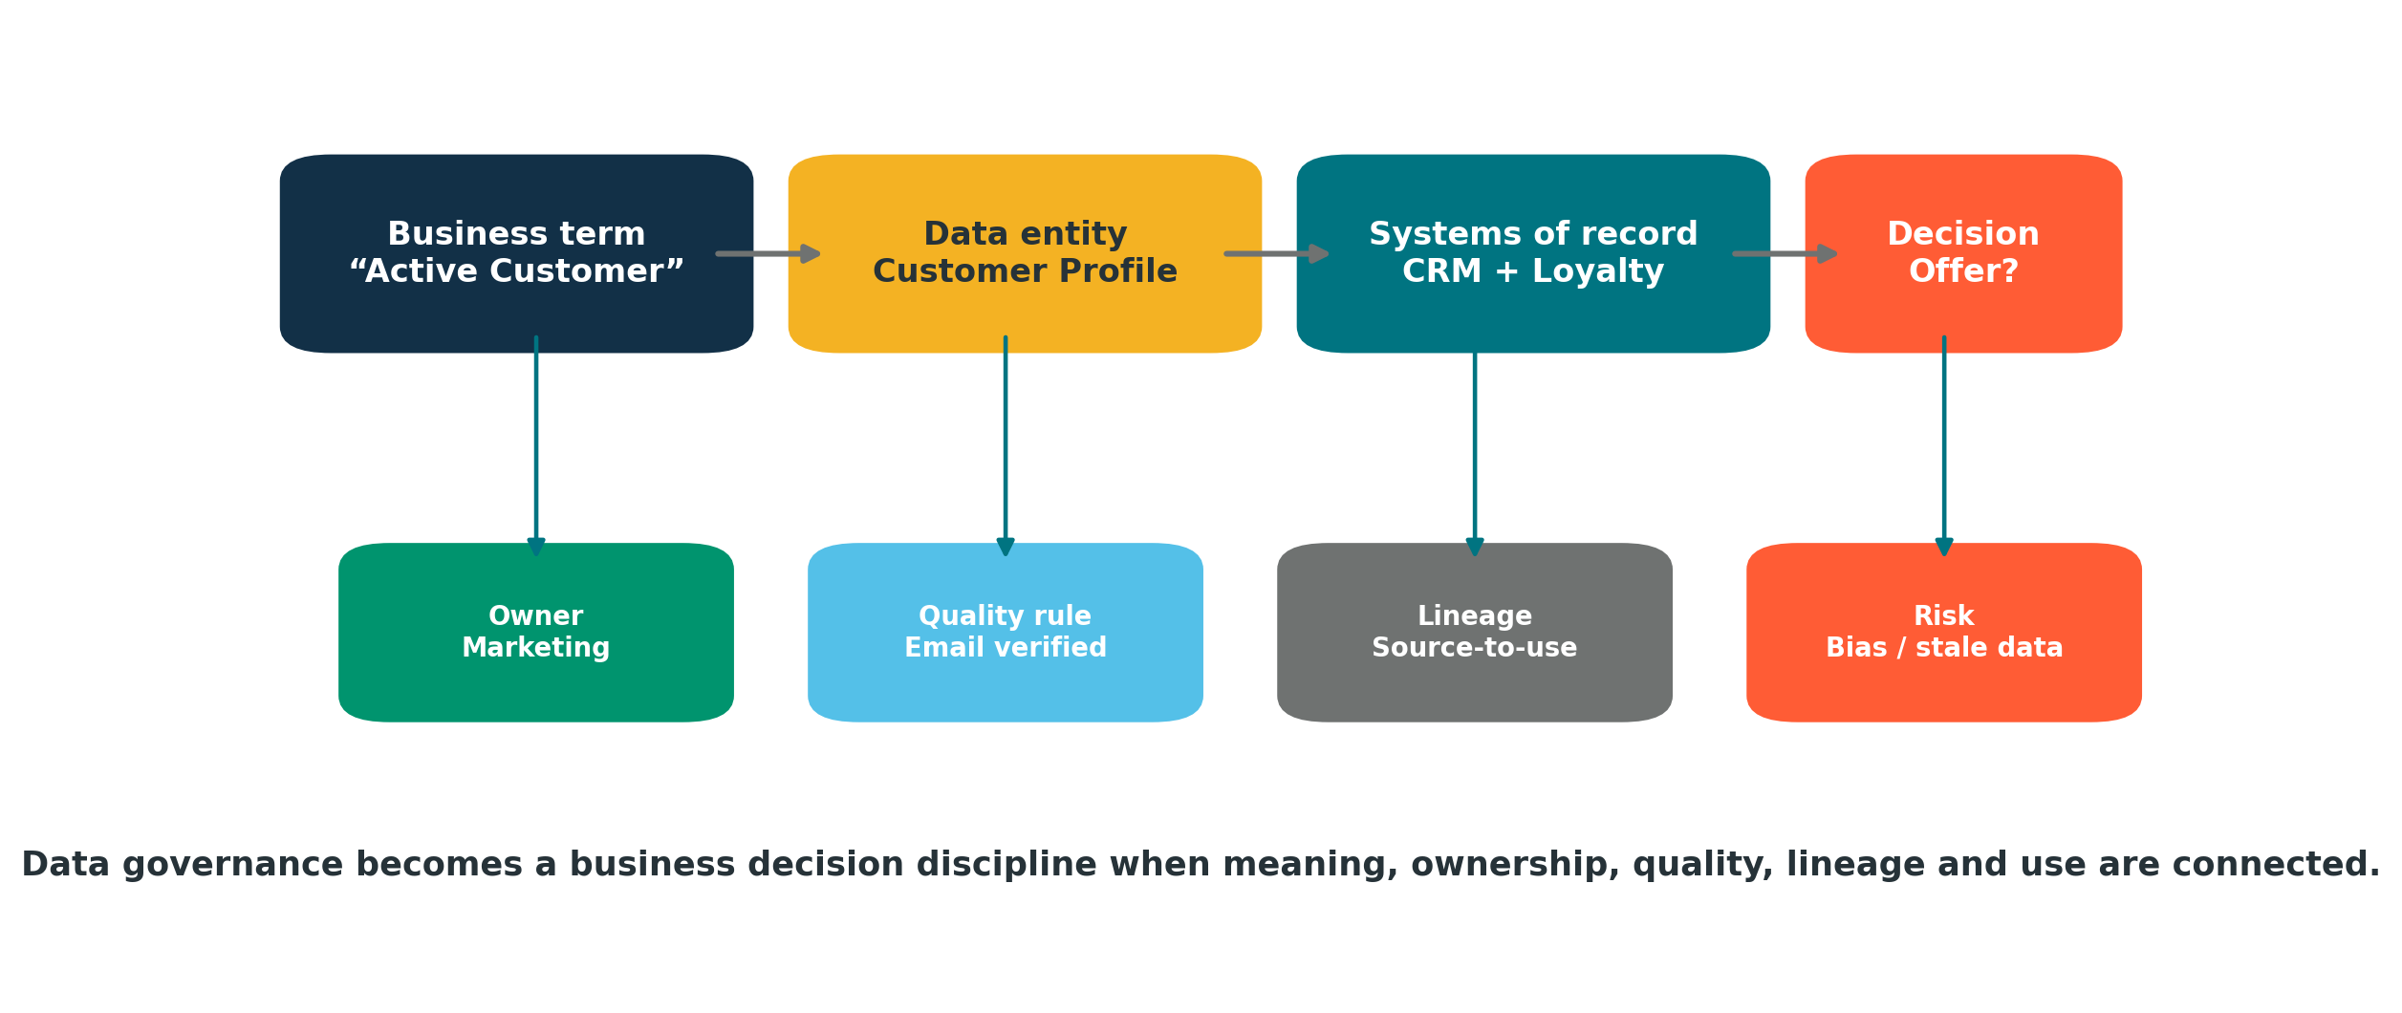
Figure 4. The data-to-decision chain: meaning, ownership, quality, lineage, use and risk.
EAXEE can connect business terms, data entities, owners, quality rules, systems of record, integrations, reports, decisions, controls and AI use cases. This creates a practical data-governance map rather than an isolated catalogue.

A different kind of data-priority question
Instead of asking, “Which data domains have the most quality issues?” leaders can ask, “Which quality issues threaten the most valuable customer journeys, regulated processes, strategic decisions or automation use cases?” That is a business architecture question—and EAXEE is designed to answer it through connected relationships.
NEW IDEA | Decision Lineage: trace a management decision backward to the data, rules, systems, processes and owners that shape it. This reveals where poor information can become poor action.

5. Customer Experience: See the Enterprise Behind the Moment
Customers encounter moments. Organizations operate systems. Enterprise architecture connects the two.
A failed check-in, delayed refund or inconsistent digital offer rarely belongs to one application. It may arise from fragmented ownership, duplicated customer data, a brittle integration, a manual handoff, an unresolved policy conflict or a capacity constraint. Customer-experience improvement therefore requires an end-to-end view beneath the visible journey.
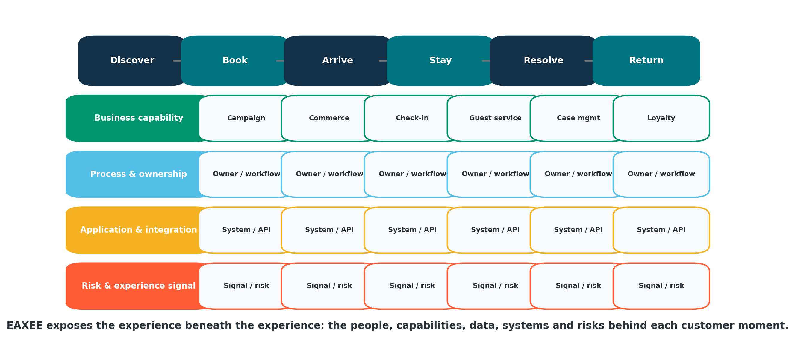
Figure 5. An EAXEE customer-experience X-ray across journey, capability, ownership, applications, data and risk.
With EAXEE, journey stages can be related to business capabilities, service standards, processes, roles, data, applications, interfaces, risks, controls and improvement initiatives. Experience teams can therefore see not only where customers feel friction, but the enterprise architecture producing that friction.

Example: service recovery
Suppose complaints are increasing even though the case-management platform is stable. EAXEE may reveal that the issue lies elsewhere: the contact center cannot see loyalty status; ownership changes at property boundaries; refund authorization is manual; and customer identity is inconsistent across channels. The architecture view reframes the problem from “fix the system” to “redesign the service.”

6. Strategic Change Management: Make the Organization Changeable
Most change plans explain milestones. Few explain the architecture of adoption.
A new digital service changes decision rights, roles, skills, operating procedures, measures, customer communication, data responsibilities and support arrangements. When these dependencies are invisible, transformation teams discover them late—usually as resistance, delay or operational failure.
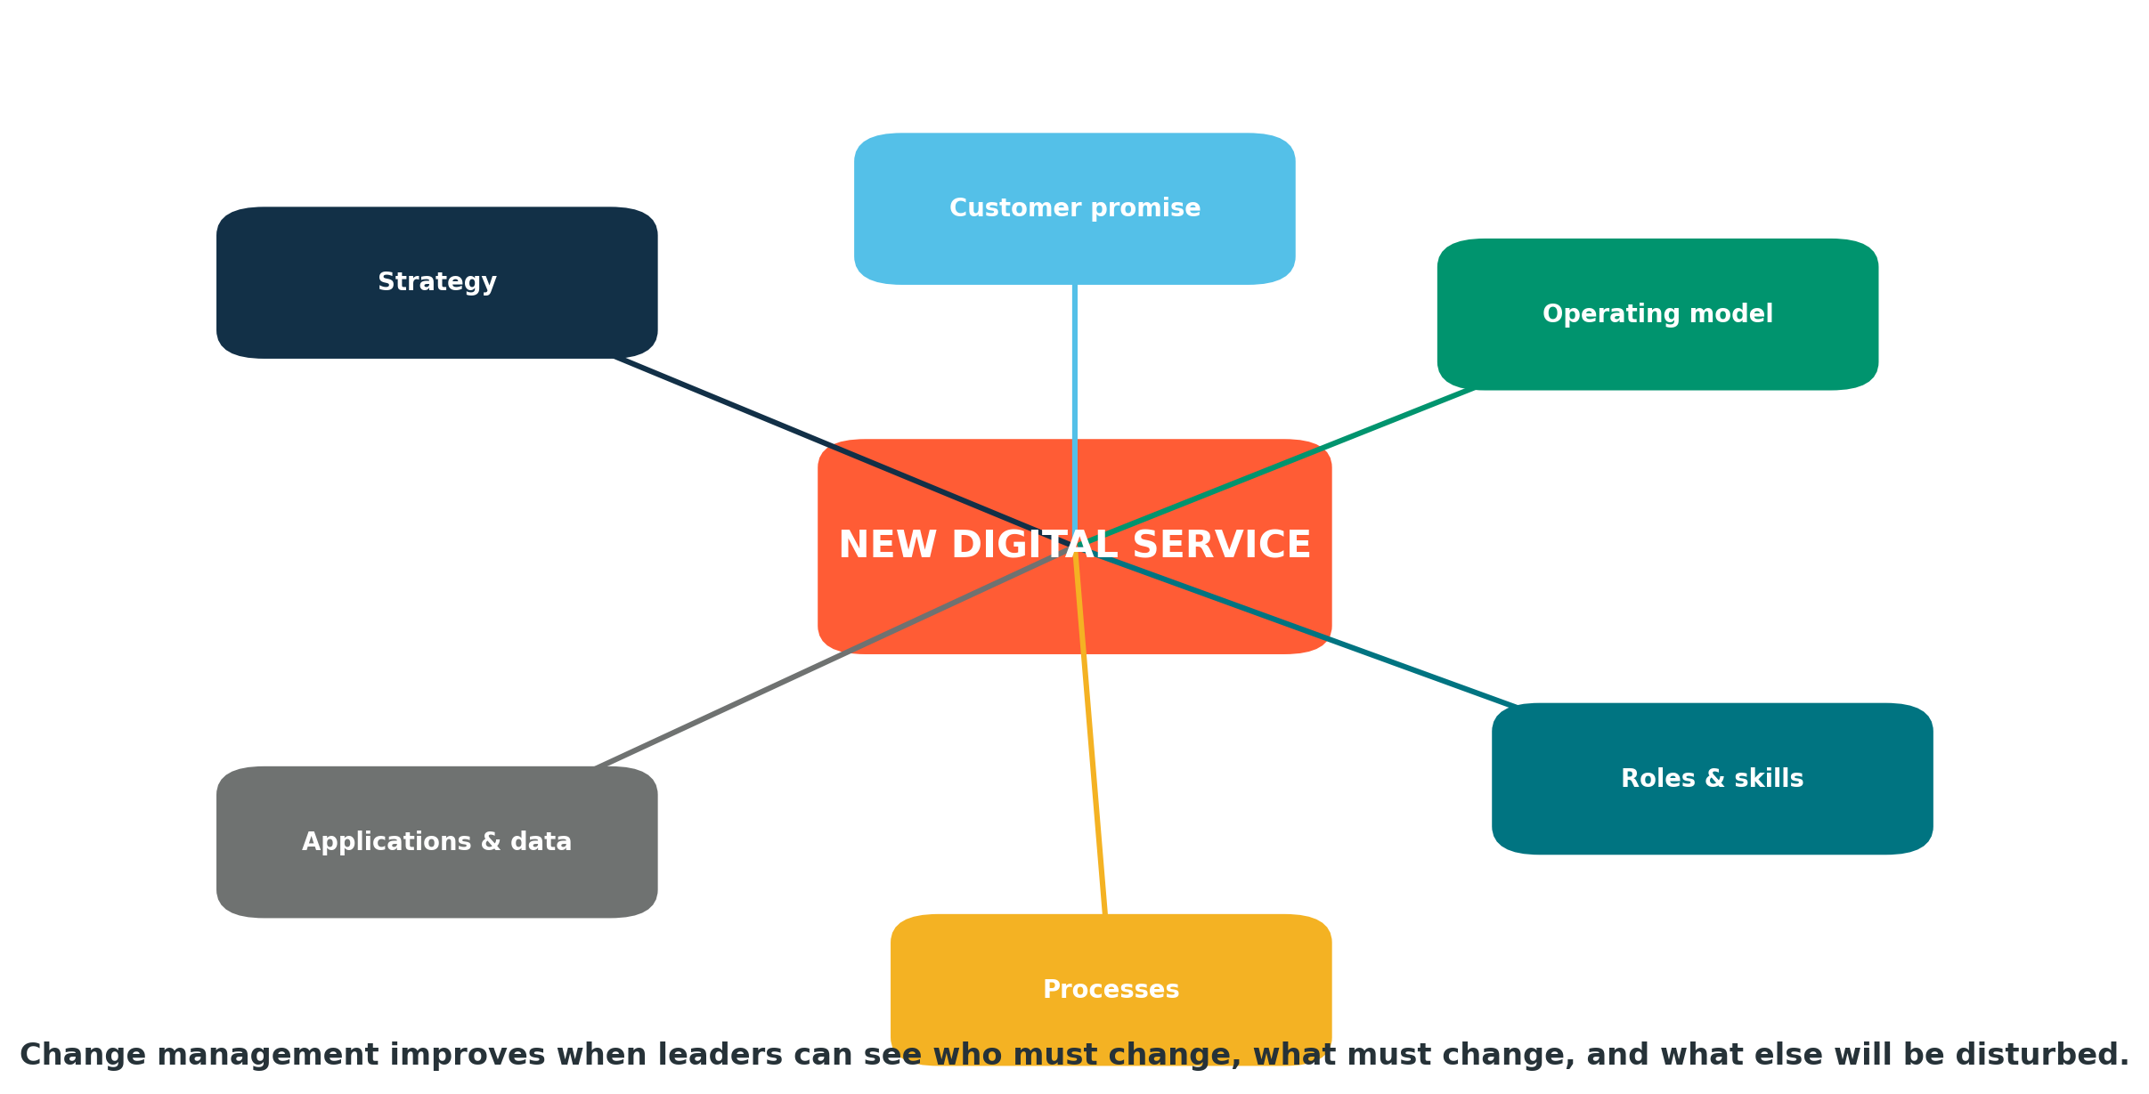
Figure 6. An EAXEE change footprint showing the organizational and operating consequences around a digital initiative.

EAXEE supports change management in three practical ways
- Change radius: identify every organization unit, role, process, policy, system and data domain touched by an initiative.
- Change collision: reveal where multiple programs demand simultaneous changes from the same teams or assets.
- Change readiness: associate target capabilities with skills, ownership, process maturity and enabling conditions.
This creates a stronger conversation between enterprise architects, transformation offices, HR, communications, operations and program leaders. The focus shifts from announcing change to engineering adoption.

7. Organizational Awareness: The Enterprise That Can Explain Itself
Organizations accumulate knowledge unevenly. A few experienced people know how critical services really work, which workarounds exist, why a policy was written, where customer data originates, which integration is fragile and which vendor contract creates hidden dependence. When those people move, the enterprise forgets.
EAXEE helps institutionalize this knowledge as a connected and governed enterprise model. The model becomes a form of organizational awareness: a navigable map of what the enterprise does, why it does it, who owns it, what enables it and what depends on it.

From repository to organizational memory
- New leaders can understand their business area through capability, process, data and system footprints.
- Project teams can discover existing assets and avoid recreating solutions.
- Risk teams can identify hidden concentrations and single points of dependency.
- Business owners can see where accountability is incomplete or contradictory.
- AI assistants can use governed enterprise context rather than generic or fragmented content.
- Mergers, reorganizations and outsourcing decisions can be evaluated against an explicit operating model.
OUT-OF-THE-BOX CONCEPT | Enterprise Explainability: the ability of an organization to answer, with evidence, how a strategic outcome is produced and what would be affected by changing it.

8. Beyond Technology: Ten Business Uses of Enterprise Architecture
Business concern | Architecture question | How EAXEE helps
Strategy execution | Which capabilities and operating changes make the strategy real? | Connects objectives, capabilities, initiatives, owners and measures.
Digital transformation | Are projects producing a coherent target enterprise? | Maps current, target and transition states with dependencies.
Regulatory compliance | Where does each obligation operate and who is accountable? | Links requirements, controls, processes, data, systems and evidence.
Data governance | Which data matters to which decisions and outcomes? | Connects meaning, ownership, quality, lineage and use.
Customer experience | What enterprise conditions create each customer moment? | Maps journeys to capabilities, processes, data, applications and risks.
Change management | Who and what must change together? | Calculates change footprints and exposes collisions.
Operational resilience | Which business services depend on fragile assets or suppliers? | Traces critical services through people, process, data and technology.
Cost optimization | Where are we paying twice or carrying low-value complexity? | Reveals duplicated capabilities, applications, contracts and platforms.
M&A integration | What should be absorbed, connected, preserved or retired? | Compares business and technology architectures across entities.
AI enablement | What trusted enterprise context should AI reason over? | Provides a governed semantic graph of enterprise knowledge.

9. EAXEE: The Commercial Proposition
EAXEE should not be evaluated as another diagramming tool. Its commercial value lies in turning fragmented enterprise knowledge into a decision environment.
The platform provides a configurable metamodel for representing business and technology concepts, relationships and attributes. Organizations can reflect their own operating language rather than forcing every question into a fixed taxonomy. The resulting repository can support architecture views, impact analysis, traceability, dashboards, collaboration, governance workflows, imports, reports and AI-assisted exploration.

What potential buyers are really procuring
- A shared language for strategy, operations, data, risk, transformation and technology.
- A connected evidence base for executive and governance decisions.
- A controlled way to expose dependencies before change is approved.
- A durable organizational memory that survives project closure and staff movement.
- A foundation for AI grounded in enterprise-specific context.
- A mechanism for reducing duplication, delay, blind risk and transformation waste.

The EAXEE difference: context before content
Most organizations have more content than they can govern: policies, process maps, project documents, inventories, spreadsheets, standards, audit reports and presentations. EAXEE adds what the content usually lacks—context. It identifies what each item describes, how it relates to other elements, who owns it, what decisions depend on it and where it sits in the wider enterprise.

10. The Executive Cockpit: From Architecture to Action
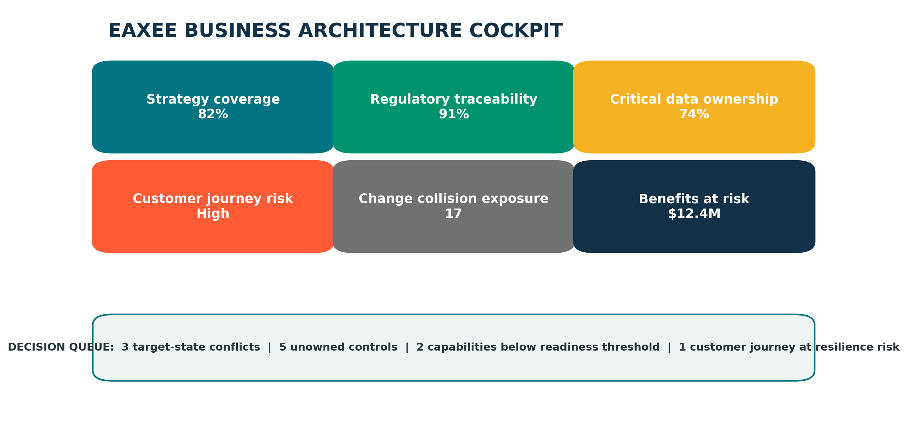
Figure 7. An illustrative EAXEE business architecture cockpit for executive governance.
Architecture becomes commercially meaningful when it changes decisions. EAXEE dashboards can be designed around questions such as:
- How much of the strategy is supported by funded and owned capability change?
- Which customer journeys carry the highest operational or data risk?
- Where are regulatory controls unowned, duplicated or dependent on obsolete systems?
- Which transformation initiatives compete for the same capability, team, platform or implementation window?
- Which critical services depend on single suppliers, fragile integrations or end-of-life technology?
- Which expected benefits are unsupported by measurable architecture change?
The aim is not to place more diagrams in front of executives. It is to place better evidence behind executive choices.

11. New Measures for a Business-Architecture Era
Traditional EA metrics—number of models, standards published, applications catalogued—measure activity. Business-oriented EA requires measures that reveal decision quality and enterprise coherence.
STRATEGIC TRACEABILITY COVERAGE | The percentage of strategic objectives connected to capabilities, initiatives, accountable owners and measurable outcomes.

ENTERPRISE EXPLAINABILITY INDEX | The percentage of critical outcomes for which the organization can trace the full enabling chain.

CHANGE COLLISION EXPOSURE | The concentration of simultaneous change across shared teams, platforms, data domains and processes.

CONTROL EVIDENCE COMPLETENESS | The percentage of material controls connected to operating evidence and accountable owners.

CUSTOMER JOURNEY ARCHITECTURE RISK | The weighted exposure of journey stages to weak ownership, poor data, fragile integration or obsolete technology.

CONTEXT REUSE DIVIDEND | The time and cost avoided when governed enterprise knowledge is reused across projects, audits, AI use cases and decisions.

ARCHITECTURE DEBT VELOCITY | The rate at which unmanaged exceptions and structural complexity are growing or being retired.

BENEFIT CONFIDENCE | The strength of evidence connecting transformation expenditure to actual capability and outcome change.

12. A Practical Adoption Path
The strongest EA programs do not begin by modelling the entire enterprise. They begin with a decision that matters.
- Choose one high-value business question—for example, customer journey risk, regulatory traceability, application rationalization or transformation collision.
- Define the minimum set of concepts and relationships required to answer it.
- Load and validate the relevant business, data, application, technology, risk and project information in EAXEE.
- Create one decision view for executives and one working view for domain owners.
- Embed the model in an actual governance process, such as investment approval, architecture review, risk acceptance or transformation planning.
- Measure whether the model improved speed, confidence, cost, risk or outcome quality.
- Expand only where reuse value is proven.
ADOPTION PRINCIPLE | Do not build an architecture library and hope the business visits. Build a business decision service that happens to be powered by architecture.

13. Lessons for Leaders

Start with consequence, not completeness.
The best first architecture question is the one tied to a costly decision, material risk or visible customer problem.

Model ownership as carefully as systems.
An unmapped owner is often more dangerous than an unmapped application.

Treat relationships as first-class data.
The value of EAXEE is not the list of objects. It is the network of dependencies and meaning between them.

Give business language priority.
Capabilities, outcomes, journeys, obligations and decisions should lead; technology should explain enablement.

Create views for decisions, not audiences.
A useful view answers a question and prompts an action. A decorative view simply looks complete.

Govern freshness.
An outdated architecture can be more dangerous than no architecture because it creates false confidence.

Use AI only after context is governed.
AI becomes more useful when it can reason over trusted enterprise relationships rather than disconnected documents.

Make architecture part of management cadence.
EA should appear in portfolio reviews, risk decisions, transformation governance, data councils and service resilience—not only architecture boards.

14. The Buyer’s Question
The procurement question is not, “Do we need an EA tool?”
The more valuable question is:
“How much are we currently paying for decisions made without a connected understanding of the enterprise?”
The cost appears in duplicated investments, regulatory surprises, failed integrations, transformation delays, inconsistent customer experiences, fragile operations, repeated discovery work and institutional knowledge loss. EAXEE addresses that cost by making enterprise context visible and reusable.

Procurement evaluation prompts
- Can the platform represent our business language and metamodel—not only a fixed technology taxonomy?
- Can users traverse from strategy and customer outcome to process, data, application, technology, risk and initiative?
- Can it expose impact and dependency without manually assembling new presentations each time?
- Can ownership, evidence, lifecycle, risk and cost be governed alongside architecture structure?
- Can multiple stakeholder groups contribute without losing consistency and control?
- Can the repository support dashboards, decisions, transformation planning and AI-assisted exploration?
- Can the organization begin with one use case and scale into a broader enterprise knowledge system?

Conclusion: Architecture Is How the Business Becomes Deliberate
Enterprise architecture is not the art of drawing the technology estate. It is the discipline of making the enterprise deliberate.
It gives leaders a way to see how strategy, customers, capabilities, operations, data, obligations, people, technology, risk and investment combine to produce outcomes. In a world of continuous digital change, that combination must be understood before it can be governed—and governed before it can be transformed safely.
EAXEE provides the software foundation for that work. It turns architecture from specialist knowledge into organizational intelligence; from static documentation into connected evidence; and from a technology conversation into a business capability for change.
The future enterprise will not be the one with the most technology. It will be the one that can understand itself quickly enough to change with confidence.
EAXEE ENTERPRISE ARCHITECTURE SOFTWARE
Make the enterprise visible. Make change governable. Make decisions connected.

