EAXEE THOUGHT LEADERSHIP SERIES

Stop Managing Systems
  - A plainspoken case for business-capability intelligence with EAXEE

Voice: direct, conversational and business-first — written to be readable by executives who do not identify as architects.

Enterprise architecture for decisions that matter

Let us start with a simple observation
Customers do not buy applications. Regulators do not regulate servers. Employees do not perform “technology stacks.” The business succeeds through abilities: serving a guest, settling a payment, maintaining an asset, onboarding a supplier, protecting information, launching a product and responding to disruption.
Those abilities are business capabilities. They are a more durable way to understand the enterprise than organization charts, project lists or application inventories. EAXEE helps organizations manage through capability by connecting each ability to strategy, operating design, information, technology, investment, risk and measurable results.
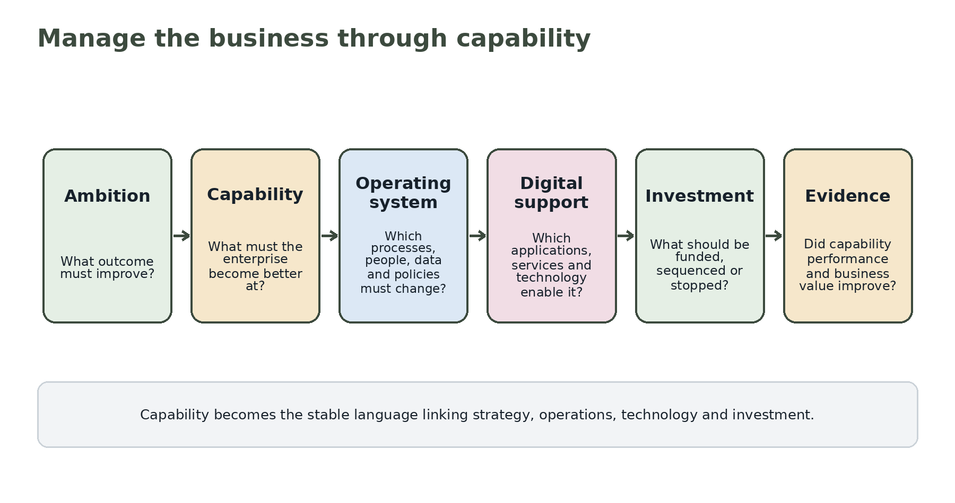
Figure 1. Capability as the bridge from ambition to evidence.

Why capabilities matter
Organization structures change. Processes are redesigned. Applications are replaced. A capability such as Revenue Forecasting or Guest Disruption Recovery remains recognizable because it describes what the enterprise must be able to do. This stability makes capability a useful anchor for long-term planning and cross-functional decisions.
“A capability map is not the answer. The answer is knowing which capabilities matter, why they struggle and what must change around them.”

What EAXEE adds to capability thinking
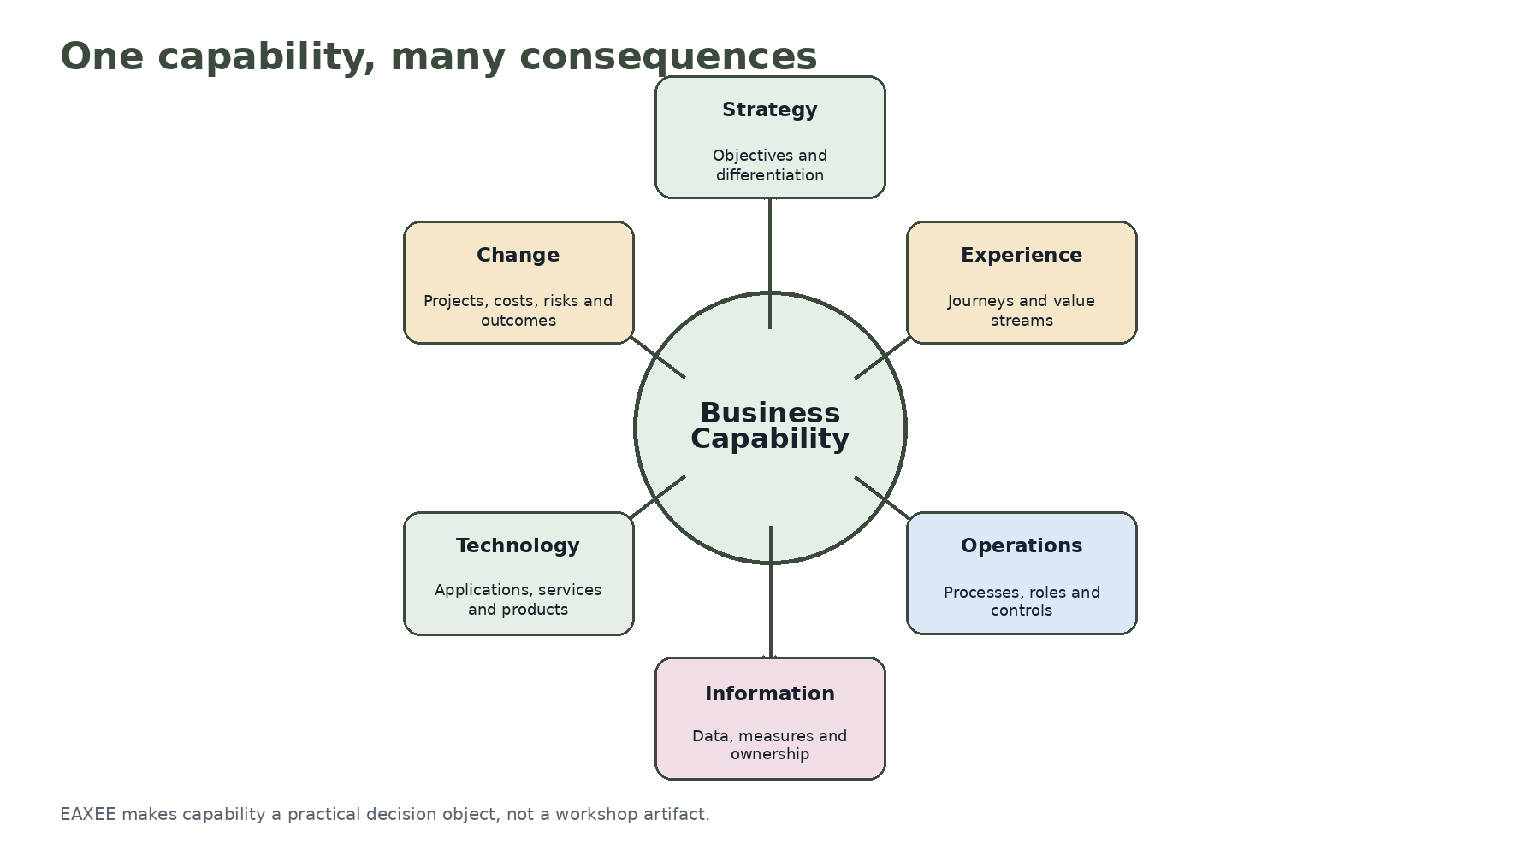
Figure 2. One capability connected to six decision domains.
Many capability exercises stop at a coloured heat map. EAXEE turns the capability into a connected decision object. Leaders can open a capability and see its strategic importance, customer journeys, processes, owners, policies, data, applications, technology, risks, costs, projects and performance measures.

The questions business leaders actually ask
Question | How EAXEE helps
Where should we invest? | Compares capability importance, performance, enablement weakness and change load
Why is this customer outcome poor? | Traces the journey to process, ownership, data and application constraints
Are we over-investing in technology? | Compares technology spend with capability priority and fitness
Where are we dependent on one supplier or skill? | Reveals concentration within critical capability footprints
Which programs are changing the same part of the business? | Shows shared capability and asset impact across initiatives
What will a policy or regulatory change affect? | Traces obligations through capabilities, processes, data and systems

Capability Confidence
A capability can be strategically important and still unreliable. Capability Confidence is a composite view of the conditions needed for dependable performance: clear ownership, effective process, suitable skills, trusted data, fit applications, resilient technology, adequate controls and manageable change. EAXEE can hold and visualize these conditions without pretending they are one-dimensional.
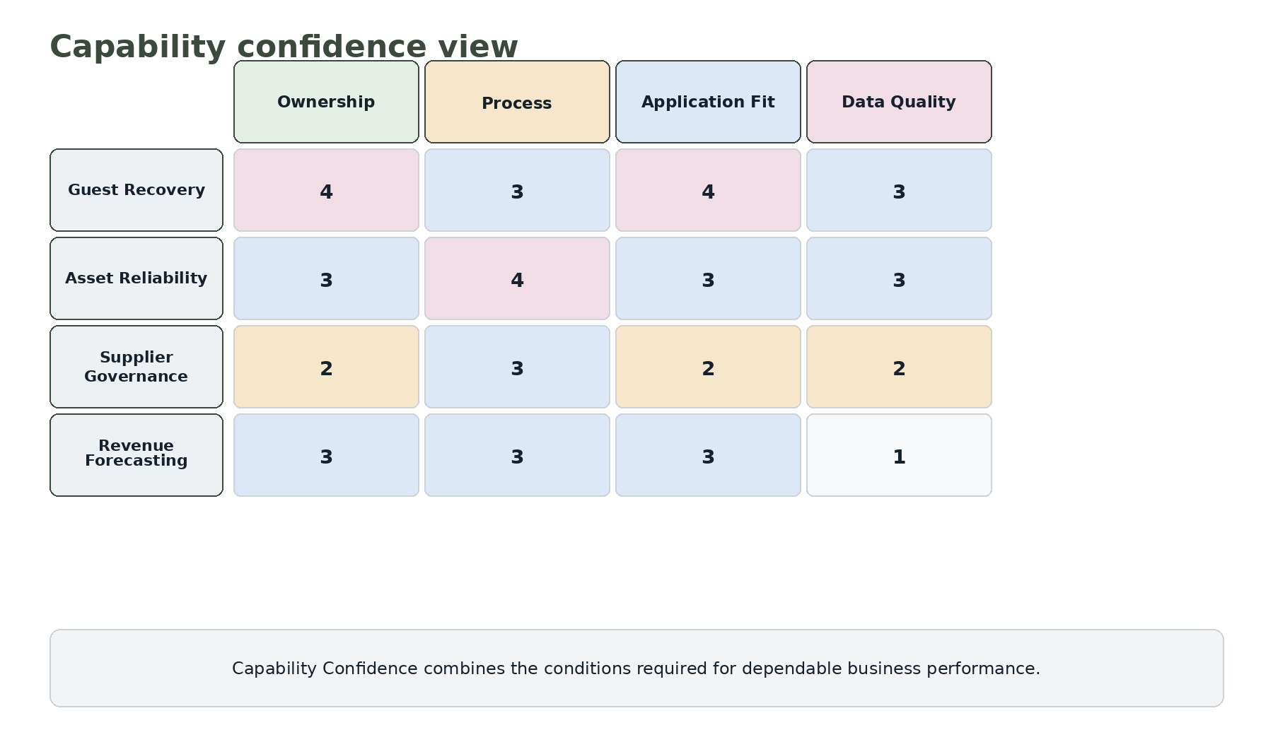
Figure 3. Illustrative Capability Confidence view.

A better way to prioritize change
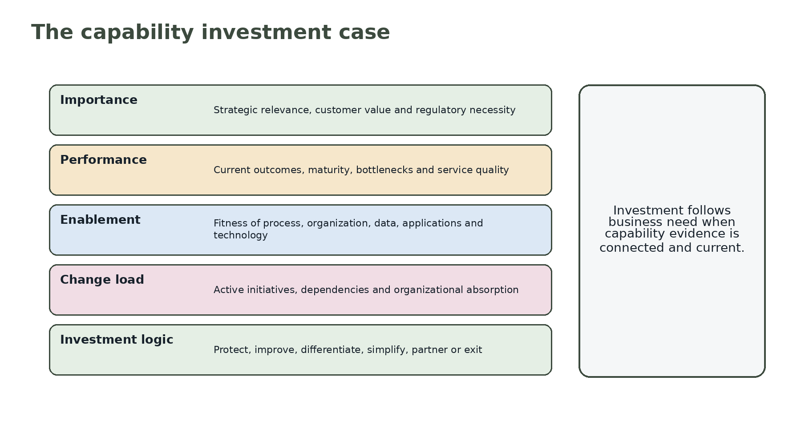
Figure 4. The capability investment case.
Investment choices become clearer when framed around capability. A capability may need protection because it is critical and already performs well. It may need improvement because it is important but weak. It may deserve differentiation because it shapes customer value. It may need simplification because fragmented enablement creates cost without advantage. Or it may be a candidate for partnership because external provision is strategically sensible.

Example: guest disruption recovery
A complaint about slow recovery after a transport disruption could trigger an application project. EAXEE broadens the view. It shows the complete capability: event detection, guest identification, entitlement rules, transport coordination, service-credit approval, communication channels, employee roles, partner interfaces and performance measures. The organization may discover that the largest constraint is not software but fragmented decision rights and inconsistent data.

Example: regulatory compliance
A new obligation may appear to require a system change. By tracing the affected capability, EAXEE reveals policies, processes, data ownership, control operation, reporting and evidence. Technology remains part of the solution, but the organization avoids treating a business obligation as a software requirement alone.

Example: artificial intelligence
AI use cases become more credible when attached to capability gaps. Instead of asking where AI can be deployed, leaders ask which high-value capability is constrained by information, decision speed or manual effort. EAXEE then connects the use case to data, processes, applications, risks and accountable owners. AI becomes a business intervention rather than a technology search exercise.

Five mistakes to avoid
- Do not build a capability map and leave it disconnected from the repository.
- Do not score capability maturity without recording evidence and ownership.
- Do not confuse capability with department; several units may contribute to one capability.
- Do not fund applications without showing which capability outcomes they improve.
- Do not treat every capability as equally strategic; differentiate, protect, standardize and partner deliberately.

A practical operating rhythm
Moment | Capability-led decision
Strategy cycle | Which capabilities must change to deliver the strategy?
Portfolio planning | Where do investment and change load align or conflict?
Architecture review | Does the proposed design improve the intended capability?
Business review | Which capability constraints explain performance results?
Risk review | Which critical capabilities carry unacceptable dependency or control exposure?
Benefits review | Did capability performance improve after the investment?

Why buyers should care about EAXEE
EAXEE offers more than capability mapping. It provides the connected repository, relationship traversal, analytical views and governance context needed to manage capabilities over time. It can serve executives, business architects, transformation teams, risk functions, data leaders and technology teams without forcing each group to maintain a separate version of the enterprise.
“Stop asking which system should be replaced. Start by asking which business ability must improve — and what is preventing it.”

Conclusion
Business-capability intelligence gives leaders a stable, understandable and decision-ready view of the enterprise. EAXEE makes that view actionable by connecting what the business must do with how it operates, what enables it, what threatens it and what is being changed. That is how enterprise architecture moves from diagrams to management.

