EAXEE THOUGHT LEADERSHIP SERIES

The Enterprise Before It Happens
  - EAXEE and the organizational digital twin as a rehearsal space for consequential change

Voice: visionary, reflective and scenario-led — written as a future-facing essay rather than a conventional product paper.

Enterprise architecture for decisions that matter

Imagine seeing the consequences before living through them
Organizations routinely commit to futures they have never assembled. A strategy is approved in one room. Programs are mobilized in another. Technology choices are made elsewhere. Operating-model changes arrive later, often after contracts and timelines have narrowed the available options. The organization discovers the future by entering it.
An organizational digital twin changes that sequence. It creates a disciplined representation of the enterprise across time: the observed present, the committed future, the unstable transition between them and the alternative futures still available. EAXEE provides the connected architecture needed to make that twin useful, governable and continuously revisable.
“A transformation plan is a promise. A transformation twin is the evidence showing whether the promise can survive contact with the enterprise.”
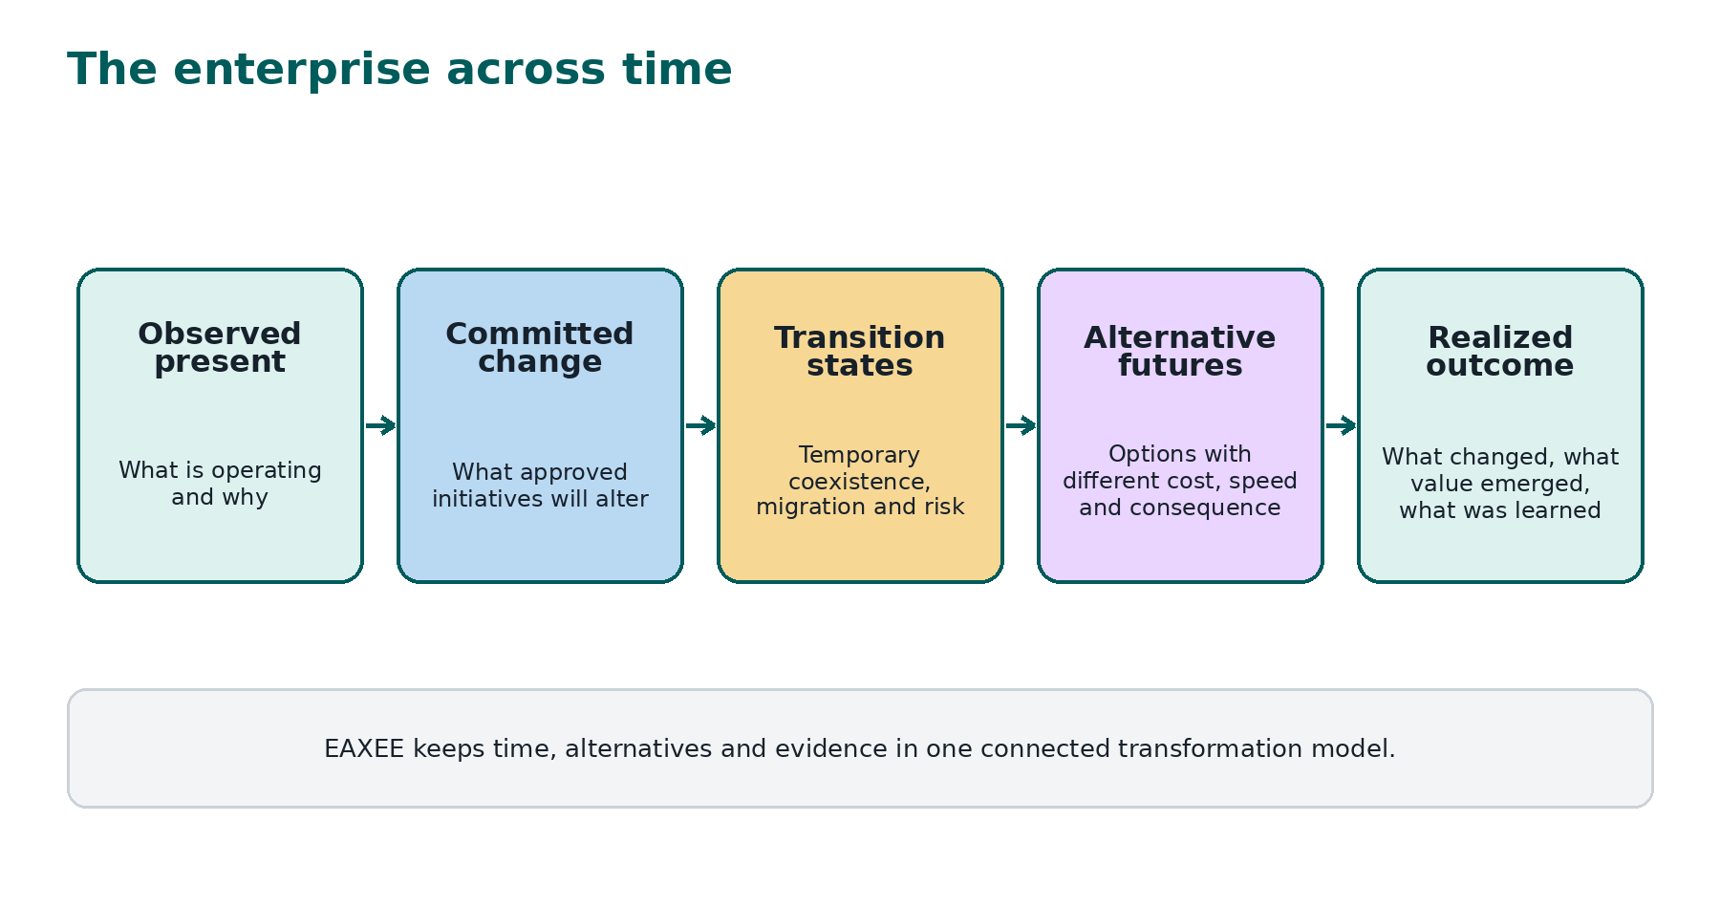
Figure 1. The enterprise represented across time.

I. A twin is not a mirror
A mirror reflects what stands before it. A useful twin explains why the enterprise behaves as it does and how that behavior may change. It links purpose to operating structures, information, digital services, physical assets and active change. It also preserves assumptions, decisions and uncertainty. EAXEE supplies the semantic relationships that turn a collection of models into a coherent rehearsal environment.
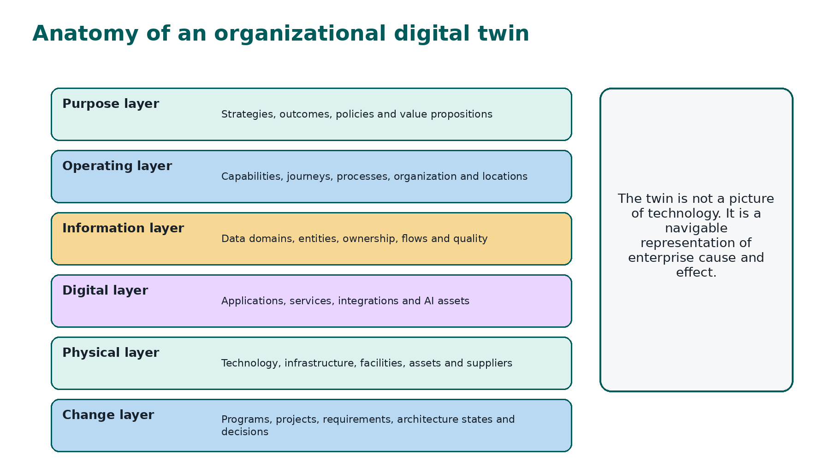
Figure 2. The layered anatomy of an organizational digital twin.

II. What leaders can rehearse
- A merger before systems and operating models are combined.
- A platform replacement before migration waves and transition controls are fixed.
- A regulatory change before obligations are translated into process, data and application impact.
- A new customer proposition before the supporting journey, capability and service footprint is funded.
- A resilience response before an outage exposes hidden single points of failure.
- A cost-reduction program before savings decisions remove critical capability or increase operational fragility.

III. Four clocks of transformation
Every transformation runs on several clocks at once. The strategy clock defines urgency. The delivery clock defines milestones. The operating clock defines when people, controls and processes can absorb change. The technology clock defines lifecycle, capacity and migration constraints. EAXEE places these clocks in the same model so that a target date is tested against readiness rather than merely announced.
Clock | Typical question | EAXEE evidence
Strategy | When must the outcome become visible? | Objectives, outcomes, external commitments and value measures
Delivery | What can be built and sequenced? | Projects, dependencies, milestones, requirements and decisions
Operations | When can the business adopt safely? | Processes, roles, controls, locations, training and continuity
Technology | What must coexist, migrate or retire? | Applications, data, integrations, products, infrastructure and lifecycle

IV. Scenario intelligence, not scenario theatre
Scenario workshops often generate attractive slides but weak institutional memory. EAXEE makes scenarios persistent objects. Each option can carry assumptions, architecture states, affected capabilities, cost ranges, risk exposure, decision points and triggers for reconsideration. When facts change, the scenario can be recalculated rather than forgotten.
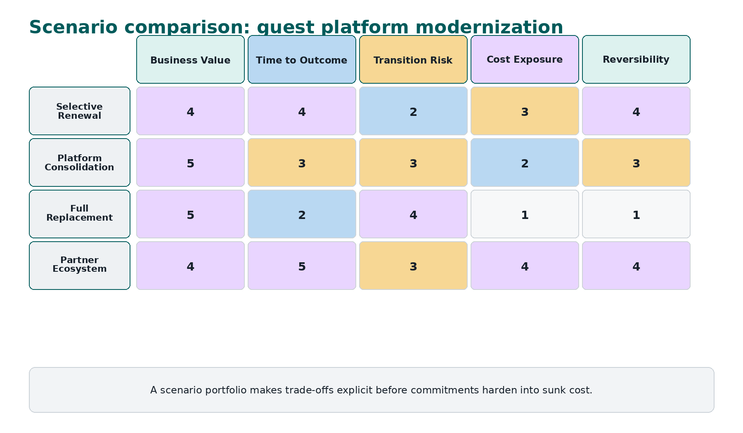
Figure 3. Illustrative scenario portfolio for a guest platform.
The value is not a single “winning score.” It is the clarity of trade-offs. Selective renewal may deliver speed with limited disruption but preserve fragmentation. Consolidation may improve long-term economics while increasing transition risk. Full replacement may create strategic freedom but reduce reversibility. A partner ecosystem may accelerate innovation while increasing dependency and data-governance complexity.

V. Decision rehearsal
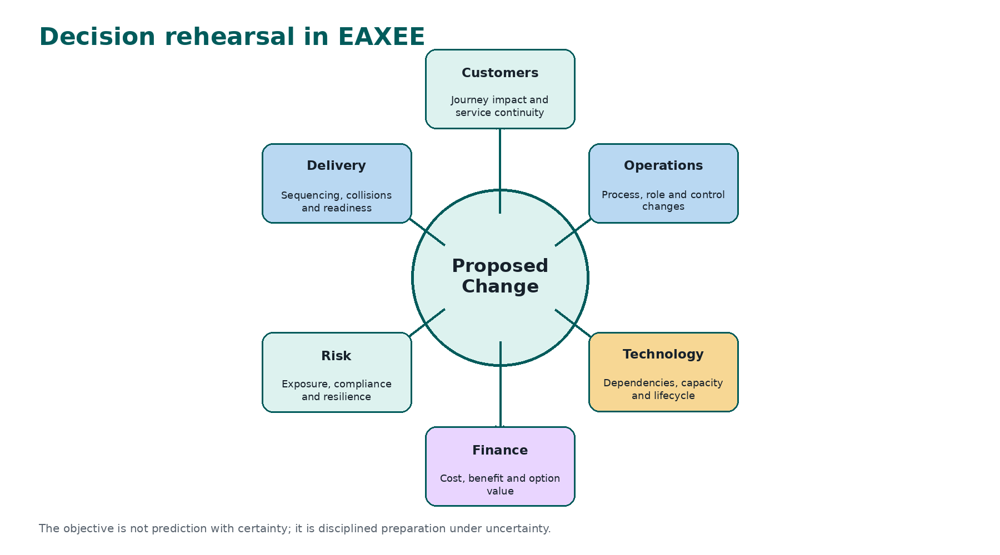
Figure 4. A proposed change examined through six consequence lenses.
Decision rehearsal is the practice of walking a proposed change through its enterprise consequences before the organization commits. EAXEE allows planners to ask not only what the target architecture looks like, but what temporary states must exist, which controls weaken during migration, which customer journeys are exposed and which other programs compete for the same people or assets.

VI. New measures for a twin-enabled enterprise
Measure | Meaning | Why it matters
Twin Confidence | Completeness, freshness, ownership and validation of the evidence supporting a scenario | Prevents false precision
Transition Risk Window | Duration and severity of temporary exposure during coexistence or migration | Makes temporary architecture governable
Option Value | Value of preserving the ability to change course later | Counters irreversible early commitments
Change Collision Density | Concentration of initiatives affecting the same capability, asset or team | Reveals overload before delivery failure
Outcome Traceability | Strength of the chain from investment to strategic and operational results | Protects value during execution

VII. Example: a destination-wide digital identity
Suppose an organization considers a unified identity for guests, employees and partners. The twin can compare a shared platform, federated identities and a phased hybrid. It reveals customer experience benefits, privacy obligations, access-control dependencies, legacy integration needs, supplier constraints, migration windows, operational fallback and the consequences of identity failure. The decision becomes a structured choice among futures rather than a contest between product presentations.

VIII. How EAXEE creates commercial advantage
- Fewer expensive surprises because hidden dependencies surface earlier.
- Faster option comparison because enterprise context is reused rather than reconstructed.
- Better executive dialogue because strategy, operations, finance, risk and technology evaluate the same scenario.
- More adaptive transformation because assumptions and triggers remain visible after approval.
- Stronger institutional learning because realized outcomes can be compared with the future that was originally imagined.

IX. A practical adoption path
Begin with one consequential decision, not an ambition to model everything. Define the decision horizon, identify the minimum enterprise footprint, connect current and target states, record assumptions and create two or three genuine alternatives. Use the outcome to improve the metamodel, ownership and data feeds. The twin becomes valuable through repeated decisions, not through repository population alone.
“The future cannot be made certain. It can, however, be made visible enough to govern.”

Conclusion
EAXEE enables the organization to encounter transformation first as a model, then as a decision and only then as an operational reality. That sequence does not eliminate uncertainty. It converts uncertainty into choices, assumptions, evidence and preparedness. The enterprise before it happens becomes a place leaders can inspect, challenge and improve.

