EAXEE THOUGHT LEADERSHIP SERIES

The Hidden Tax on Transformation
  - A CFO-minded case for application rationalization, technical-debt economics and EAXEE

Voice: financially literate, evidence-heavy and commercially direct — written for CFO, CIO, procurement and transformation leaders.

Enterprise architecture for decisions that matter

The number on the invoice is not the cost
Application portfolios carry a hidden tax. It appears in duplicate licences, slow releases, specialist contractors, repeated interfaces, fragile controls, data reconciliation, cyber remediation and projects that spend more effort navigating the existing estate than creating new value. Most of this tax is distributed across budgets, which is why it survives.
EAXEE makes the tax attributable. By connecting applications to capabilities, processes, data, integrations, technology, suppliers, risks, costs and change initiatives, it reveals the enterprise economics of architecture decisions.
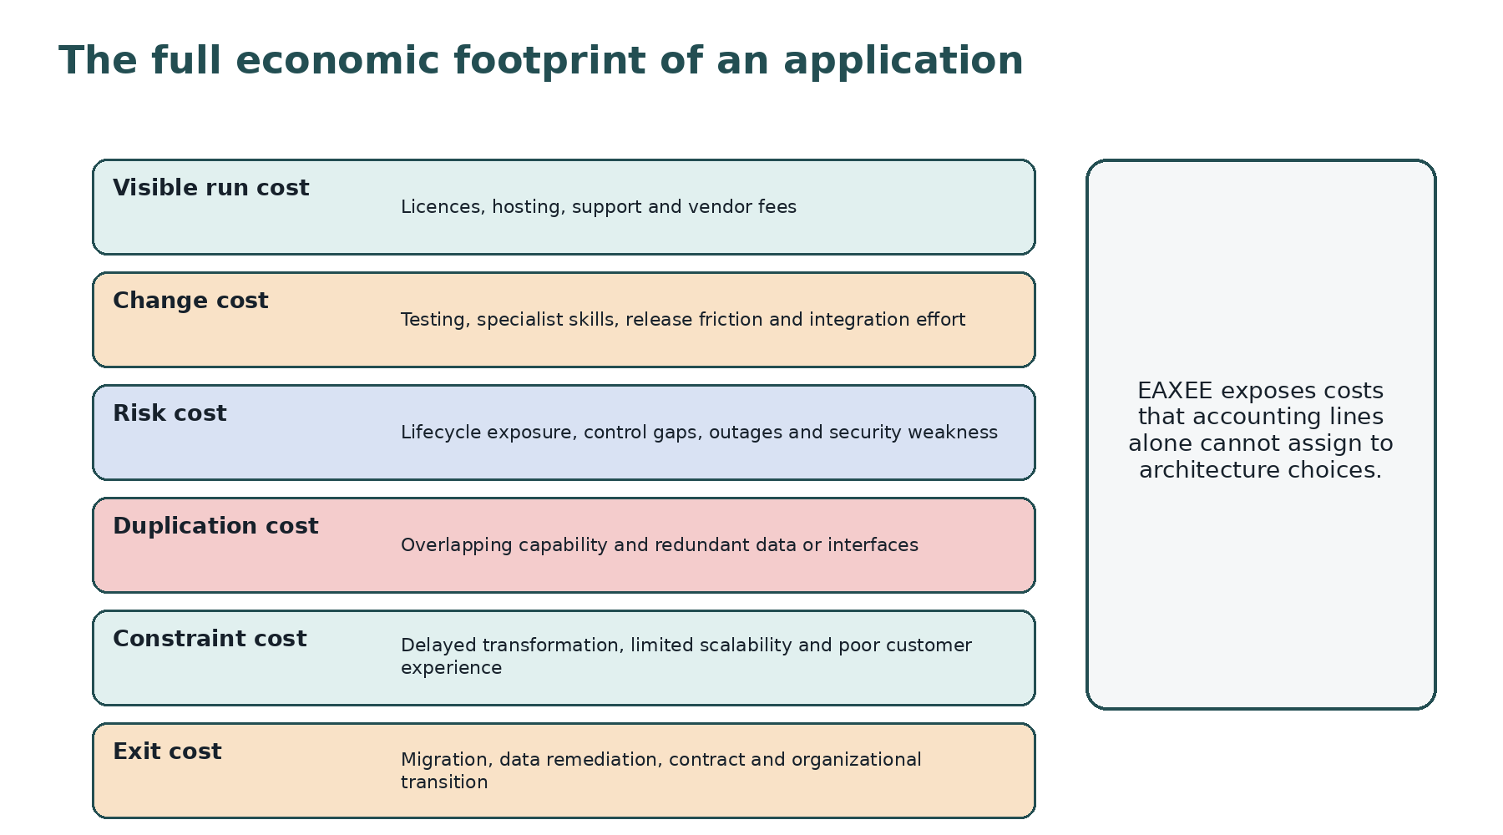
Figure 1. The full economic footprint of an application.

1. Rationalization is an investment discipline
Traditional rationalization often ends with a four-box classification. The classification is useful, but the economic value appears only when the organization can execute a credible decision: invest, contain, migrate, consolidate, replace or retire. EAXEE supports the complete investment chain from evidence to option to sequence to realized result.
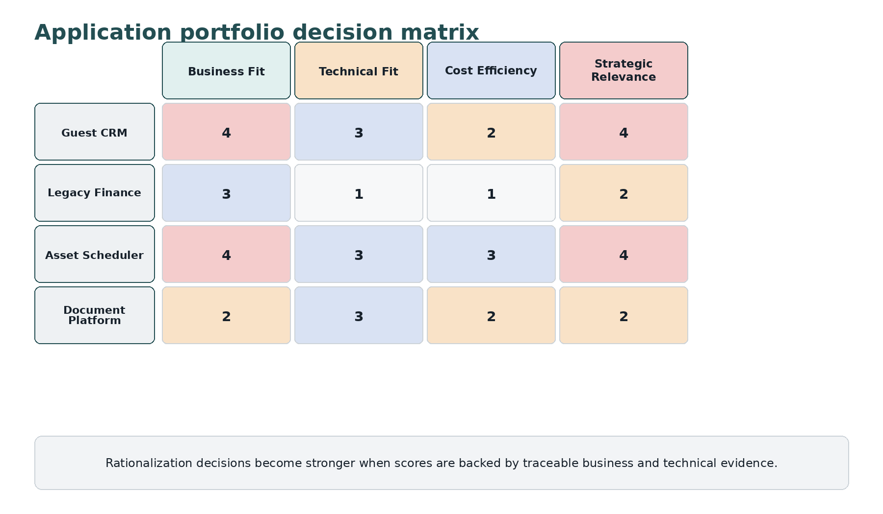
Figure 2. Illustrative portfolio decision matrix.

2. The seven evidence questions
Question | Evidence EAXEE provides
What business value does the application enable? | Supported capabilities, processes, customer journeys and business services
How well does it perform that role? | Fitness, user experience, service levels, incidents and capability performance
What does it truly cost? | Licence, hosting, support, change effort, integration and supplier dependencies
What risk does it introduce? | Lifecycle, security, control, resilience and concentration exposure
What duplicates it? | Overlapping capability, functions, data, reports and interfaces
What future depends on it? | Programs, target states, AI use cases, data products and regulatory commitments
What would exit require? | Data migration, interface replacement, process change, contract and organizational readiness

3. Functional Shadow Price
The Functional Shadow Price is the full economic consequence of retaining an application for another planning period. It combines direct run cost with change friction, expected risk, duplicated capability, strategic constraint and eventual exit cost. The measure is not intended to create false accounting precision. It is intended to expose costs that remain invisible when applications are evaluated only through invoices.
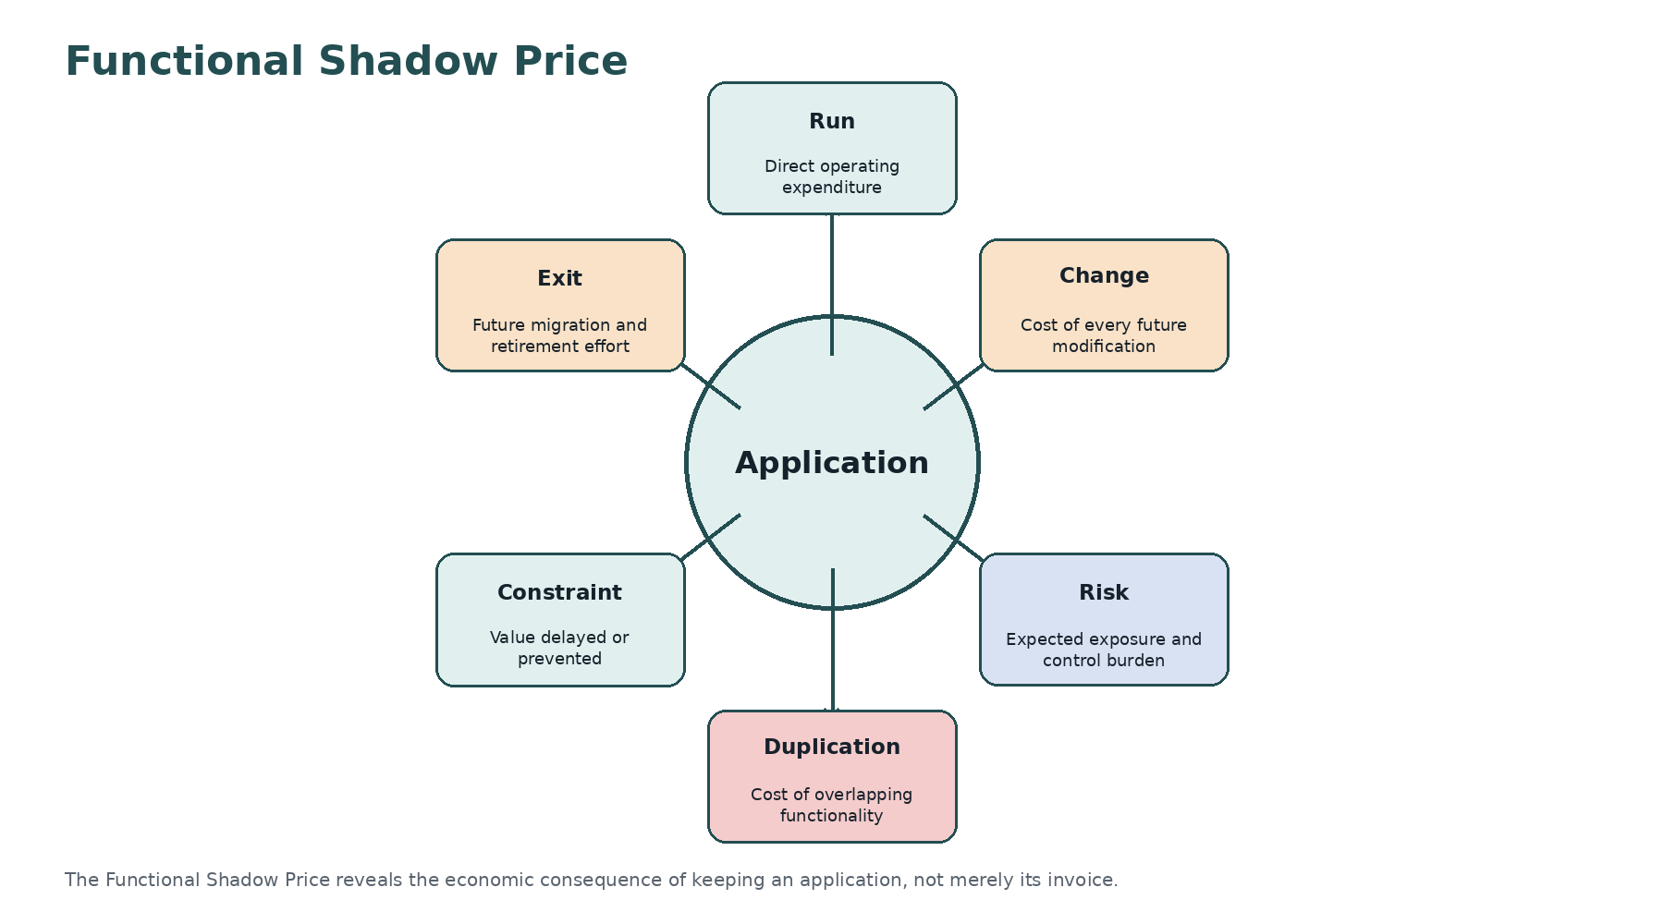
Figure 3. Components of the Functional Shadow Price.

4. Technical debt is a portfolio claim on future cash
Technical debt is often described as an engineering concern. Financially, it is a claim on future cash and delivery capacity. Unsupported products require compensating controls. Tightly coupled integrations increase testing effort. Poor data structures create reconciliation work. Scarce skills raise supplier dependence. EAXEE links these conditions to the business capabilities and transformation initiatives that will bear the cost.

5. Avoiding the retirement trap
An application can be classified for retirement and remain in service for years because the exit path was never architected. EAXEE forces retirement to become a transformation design. It identifies consumers, interfaces, data retention, reporting, controls, contractual dates, replacement capability and transitional coexistence. A retirement candidate without an exit architecture is merely an intention.
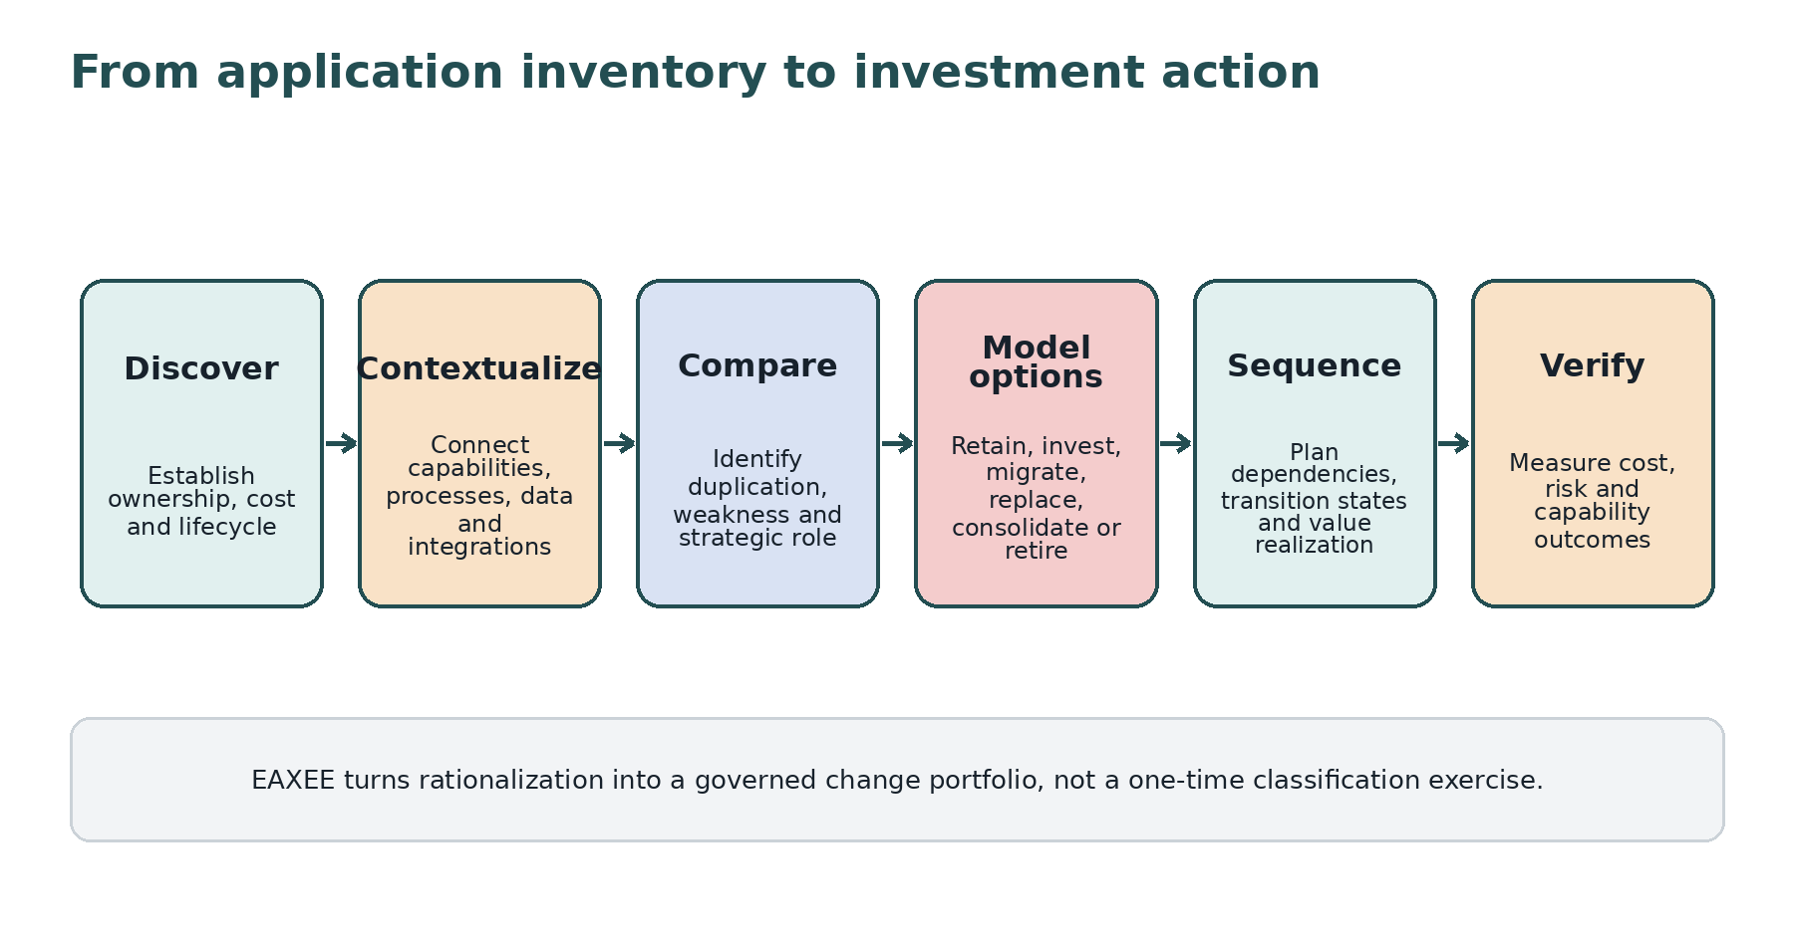
Figure 4. Rationalization as a governed investment lifecycle.

6. Portfolio patterns worth finding
- Two applications supporting the same capability in different business units with no deliberate differentiation.
- A low-cost application whose integration and manual reconciliation create a high shadow price.
- A strategic application constrained by obsolete infrastructure or single-supplier skills.
- A platform funded by several programs without a shared target architecture.
- An application marked non-critical that is the sole source of data for a regulated report.
- A replacement program that leaves legacy data, licences and support obligations behind.

7. Example: consolidating document platforms
Suppose the organization operates five document platforms. Licence comparison alone suggests immediate consolidation. EAXEE reveals that they serve different regulatory retention rules, external collaboration patterns, engineering records and guest communications. It also identifies duplicated capabilities, common identity dependencies, migration complexity and contracts nearing renewal. The result may still be consolidation, but the sequence becomes risk-aware and the business case includes the real exit effort.

8. Economics of option sequencing
The cheapest target is not always the best first move. EAXEE can compare option value: whether an action reduces immediate cost, unlocks future modernization, lowers risk or preserves flexibility. For example, simplifying integrations before replacing a core application may create a lower-risk and more reversible sequence than attempting both changes together.

9. Measures for executive portfolio governance
Measure | Interpretation
Functional Shadow Price | Estimated full economic consequence of retention
Duplication Density | Concentration of overlapping applications within a capability
Change Friction Index | Effort required to modify an application relative to delivered value
Retirement Readiness | Completeness of the exit architecture and business transition
Technical Debt Exposure | Debt weighted by business criticality and strategic dependence
Run-to-Change Leverage | Amount of transformation capacity released by portfolio action

10. Procurement relevance
A rationalization platform should do more than store application facts. It should expose business context, calculate affected stakeholders, compare options, preserve decision rationale, manage transition states and verify outcomes. EAXEE supports this broader economic discipline, enabling EA teams to speak credibly with finance, procurement, risk and business leaders.
“The most expensive application may not have the highest invoice. It may be the one that quietly taxes every change around it.”

Conclusion
EAXEE transforms application rationalization from periodic inventory cleanup into continuous investment governance. It allows leaders to see where money, risk and transformation capacity are trapped in the current architecture — and to release them through evidence-based, sequenced action.

