EAXEE THOUGHT LEADERSHIP SERIES

The Strategy-to-Execution Fault Line
  - How EAXEE prevents transformation promises from breaking apart during delivery

Voice: analytical, operational and candid — organized like a management diagnostic with fault patterns, controls and repair actions.

Enterprise architecture for decisions that matter

Diagnosis: the strategy is not failing where leaders think
Transformation strategies rarely collapse because the ambition was unclear. They fracture as the ambition crosses organizational boundaries. A strategic objective becomes a program theme. The program theme becomes a list of projects. Projects become requirements, procurements and releases. Somewhere along that path, the original business outcome is diluted, duplicated or displaced by what is easiest to deliver.
This is the strategy-to-execution fault line. EAXEE addresses it by preserving traceability from strategic promise to capability change, operating impact, digital enablement, delivery commitments and value evidence.
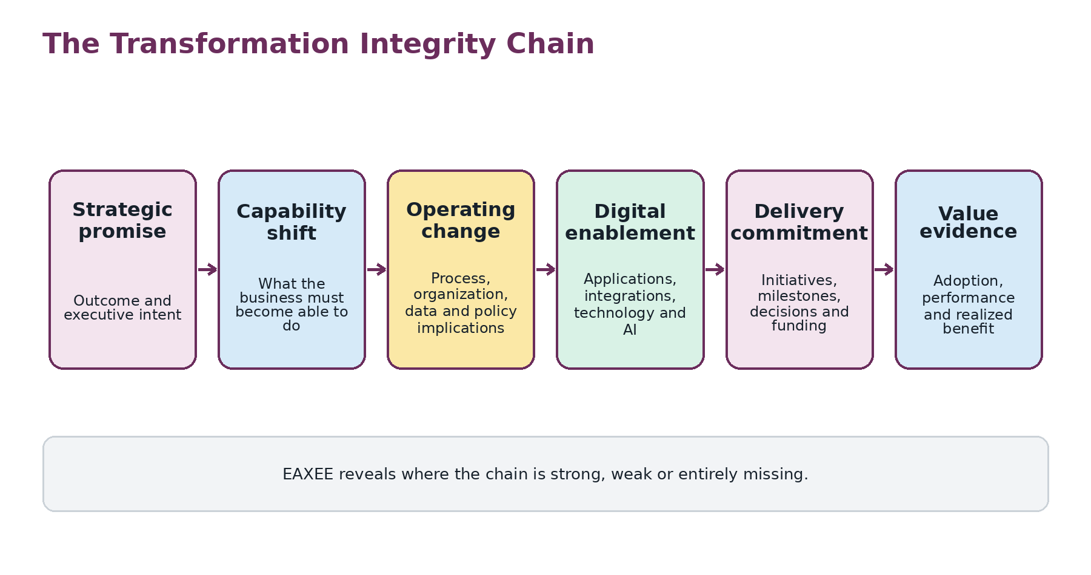
Figure 1. The Transformation Integrity Chain.

Fault pattern 1: labelled alignment
A project is often called “strategic” because it references an objective in a business case. That is labelled alignment. Demonstrated alignment requires evidence of what capability will improve, how performance will change, which operating conditions are necessary and how the contribution will be measured. EAXEE makes the difference visible.
Weak statement | Stronger EAXEE-grounded statement
Supports customer experience | Reduces disruption-recovery time by connecting guest identity, service entitlement and transport rebooking across three journey stages
Enables efficiency | Automates the supplier-onboarding controls that constrain procurement cycle time
Improves data | Establishes accountable ownership and quality controls for the data used in revenue forecasting
Modernizes technology | Removes lifecycle exposure from applications supporting two critical business services

Fault pattern 2: capability change without operating change
Digital initiatives frequently describe new functionality while under-specifying roles, policies, decision rights, controls, skills and service-management responsibilities. The result is technical delivery without organizational adoption. EAXEE connects the desired capability shift to the complete operating footprint that must change.

Fault pattern 3: the collision nobody owns
Transformation portfolios are usually governed project by project. The enterprise experiences them asset by asset. Several programs may modify the same capability, application, data domain, integration, supplier or specialist team. Each project can appear healthy while the shared target becomes overloaded or internally inconsistent.
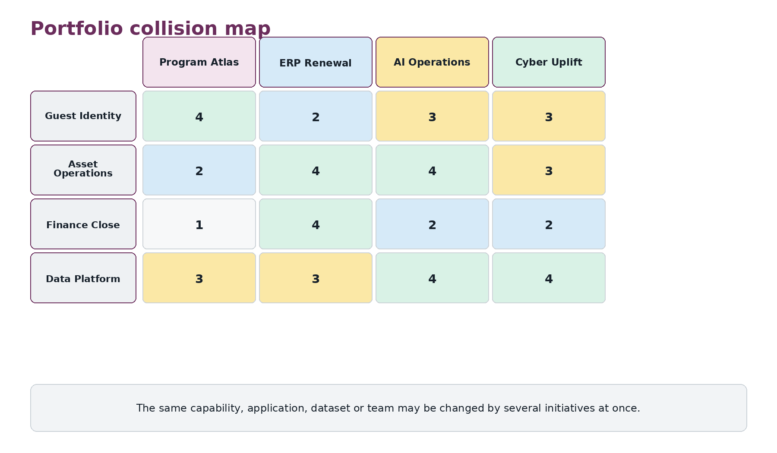
Figure 2. A portfolio collision map produced from connected EAXEE relationships.
EAXEE can identify collision density, incompatible target states, repeated dependencies, resource concentration and sequencing conflicts. This is portfolio intelligence unavailable from isolated schedules.

Fault pattern 4: architecture arrives as review, not evidence
When architecture is treated as a late approval gate, it is forced to challenge decisions after commercial and schedule commitments have already hardened. EAXEE shifts architecture earlier by making target states, standards, dependencies, risks and transition constraints available during shaping and option selection.
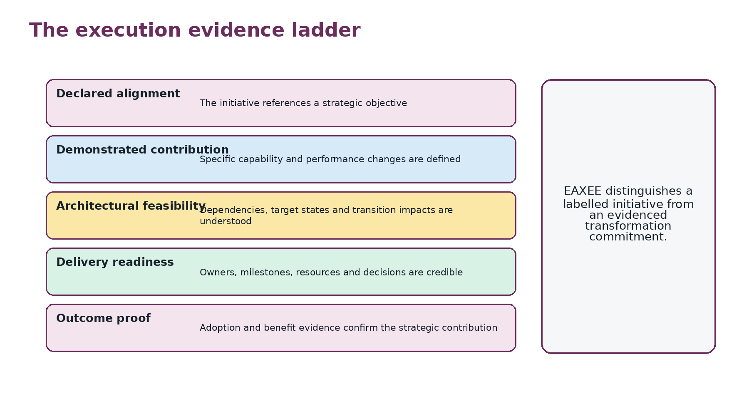
Figure 3. The execution evidence ladder.

Fault pattern 5: benefits survive on paper
Benefits are often measured separately from the architecture and operating changes expected to produce them. EAXEE can connect a benefit to the capability performance, process adoption, application use, data quality and organizational readiness on which it depends. This produces Benefit Confidence: an evidence-based view of whether a promised outcome remains plausible.

Repair mechanism: the transformation control room
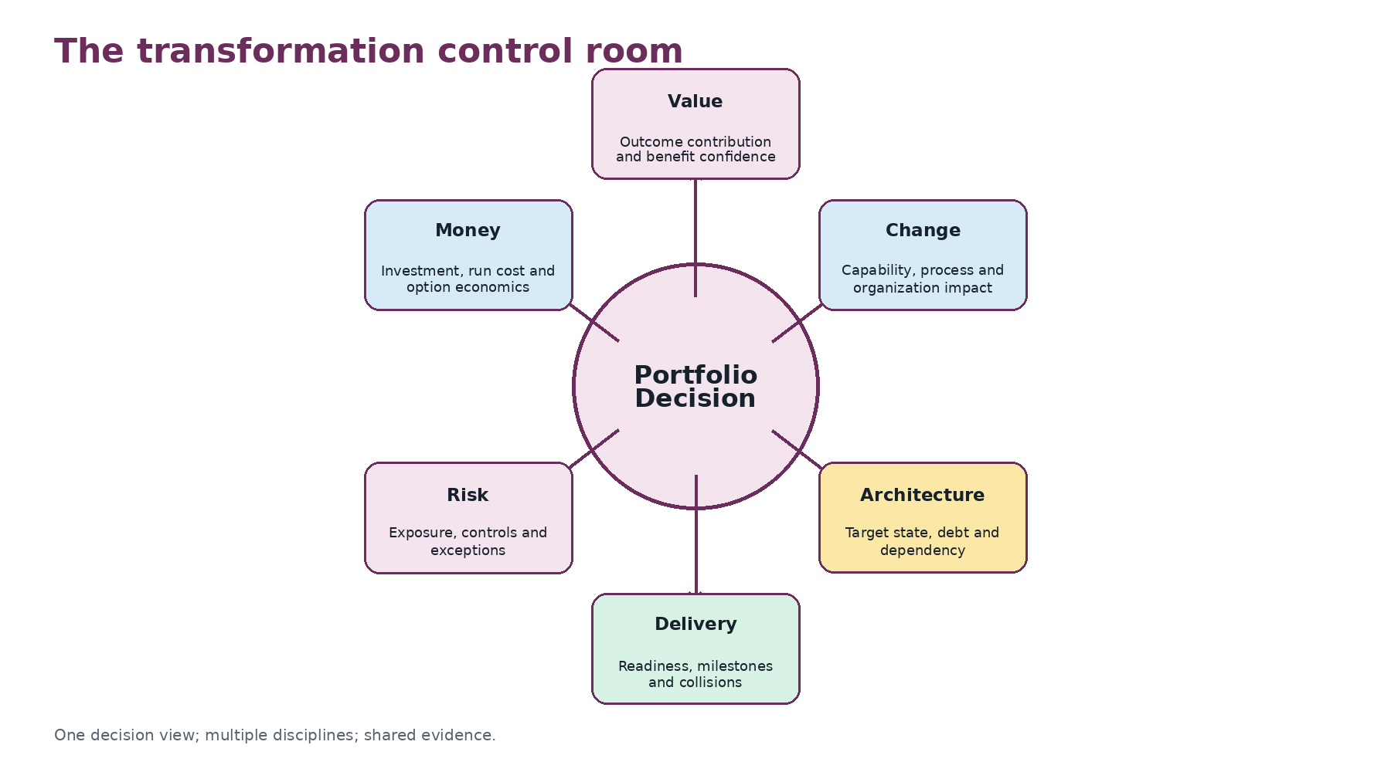
Figure 4. A shared portfolio decision view.
The control room is not another dashboard. It is a decision workspace that combines multiple lenses over the same connected facts. A portfolio review can therefore ask: Are we still pursuing the right outcomes? Are target states coherent? Where are initiatives colliding? Which exceptions are accumulating? Which benefits are losing supporting conditions?

A governance cadence that uses EAXEE
Cadence | Primary decision | Required EAXEE evidence
Quarterly strategy review | Continue, redirect or rebalance outcomes and investment | Objective-to-capability coverage, outcome indicators and portfolio contribution
Monthly portfolio review | Resolve collisions, dependencies and sequencing | Shared-asset impact, milestone dependencies, target-state conflicts and benefit confidence
Architecture decision forum | Approve options and exceptions | Alternatives, principles, standards, transition states, risk and cost consequences
Release readiness review | Authorize operational change | Process, role, control, data, service and continuity readiness
Benefits review | Confirm realized value or corrective action | Adoption, performance, benefit dependency and architecture outcome evidence

Example: finance transformation
An ERP renewal is often governed as a system implementation. EAXEE reframes it as a transformation of financial capability. The model connects close, planning, procurement and asset accounting capabilities to processes, organizational units, policies, master data, integrations, reports, applications and controls. It can reveal that the target system is technically ready while data ownership, approval design and local operating procedures remain unresolved. The program is then managed against the real outcome rather than the software milestone alone.

Measures worth adopting
- Strategic Traceability Coverage: percentage of funded change with an evidenced path to outcomes.
- Transformation Coherence Score: consistency of target states across initiatives affecting shared architecture.
- Collision Exposure: concentration of concurrent change on common assets and teams.
- Benefit Confidence: strength and freshness of evidence supporting expected value.
- Decision Latency: time lost because required cross-domain evidence is unavailable or disputed.
- Exception Debt: accumulated cost and risk created by temporary deviations that have not been resolved.

Buyer’s test
Ask an EA platform to demonstrate one strategic outcome through capabilities, operating changes, applications, data, projects, costs, risks and benefits. Then change one dependency and observe whether affected initiatives and decisions become visible. If the platform cannot maintain that chain, it is documenting architecture, not governing transformation.
“Execution does not need more status. It needs stronger evidence that the work still adds up to the strategy.”

Conclusion
EAXEE repairs the strategy-to-execution fault line by maintaining the integrity of transformation as it moves through the enterprise. It turns alignment from a label into a traceable claim, portfolio governance from project reporting into collision management and benefits from promises into evidence. The result is not simply better architecture. It is transformation that remains coherent while being delivered.

