EAXEE THOUGHT LEADERSHIP SERIES

Who Governs the Machines?
  - How EAXEE gives leaders visibility, control and confidence in enterprise AI

Voice: investigative, urgent and board-facing — written as a challenge to leaders who are scaling AI faster than governance can follow.

Enterprise architecture for decisions that matter

The question nobody can delegate
Artificial intelligence is entering the enterprise through sanctioned programs, embedded product features, departmental experiments, vendor platforms and increasingly autonomous agents. The central governance question is no longer whether the organization uses AI. It is whether anyone can explain, with evidence, where AI is operating, what it can influence, which data it touches, who is accountable and what happens when it is wrong.
“An AI inventory tells you what exists. An enterprise architecture tells you what each AI asset can affect.”
This is the distinction on which responsible scale depends. AI governance that is separated from enterprise architecture can catalogue models and policies, but it cannot reliably expose business consequences. EAXEE closes that gap by connecting AI use cases, agents and models to the capabilities, processes, applications, data, people, suppliers, regulations and risks that form their operating environment.
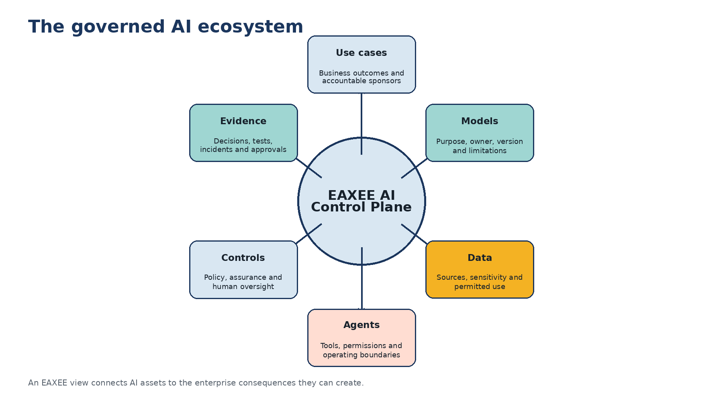
Figure 1. EAXEE as the AI control plane.

1. Governance must follow consequence, not novelty
Many governance programs begin with model registration. That is necessary but insufficient. A low-complexity model may have a high consequence if it controls access, prioritizes safety work or influences a regulatory submission. A sophisticated model may present modest enterprise risk if its output is advisory, reversible and isolated from sensitive data. EAXEE allows governance to be calibrated to consequence by tracing what the AI touches and what the business depends upon.
- Connect every AI use case to a business outcome and accountable executive.
- Identify the processes, decisions and customer moments influenced by AI.
- Trace training, grounding and operational data to classification, ownership and permitted-use rules.
- Map model and agent dependencies on applications, APIs, vendors and infrastructure.
- Reveal affected regulations, controls, risks and continuity arrangements.

2. Six governance questions EAXEE makes answerable
Executive question | What EAXEE connects | Decision enabled
Why are we using AI here? | Strategic objective, capability gap, customer or operational outcome | Fund, reshape or stop the use case
What can it affect? | Process steps, decisions, applications, data and downstream services | Set risk tier and control depth
Who owns the result? | Sponsor, process owner, data owner, model owner and operator | Remove accountability ambiguity
What is it allowed to do? | Permissions, tools, decision rights, approval thresholds and fallback | Define agent operating boundaries
How do we know it remains safe? | Tests, monitoring, drift, incidents, overrides and control evidence | Authorize continued operation
What happens if it fails? | Business service dependencies, alternatives, recovery and human procedures | Design resilience and containment

3. The governed AI lifecycle
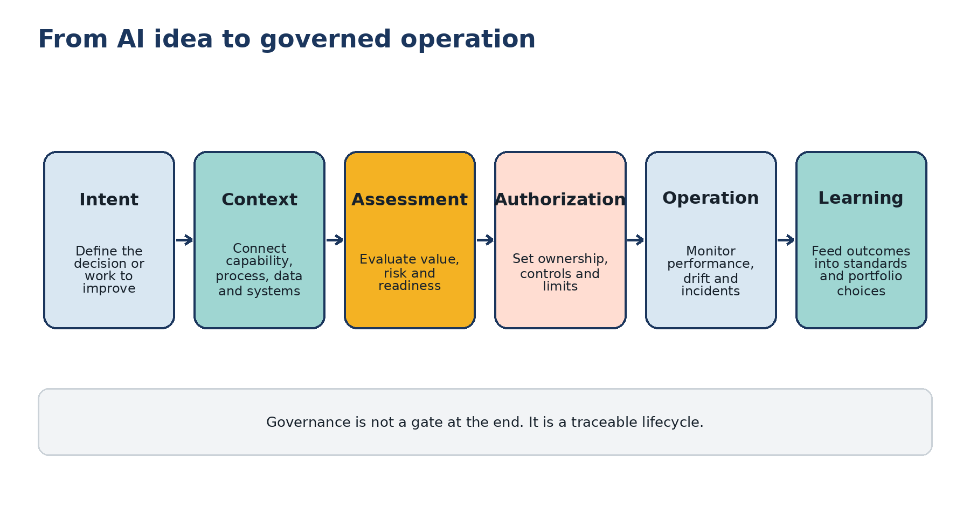
Figure 2. A traceable lifecycle from idea to learning.
EAXEE turns governance into a lifecycle rather than a one-time approval. An idea starts with business intent. Architecture adds context. Risk and readiness are assessed against the real operating footprint. Authorization establishes boundaries. Operational evidence confirms or challenges assumptions. Lessons flow back into standards, reference architectures and portfolio choices.

4. Governing agents: permission is architecture
Autonomous and semi-autonomous agents change the unit of governance. The relevant question is not only what a model predicts, but what an agent can observe, decide, invoke and change. EAXEE can model an agent as an enterprise actor with relationships to tools, APIs, datasets, processes, control points and accountable roles. This creates an auditable operating envelope.
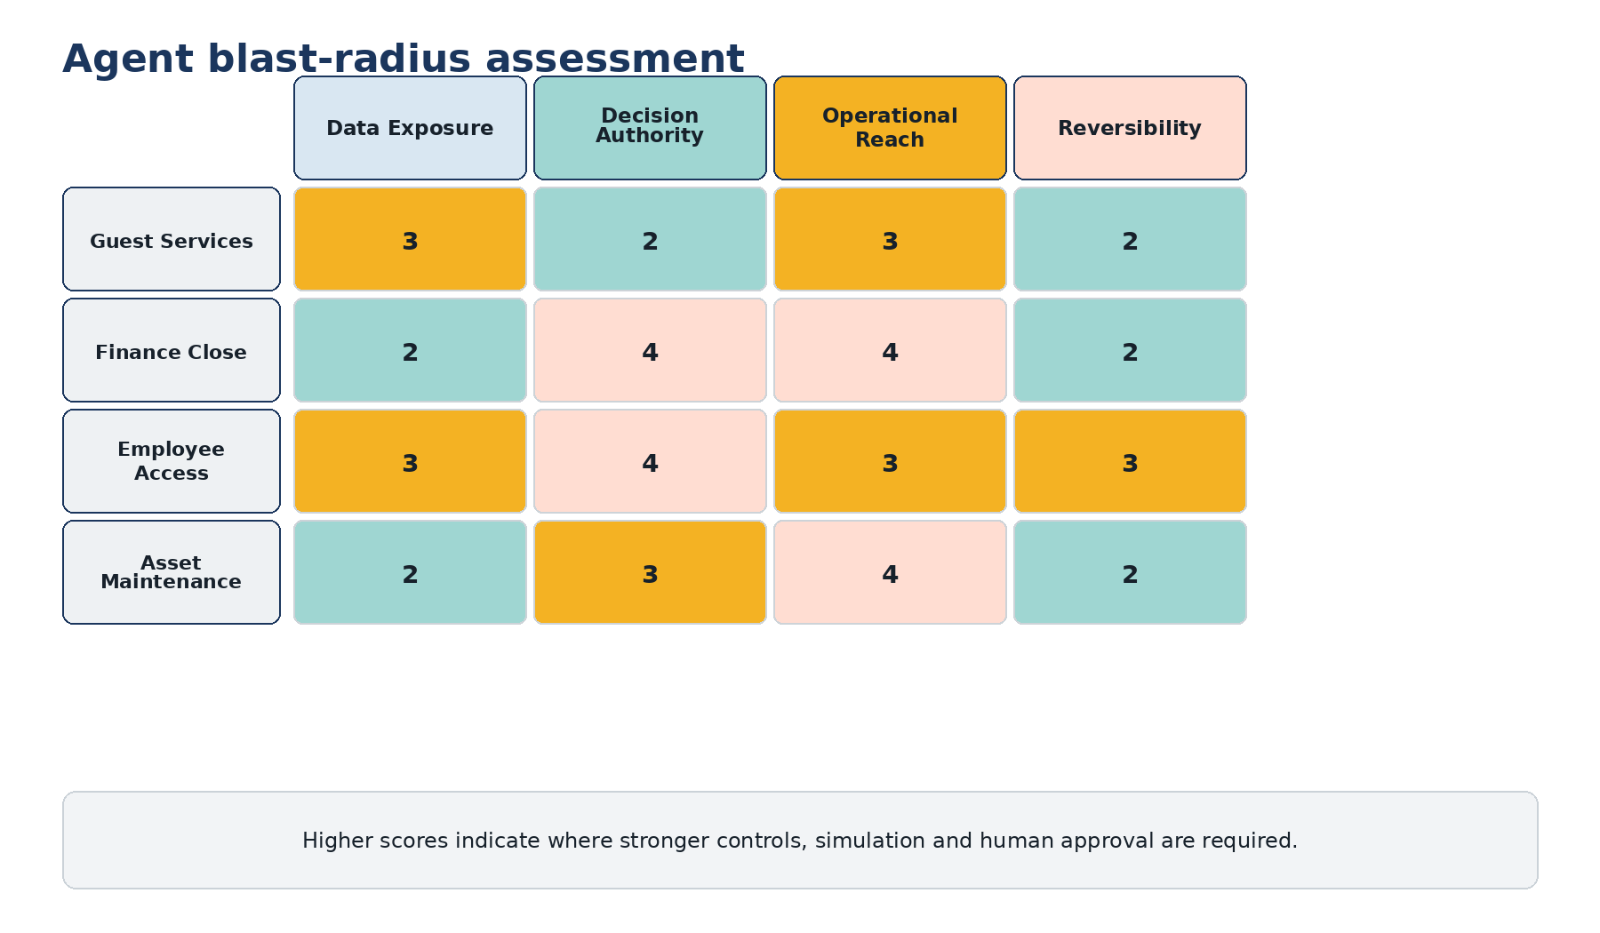
Figure 3. Illustrative agent blast-radius assessment.
The proposed Agent Blast Radius combines operational reach, data exposure, decision authority, reversibility and dependency criticality. It helps distinguish an assistant that drafts text from an agent that creates suppliers, changes access rights or reschedules critical maintenance. Governance effort can then be concentrated where consequences are greatest.

5. The AI assurance evidence stack
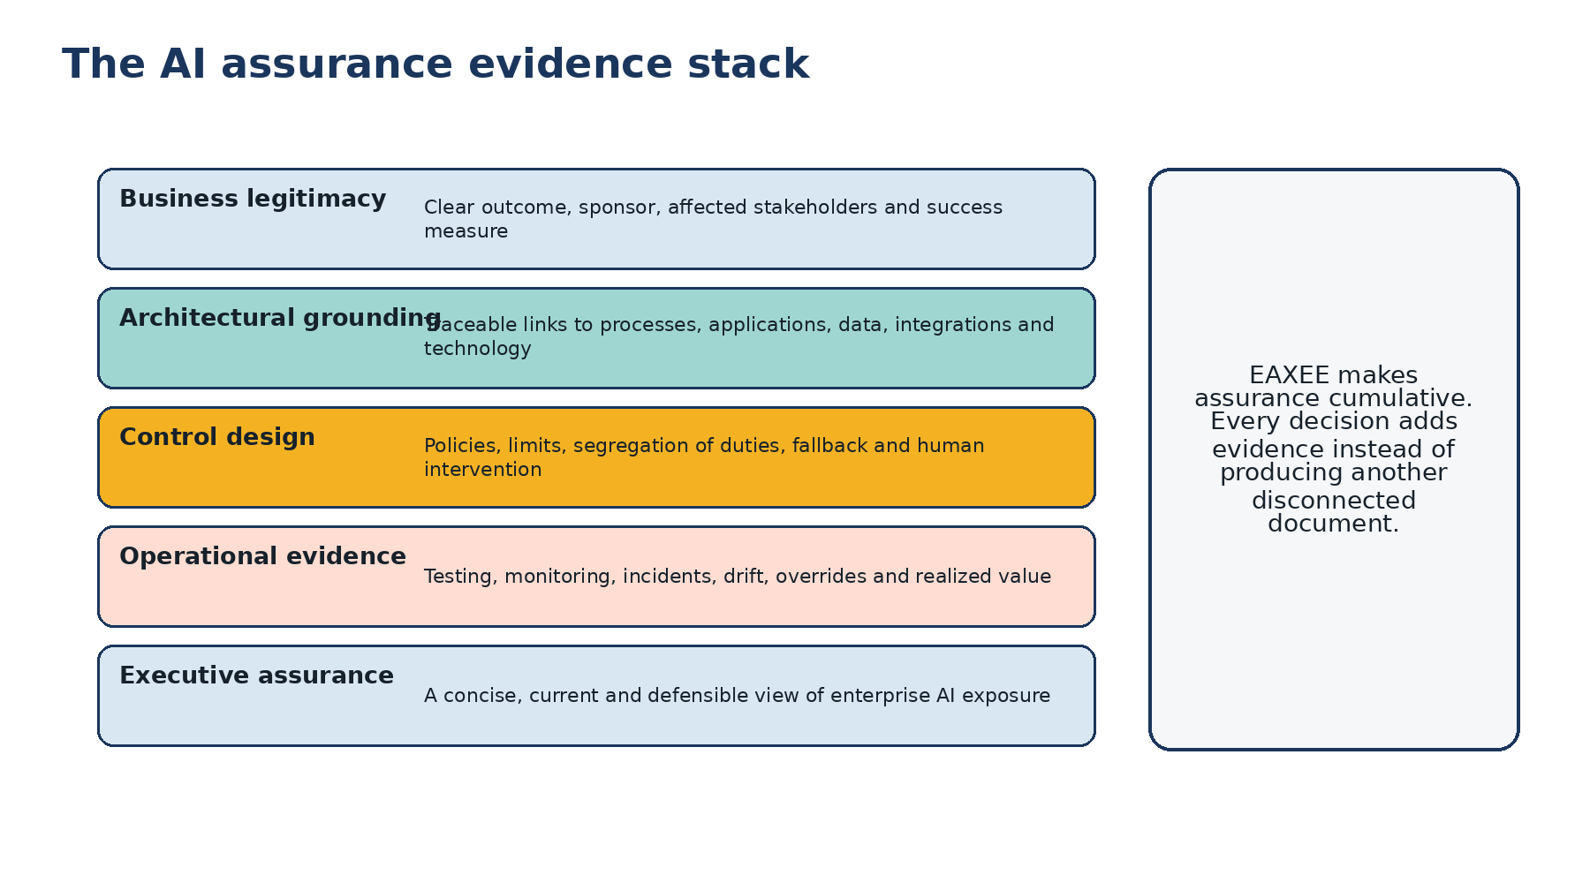
Figure 4. Assurance evidence accumulated through EAXEE.
A procurement-grade AI governance capability should not produce a stack of disconnected policy documents. It should produce a connected evidence chain. EAXEE gives each control a visible relationship to the risk it addresses, the process or asset it protects, the owner responsible for it and the evidence that demonstrates operation.

6. Commercial value for the organization
- Faster approval of well-grounded AI use cases because reviewers receive reusable context instead of rebuilding it.
- Lower regulatory and reputational exposure through traceability from obligation to implementation evidence.
- Reduced duplication by revealing overlapping AI use cases, models, data pipelines and vendor capabilities.
- Safer agent deployment through explicit permissions, boundaries and blast-radius analysis.
- Better portfolio economics by comparing value, readiness, risk and context reuse across candidate investments.

7. A practical example: AI for guest disruption recovery
Consider an AI agent proposed to rebook guests, issue service credits and coordinate transport when a destination service is disrupted. A model registry might record the model and vendor. EAXEE reveals the true governance picture: the affected customer journey, booking and payment applications, loyalty data, transport providers, credit limits, approval policies, identity controls, regulatory obligations, fallback procedures and the executives accountable for guest recovery. The decision moves from “Is the model accurate?” to “Is the complete operating arrangement safe, controlled and valuable?”

8. Procurement takeaways
Look for | Avoid
A connected enterprise model linking AI to business and technology context | A standalone AI inventory with weak operational relationships
Agent permissions and operating boundaries represented explicitly | Governance based only on model documentation
Evidence freshness, ownership and exception management | Annual attestations that become stale immediately
Scenario and blast-radius analysis | Generic risk scores detached from business consequences
Reusable decision views for executives, risk, architecture and delivery | Different spreadsheets for every stakeholder
“The organization that governs AI best will not be the one with the longest policy. It will be the one that can see consequence fastest.”

Conclusion: architecture is the missing control surface
EAXEE gives enterprise AI a control surface grounded in how the organization actually works. It helps leaders pursue speed without surrendering accountability, experimentation without losing traceability and autonomy without creating invisible operational exposure. In the age of enterprise AI, governance cannot remain outside the architecture. It must be built into the enterprise model itself.

